**DevOps**

* Continuous Integration and continuous deployment is the DevOps methodology.
* Which enables the programmers to share their code in shared repository and then deploy the code more efficiently and quickly.

1. One VM instances are created as like below,

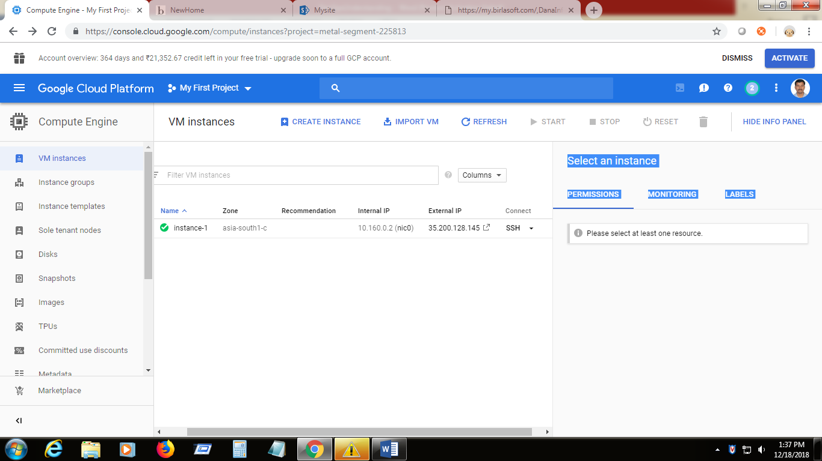

1. Click the connect->SSH -> open in browser window : it will open the SSH shell window

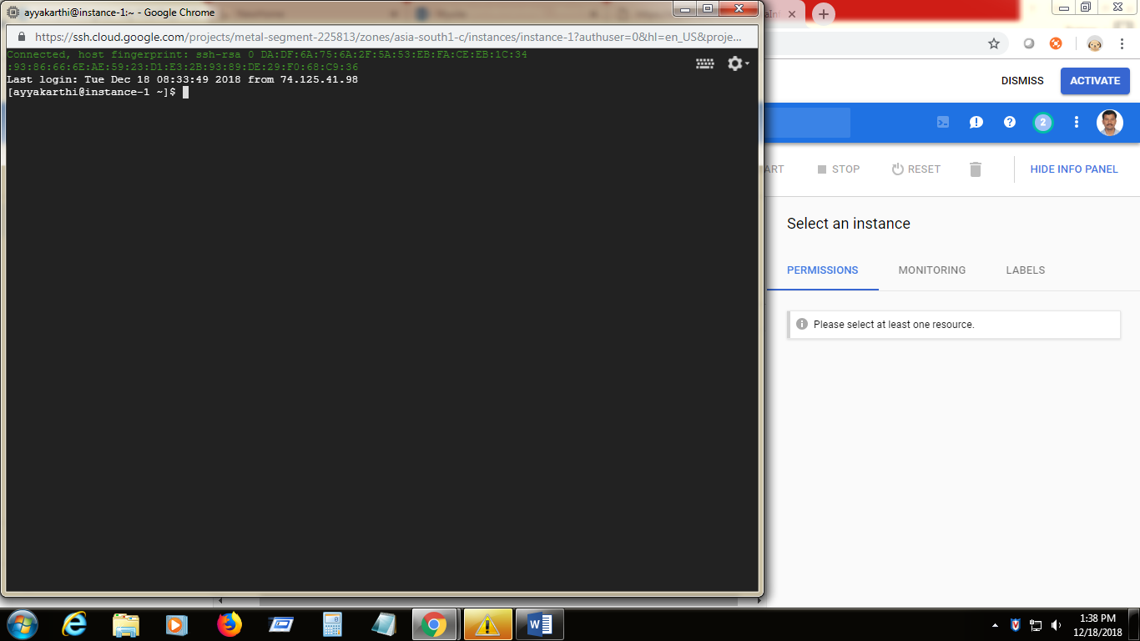

1. Changed the prompt to the root user 🡪 **sudo su –**

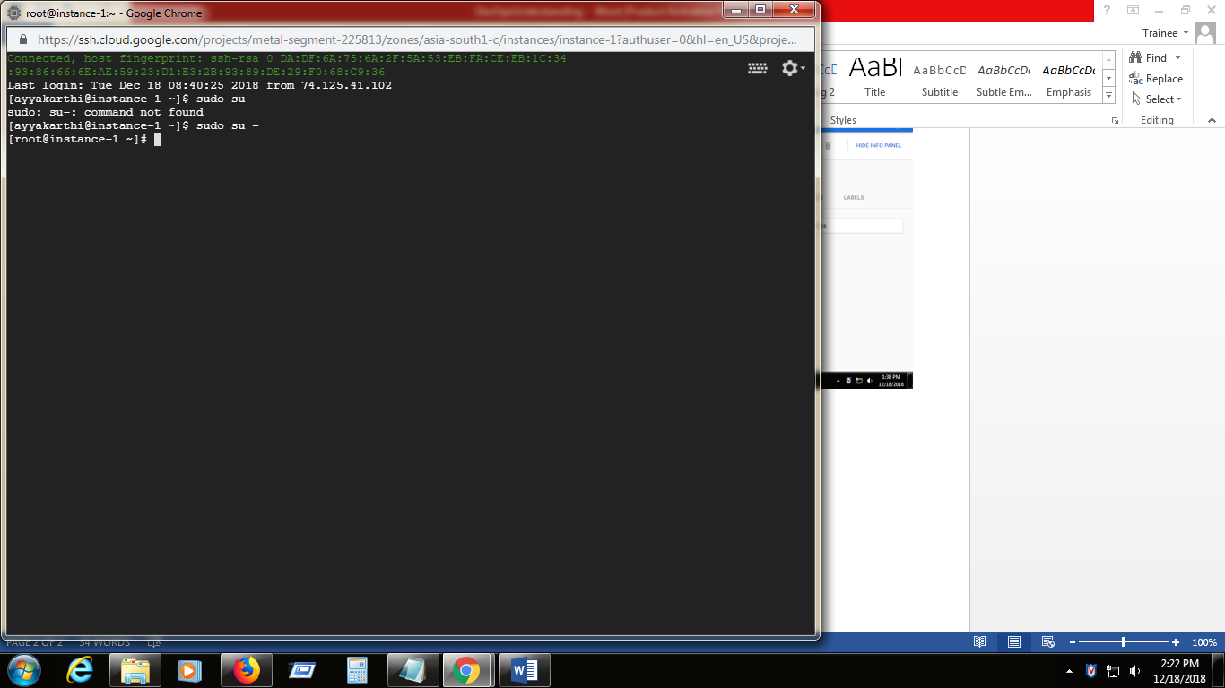

1. Change the password for the root user - > **passwd (devopstrain)**

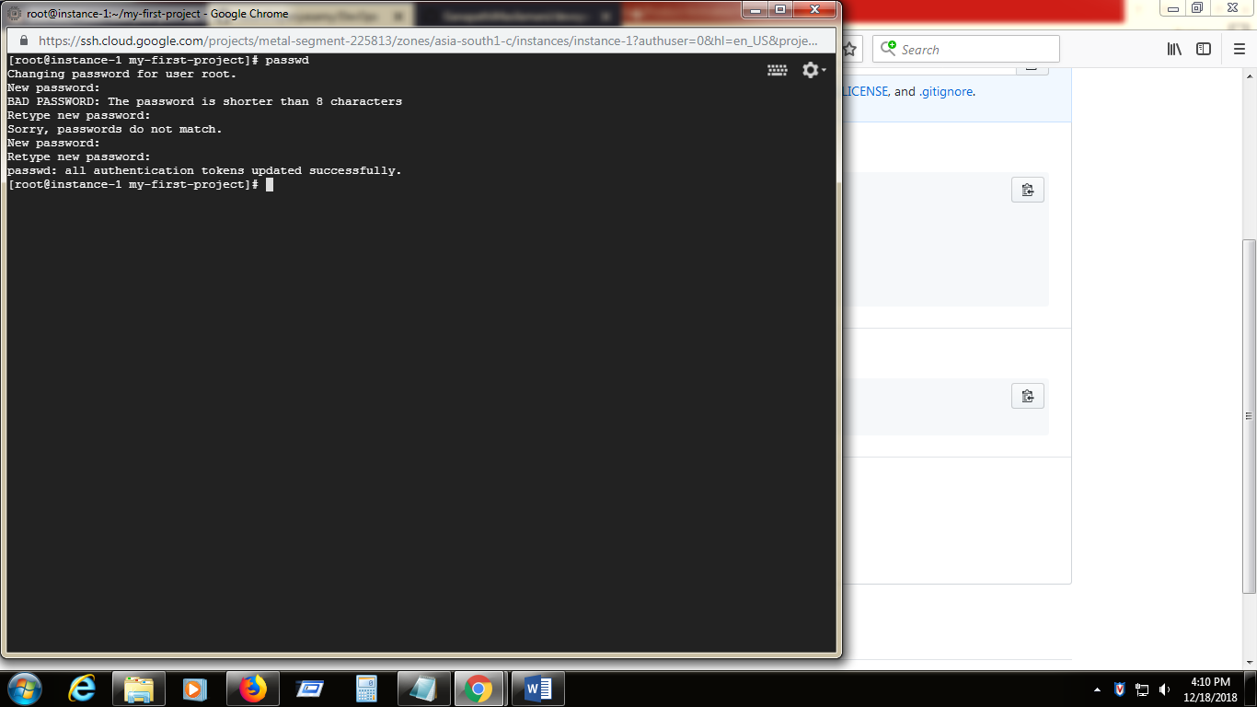

1. Then check the type OS environment in which VM instances is using -> cat /etc/\*release

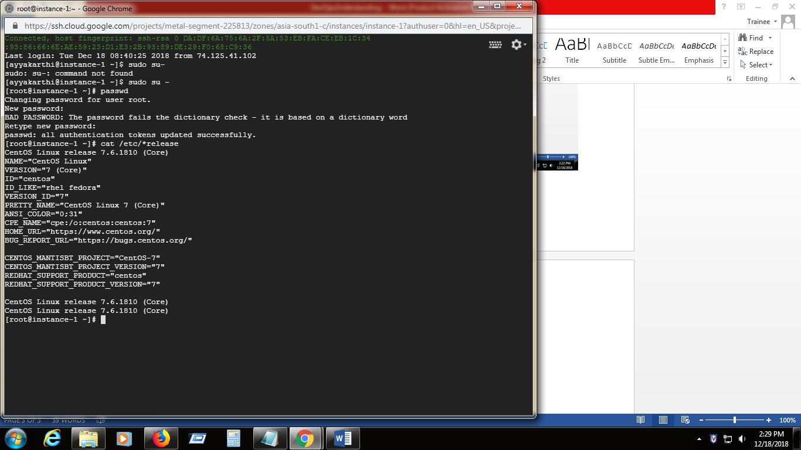

The above are all some basic commands to get to know about the environment.

**Git installation**

1. Check whether Git is already installed 🡪 git –version

If it not installed , install it.

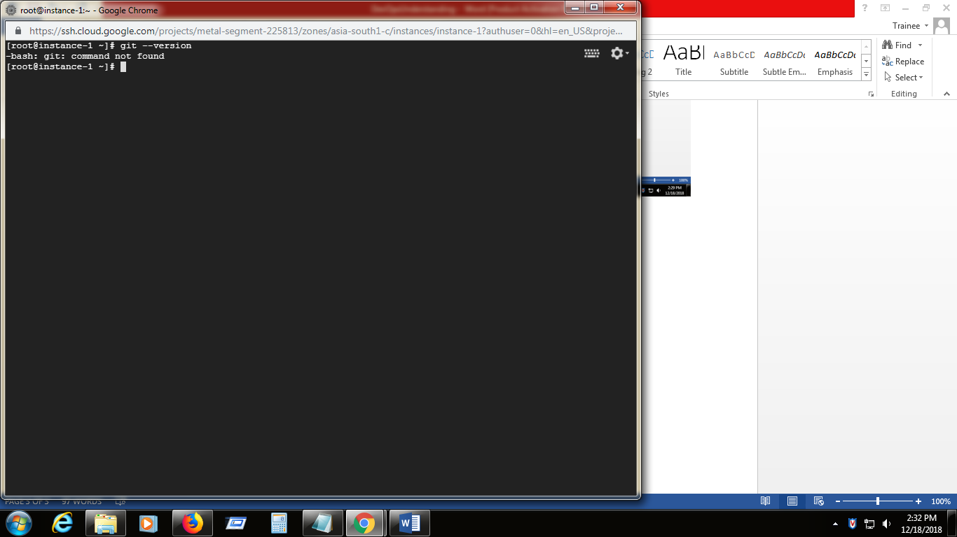

1. Install git using -🡪 **yum install git vim –y**

**yum :-** Yellodog Updater Modified is an opensource tool a Linux systems allows users to easily install , search and update the software packages on a systems.

Git installation should be complete .

To verify the status and version 🡪 **git –version**

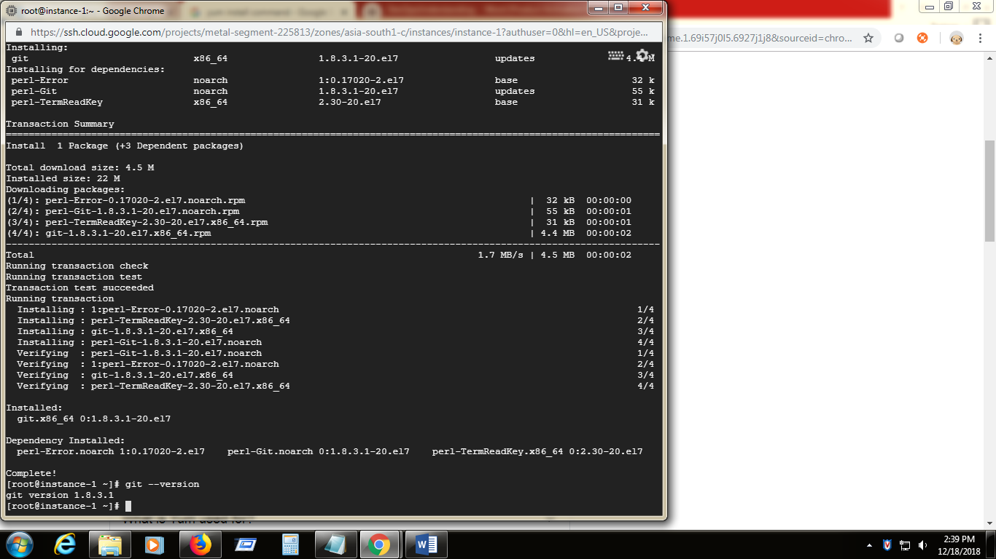

1. Create the working directory using -🡪 mkdir my-first-project

And go inside the directory in prompt using 🡪 cd my-first-project

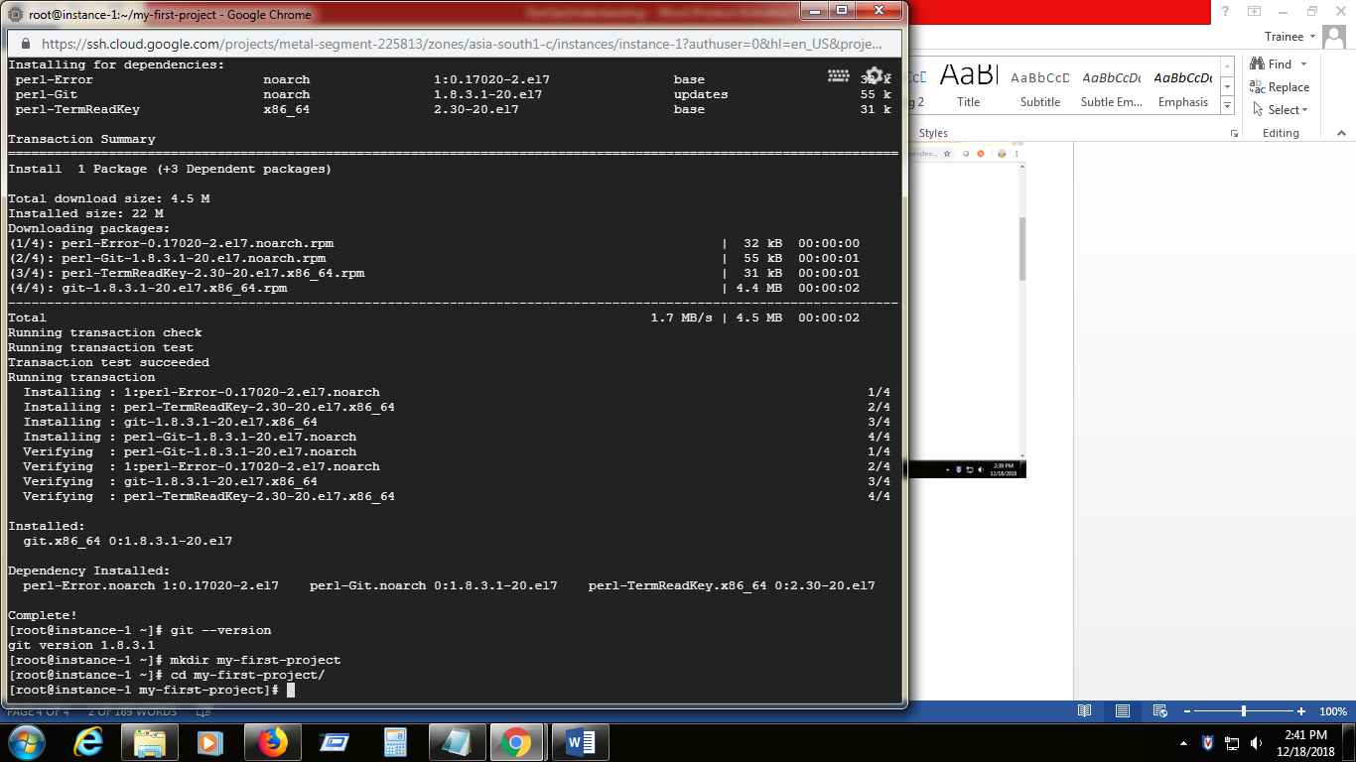

1. Create the new file using 🡪 **echo "This is my new git file" >>firstfile.txt**

This above statement will create the new file with the statement(**This is my new git file)** given in echo into the file firstfile.txt

See the contents of the file using 🡪 **vi firstfile.txt**

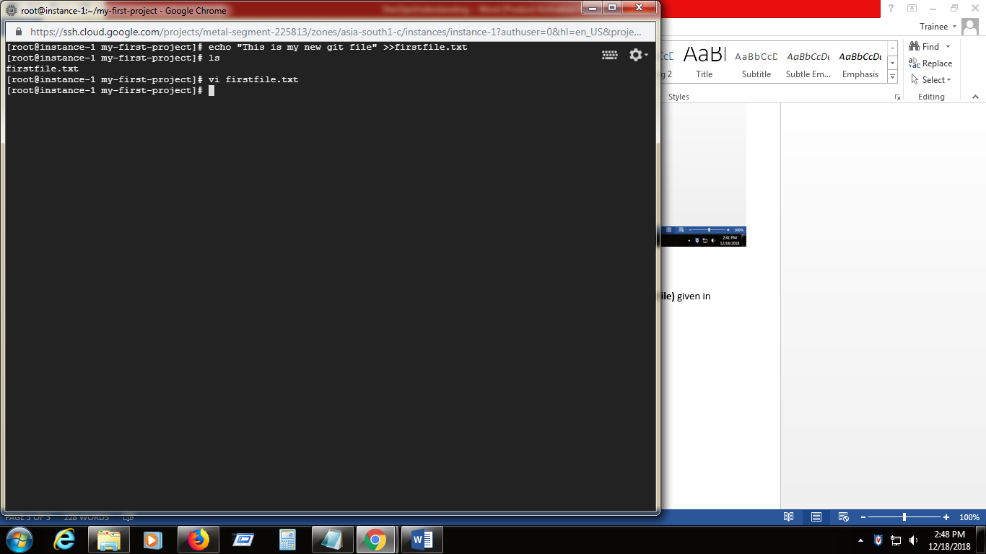

1. It will open the file in vi editor as like below

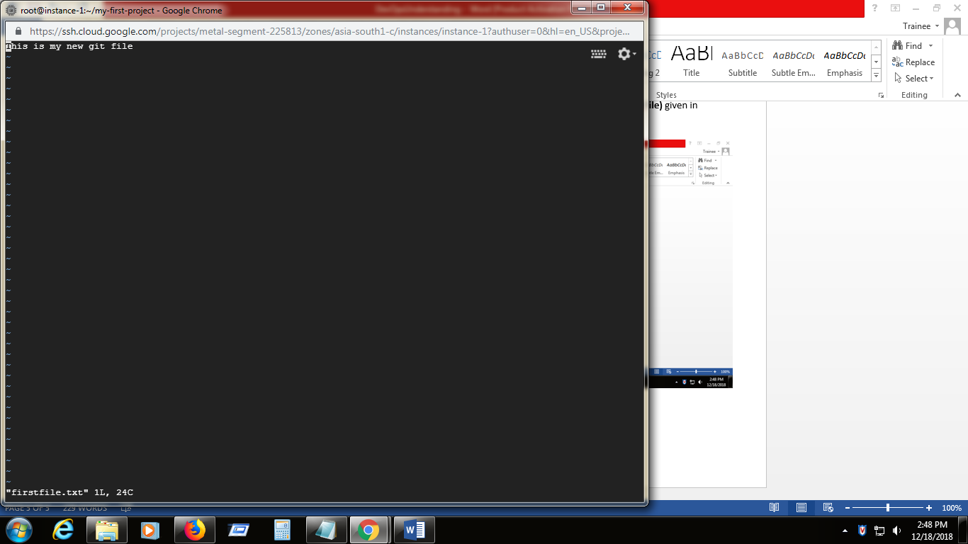

**Press :wq** to come out the the vi editor .

1. Give **vi firstfile.txt ,** it will open the vi editor -> then press I to enter into the insert mode -> press end button ,-> press enter 🡪 add extra line as like below ,

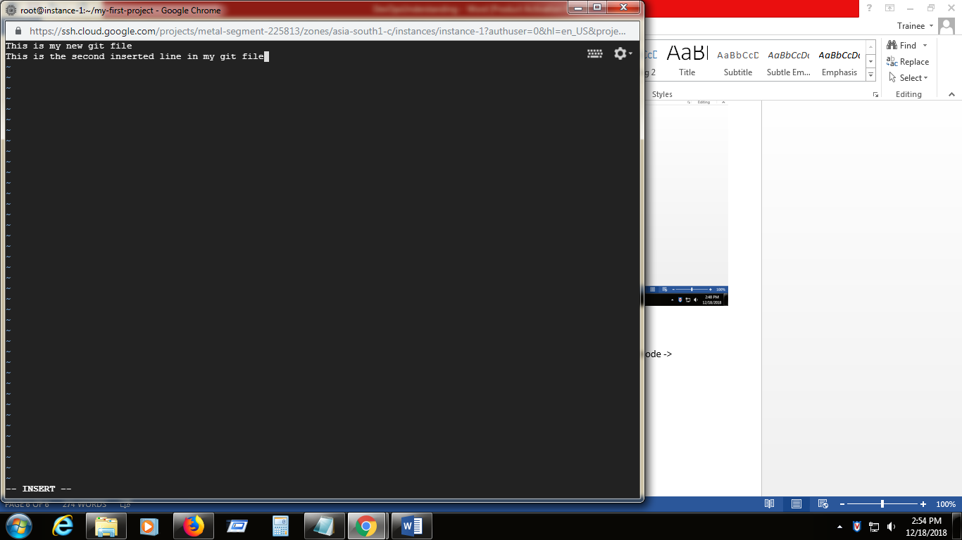

1. After editing give any one of these after pressing ESC key

:q! – exit without save

:wq – save and exit

1. Check the content of the file from command prompt with entering into vi editor use,

**cat firstfile.txt**

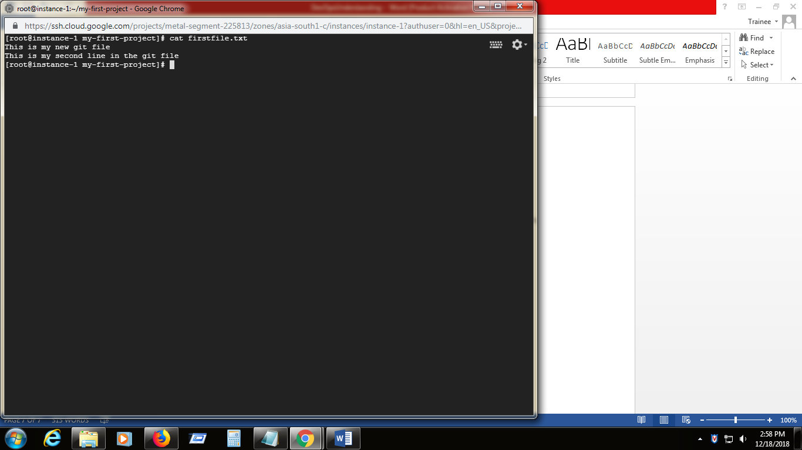

1. List all the content from directory (file names )

**ls** -> list all the file names

**ls** –a -> list visible and hidden files too.

**ls** –l -> list files with details(created time , permissions and size)

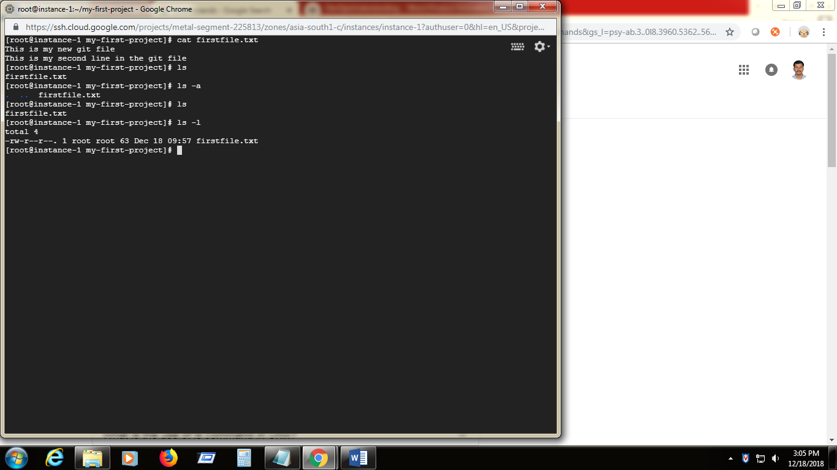

1. Now we have to initiate the Git, using **Git init**

It will initialize the empty git directory in the my-first-project directory

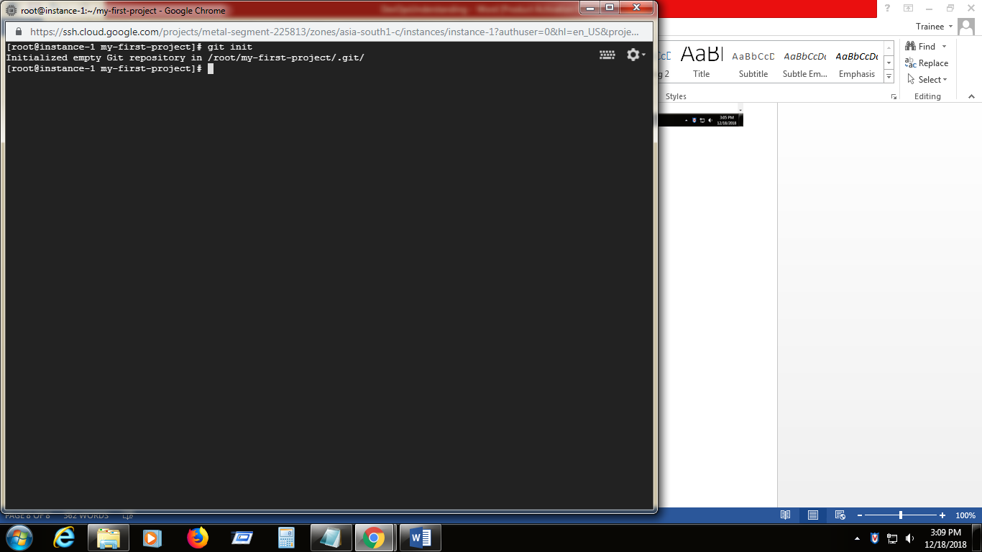

1. To list out this create empty git directory

Use 🡪 ls - a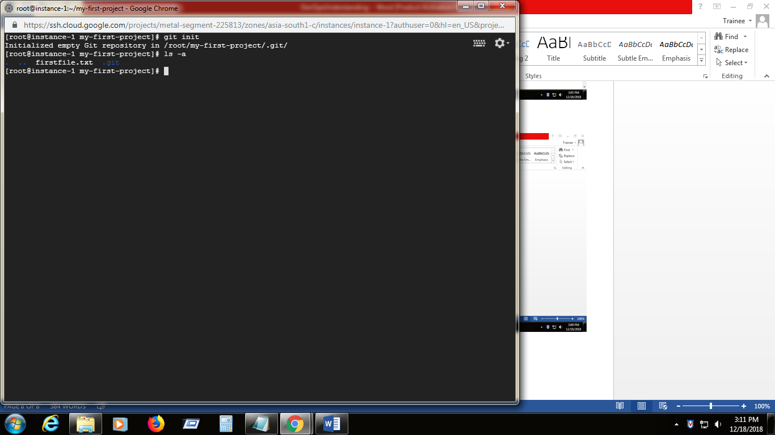

1. Now add the newly created file(firstfile.txt) to the Git using

**git add .**

And check the status of the above operation is using

**git status**

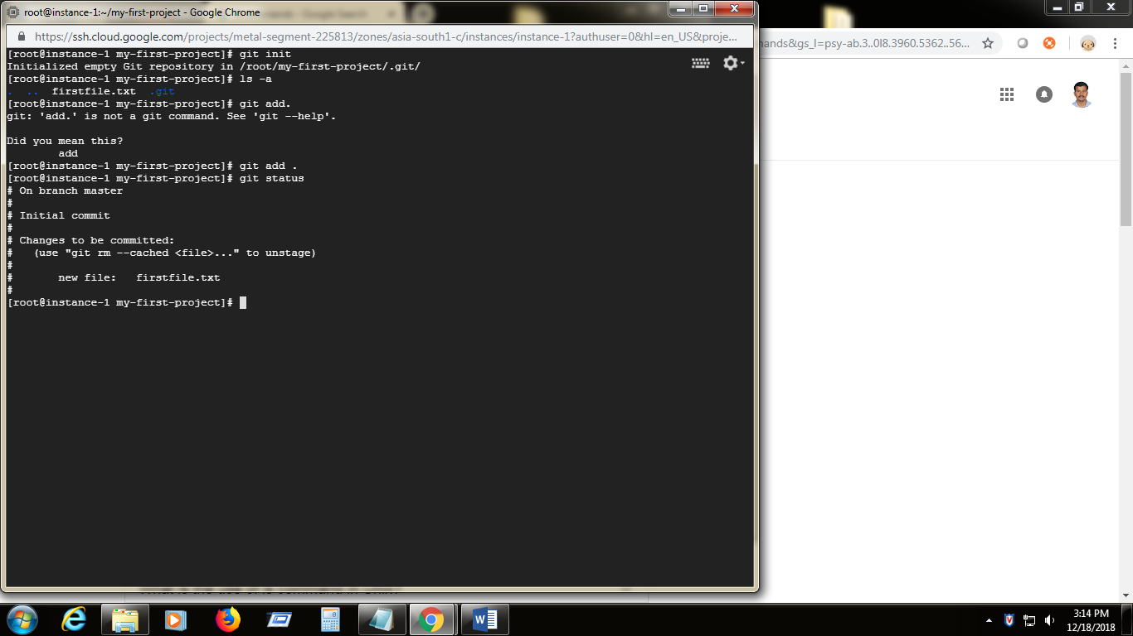

Now there is a change to commit.

1. Commit the file using **git commit –m “First Commit”**

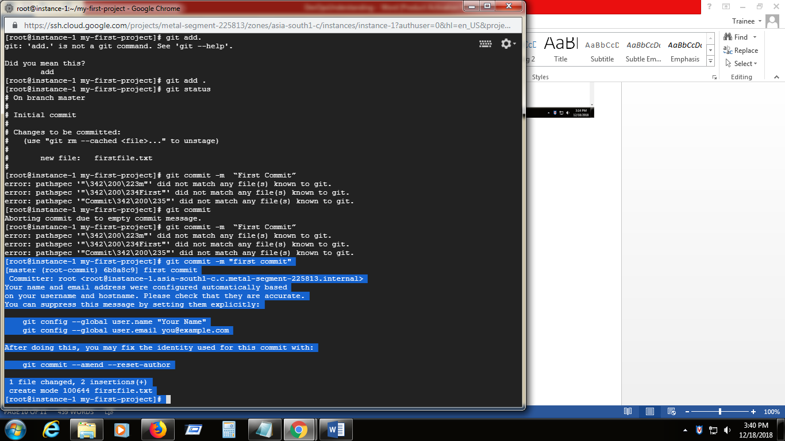

1. Create new repository in GitHub.com

**Github login**

[**Akkammal.periyasamy@gmail.com**](mailto:Akkammal.periyasamy@gmail.com)

**akkammal@2019 -same for my gmail and github login**

Once created it will list some of the git commands for practice

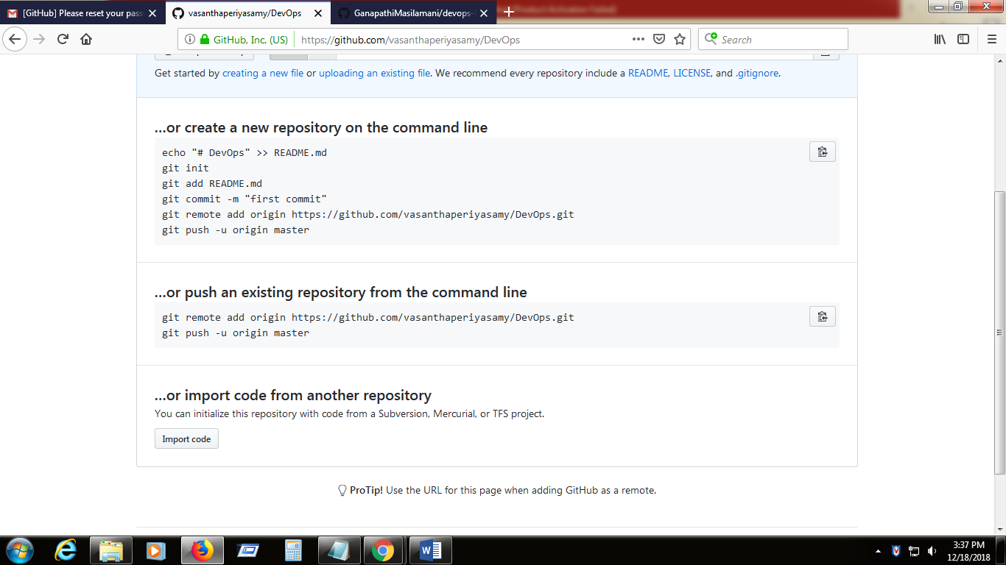

1. Create user and email id by using the

[root@instance-1 my-first-project]# **git config --global user.name "Vasantha"**

[root@instance-1 my-first-project**]# git config --global user.email**

1. Connect to the Git hub repository which we created in github.com

Using **git remote add origin** [**https://github.com/vasanthaperiyasamy/DevOps.git**](https://github.com/vasanthaperiyasamy/DevOps.git)( specifying the remote repository location for the upcoming git push )

And check the config with **git config –list**

**git remote add origin –**it will link the local repository to the remote repository in github.com

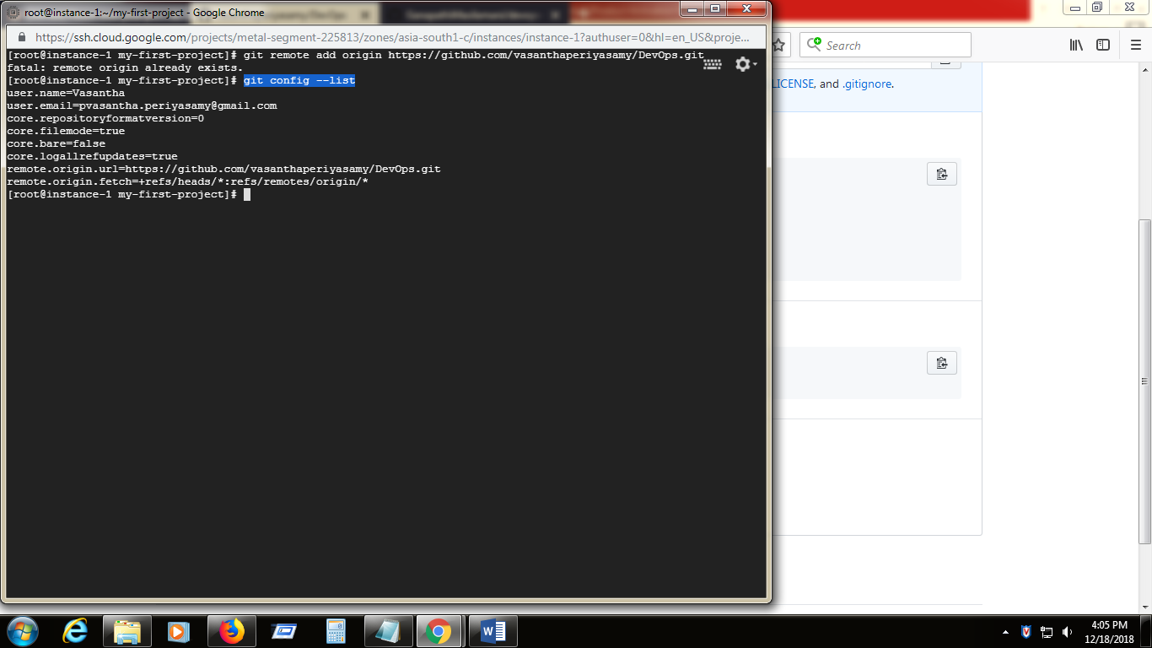

1. Now push the file to github using **git push -u origin master (**push only the master branch to the origin mapped in previous step)

**git push 🡪** PUSH THE LOCAL CHNAGES TO THE REMOTE REPOSITORY

It will ask the github username and password

**'https://github.com/vasanthaperiyasamy/DevOps.git/'**

**Username is :vasanthaperiyasamy**

**Password is:akkammal@2019**

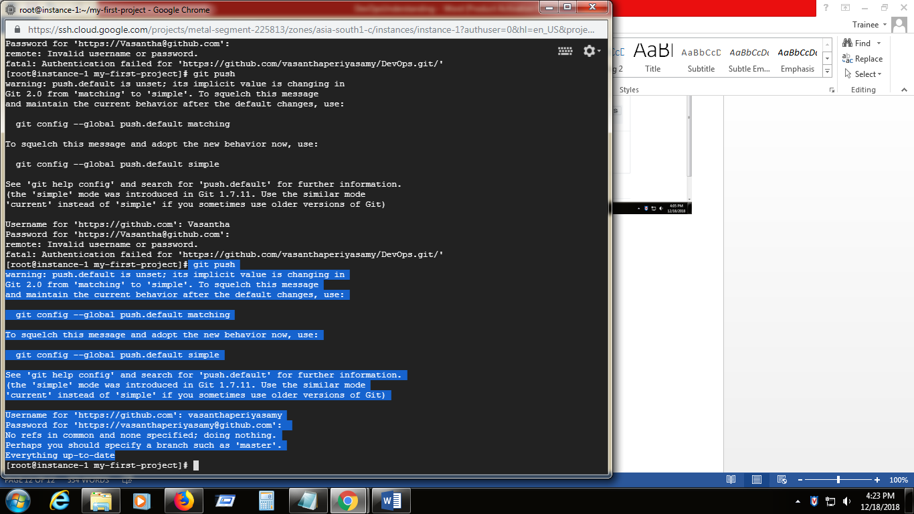

Now the file is pushed to repository in the GitHub.com

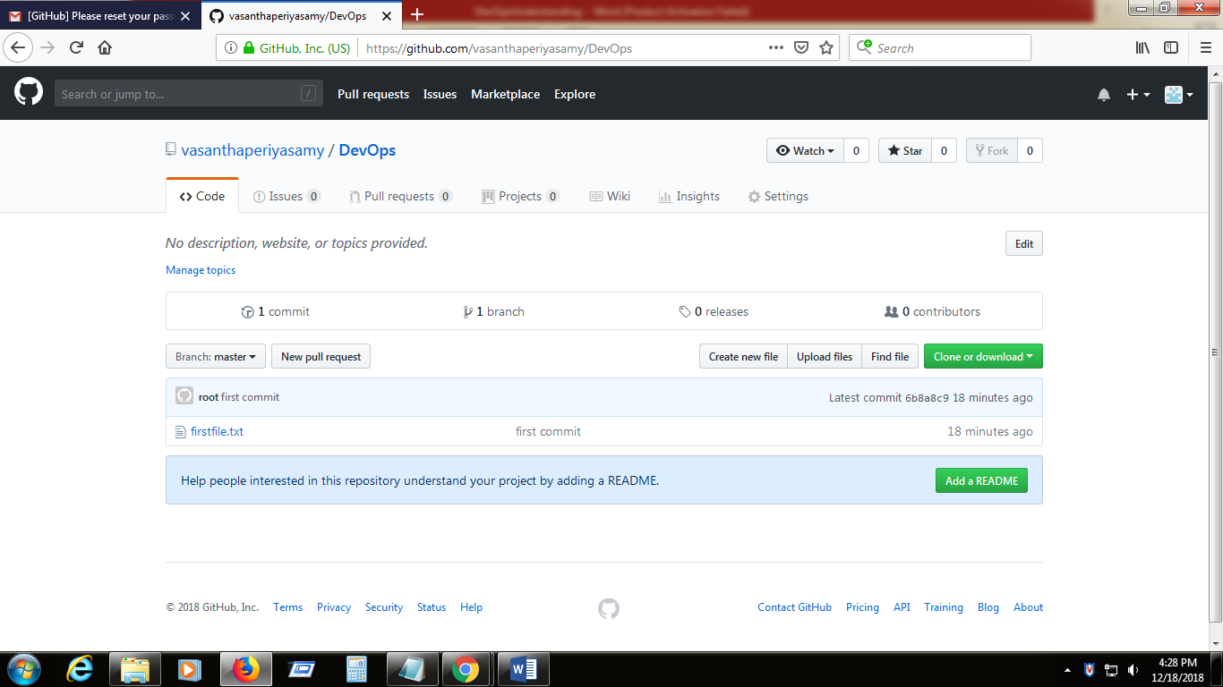

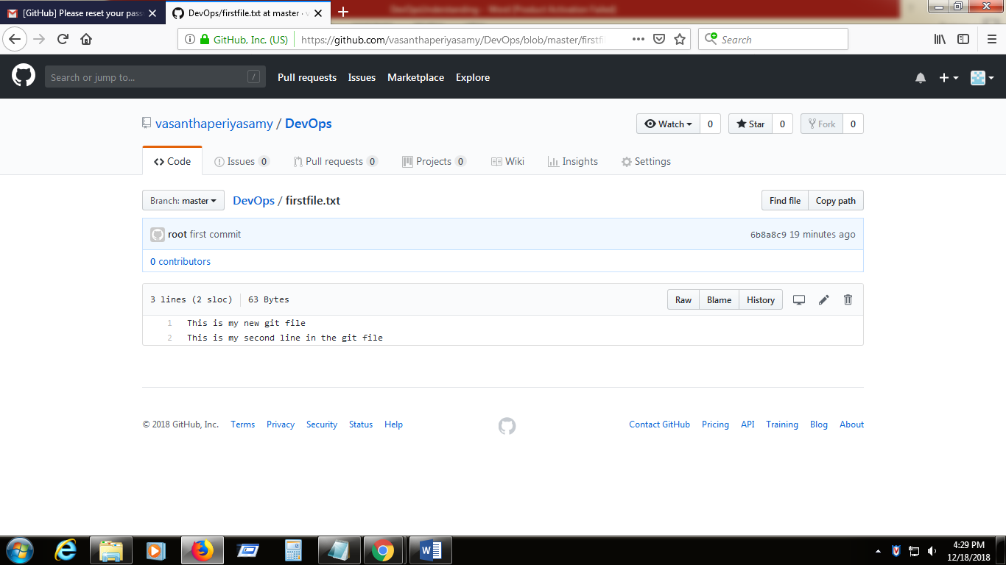

This way we can create multiple files and push to git repository in github.com

Note: 1 cd .git 🡪ls –a -- > list out the directory structure for the local git repo

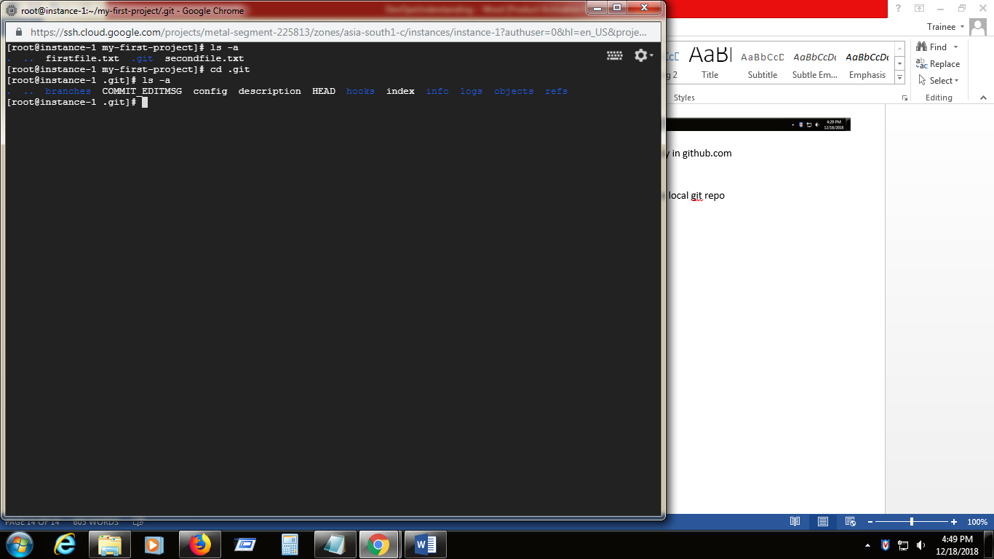

Note 2: Git log -> displays log

Note 3: git diff HEAD~1 HEAD~2 -> Shows the difference between current version and previous version.

Note 4: history -> list out all the unix commands which we have used to execute

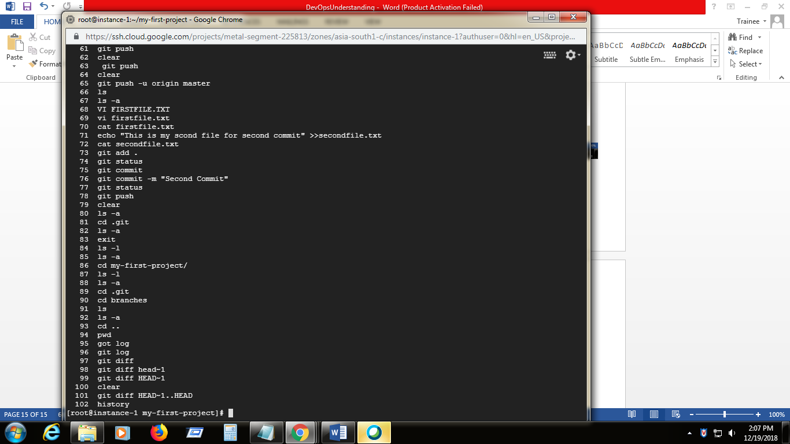

Note 5: diff –help -> displays all the help details

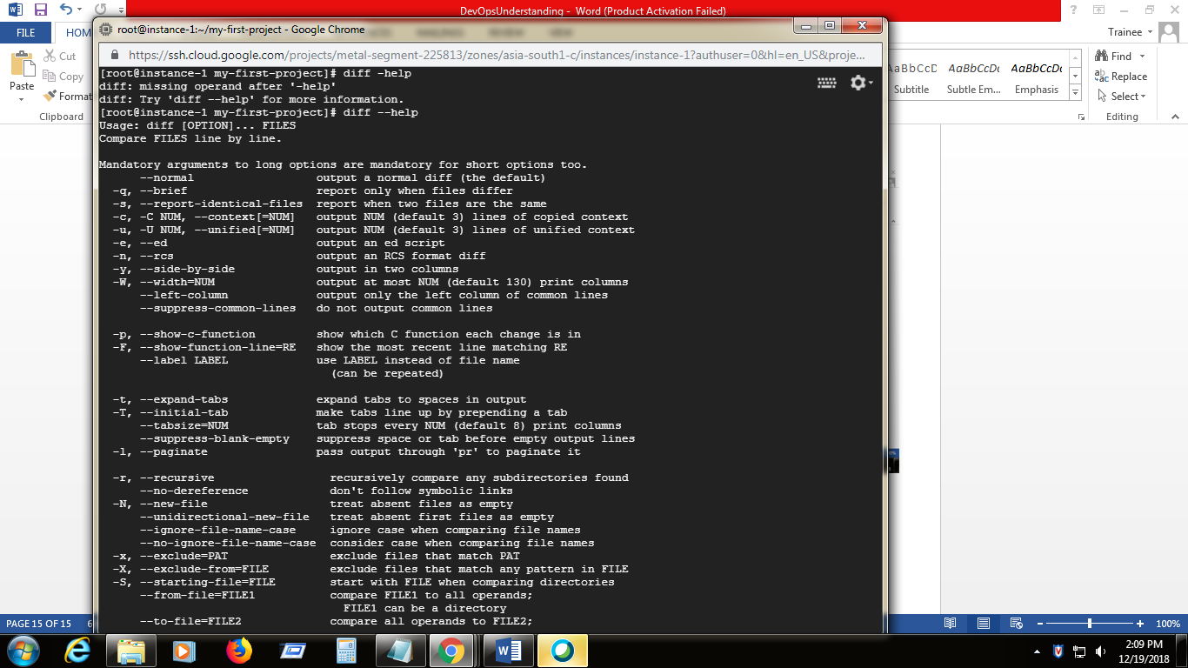

Note 6: history –c 🡪 deletes history

**To Remove file from GIT :**

1. Remove file from Local repo using git **rm –rf firstfile.txt**
2. Check the status using **git status**
3. Commit the changes using **git commit -m "second file also deleted"**
4. Push the changes to git remote repository using **git push**

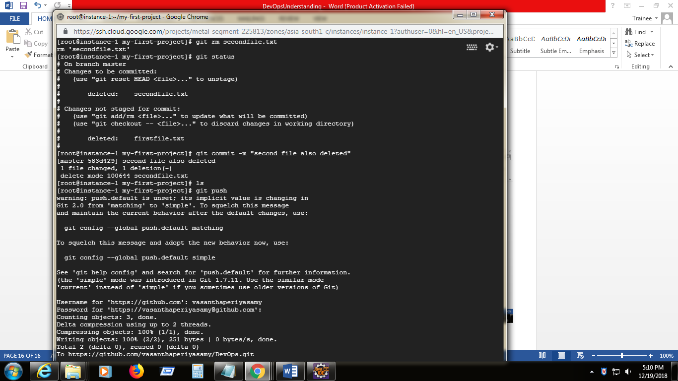

These changes are committed into master branch.

Note 1: To verify the HEAD is pointed to which branch use , cat HEAD

It will display like ,

[root@instance-1 .git]# cat HEAD

ref: refs/heads/master

**Creating new branch and work on:**

1. To create the new branch use, **git checkout –b development (**it will check out the master branch and create new one with the specified name as development)

To check available the branches use , **git branches**

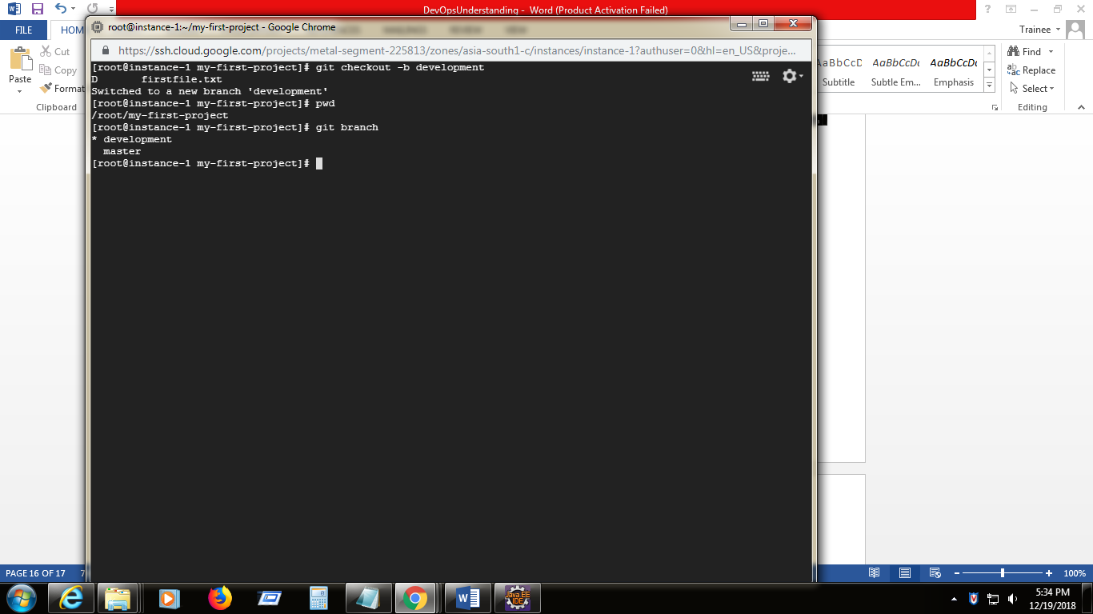

1. Now the HEAD is pointed to development branch(new created)

Use **git ls to** verify the files copied from master branch

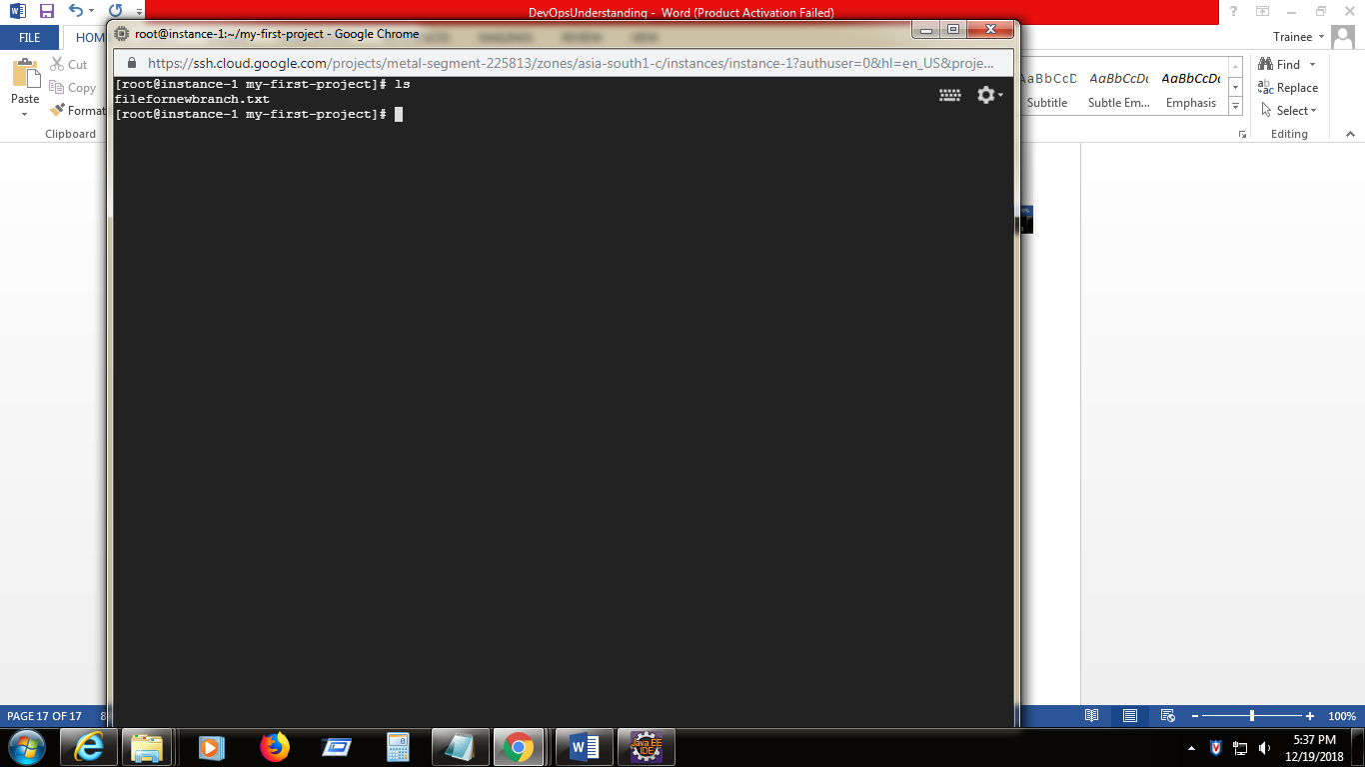

1. create new file for this branch and commit using **git commit –m “development branch commit”**

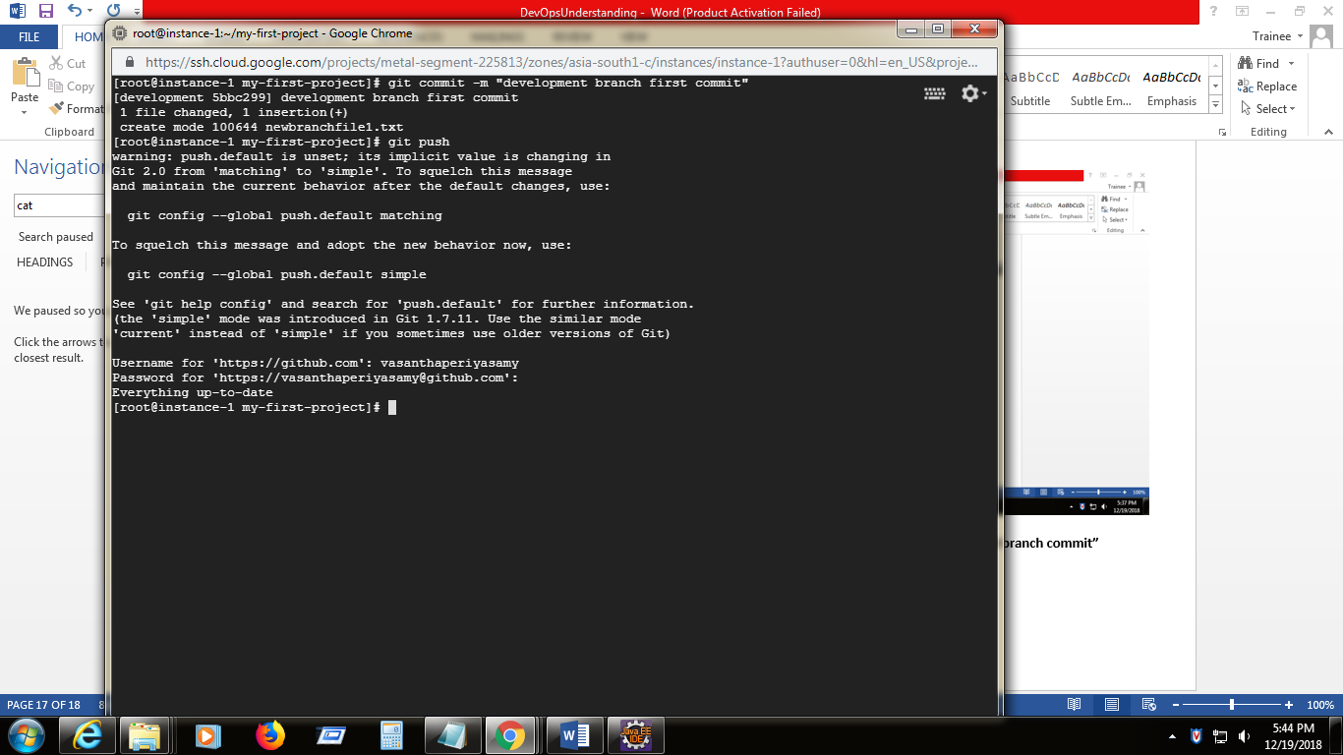

1. push the new branch with the updated files using **git push origin development**

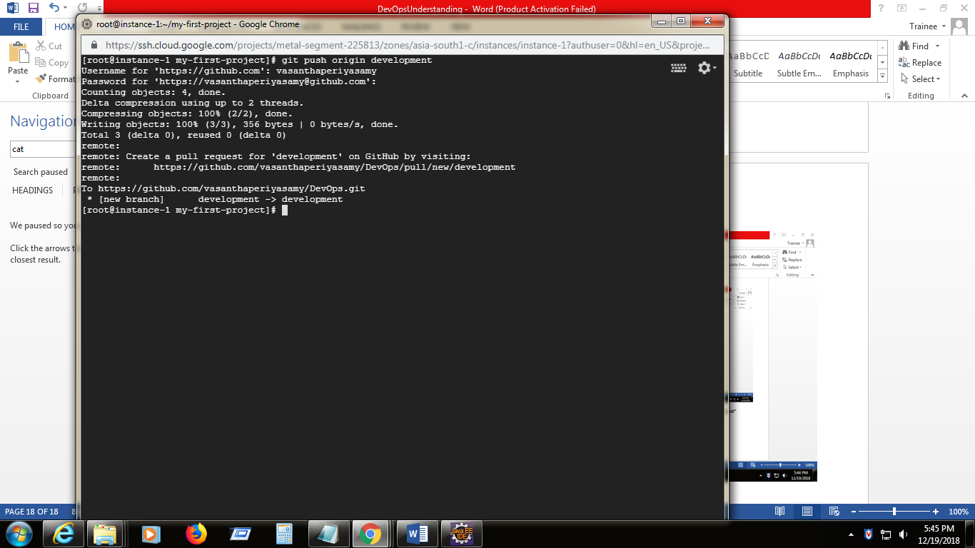

Now the new development branch is created with files on Github

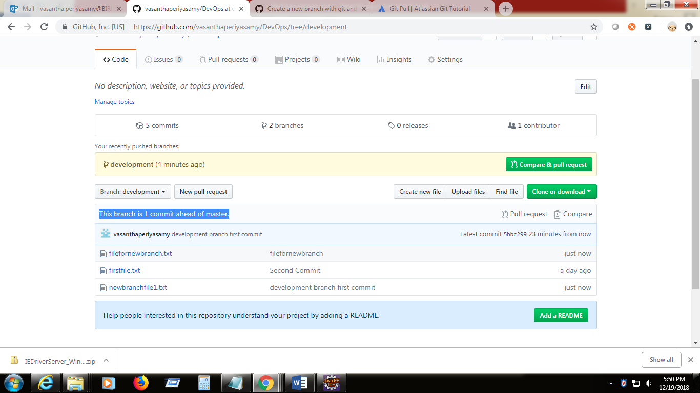

1. Now the changes from development branch needs to be merged with master , becoz always master should have latest updates

Checkout the master branch (it will do both check out and switch) using **git checkout master**

Now the git head points master branch

Use for merging dev1 to master, **git merge dev1 –m “dev1 is merged”**

And commit **git commit –m “dev1 is merged amd commited”**

Now push the master branch changes to remote repository

**git push origin master**

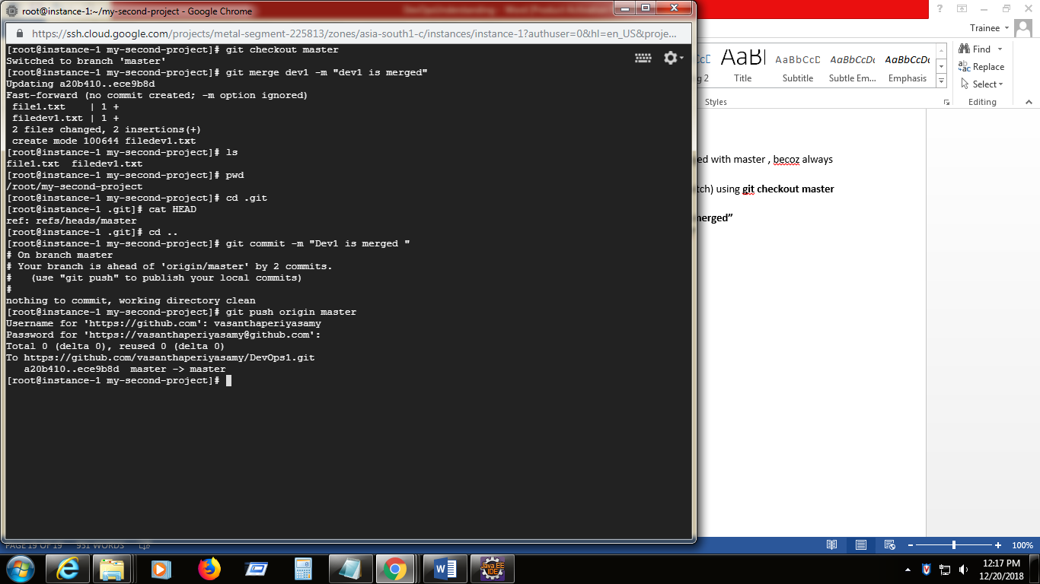

Note: **Git Fetch ->** it just fetch the changes(files , references) from remote repository but it will not merge into local repository. These type of fetched changes needs to be checkout explicitly using the **git checkout.** This way ensures to review the commits before merging into our local repository.

**Git pull ->** it will fetch the changes and merge into our local repository . just opposite to the git fetch command .if we already have any changes in our local , it will conflict .

**To set up Jenkins :**

1. Install java using yum install java wget –y (wget is web browser get , the respective java exe is get from cloud)
2. To check the java version installed, **java –version**
3. Download Jenkins war from **wget** [**http://mirrors.jenkins.io/war-stable/latest/jenkins.war**](http://mirrors.jenkins.io/war-stable/latest/jenkins.war)
4. Jenkins.war is inatalled in the current folder

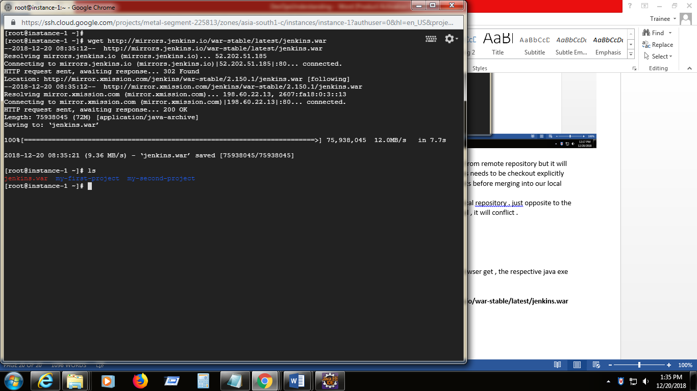

1. Run the Jenkins in the background using

**nohup java -jar jenkins.war --httpPort=9090 &**

1. Now take the initial admin password to login to the Jenkins console

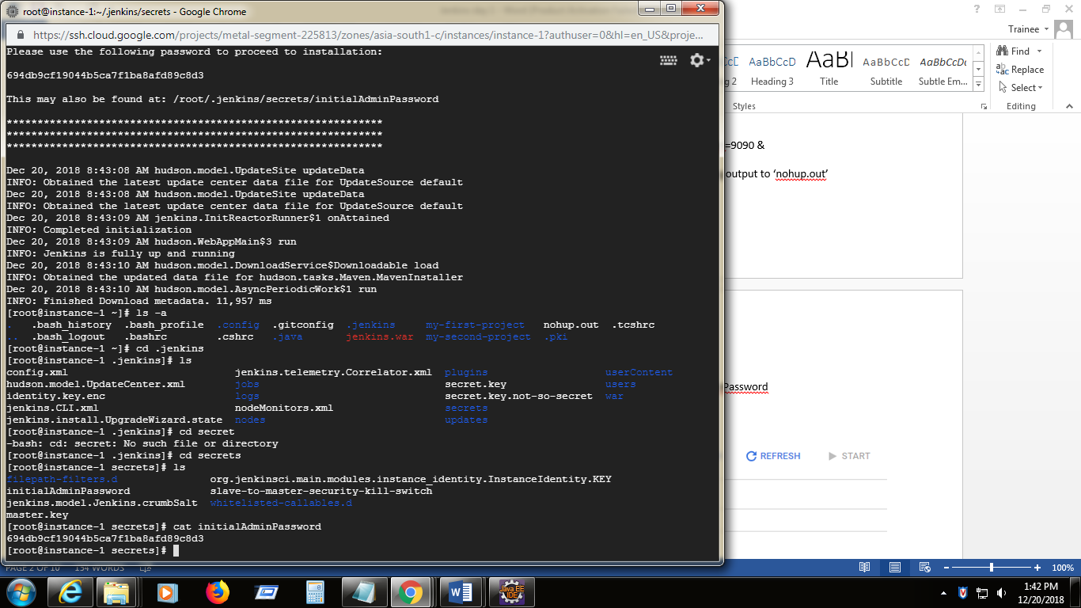

1. Got to created VM instances click on external ip and change the url pointing to port 9090 which we have set in previous step

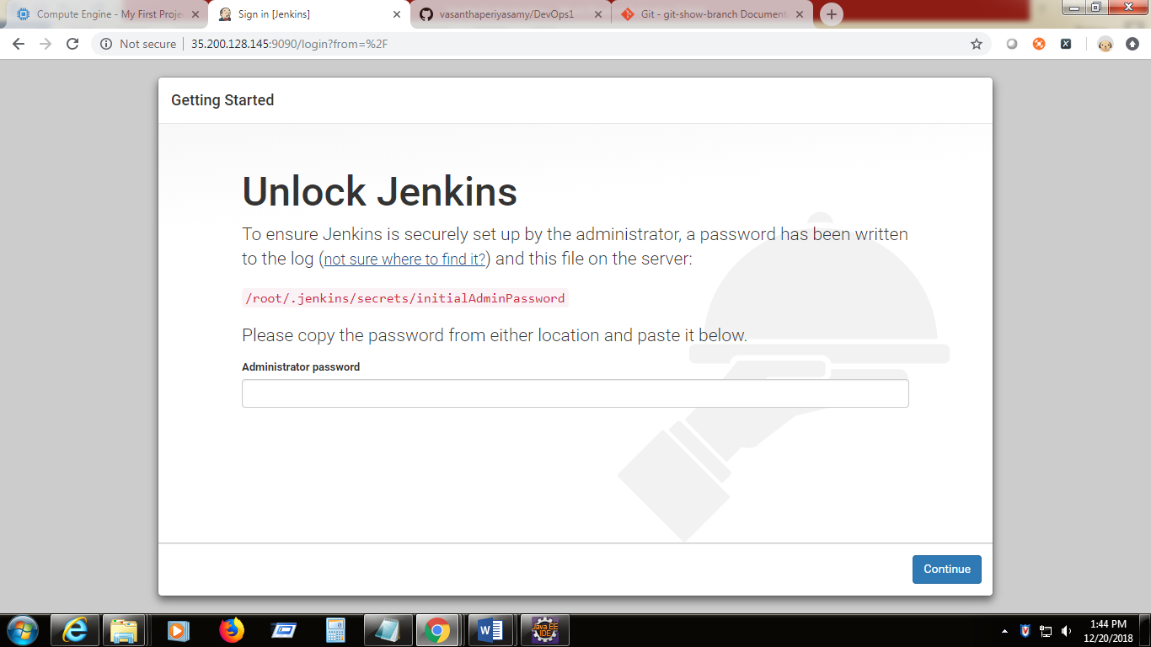

1. Give the initial password which taken from .jenkins.secrets/initialAdminPassword

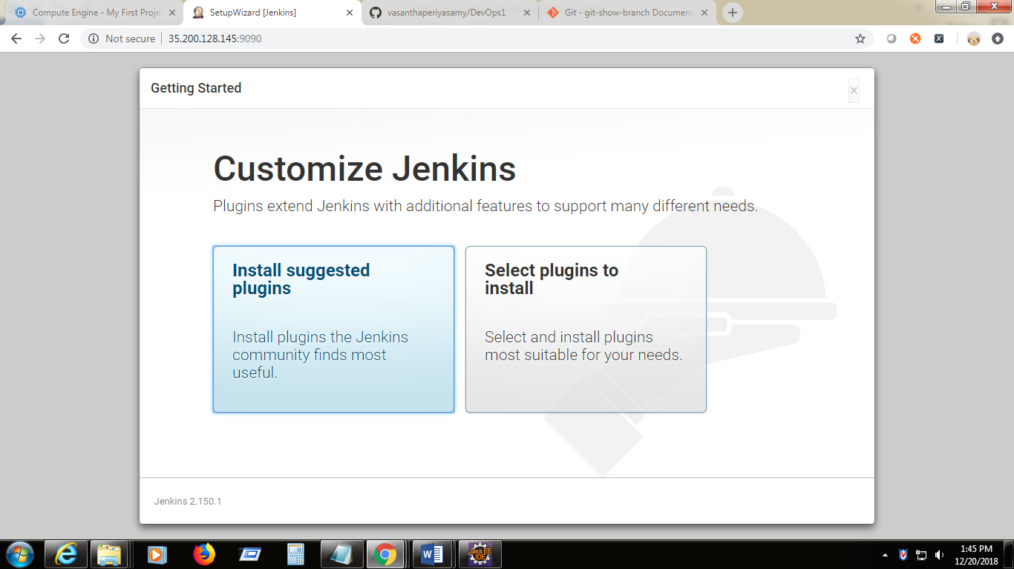

1. Now click on install suggested plugins option .

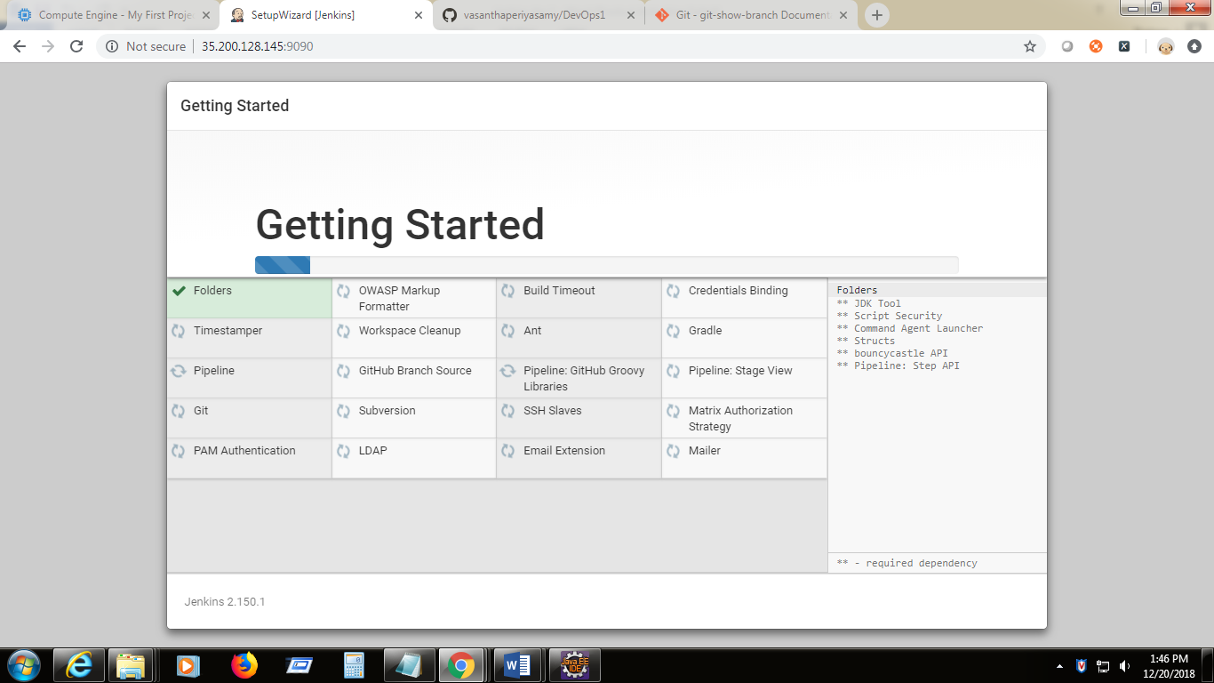

1. Set the userprofile

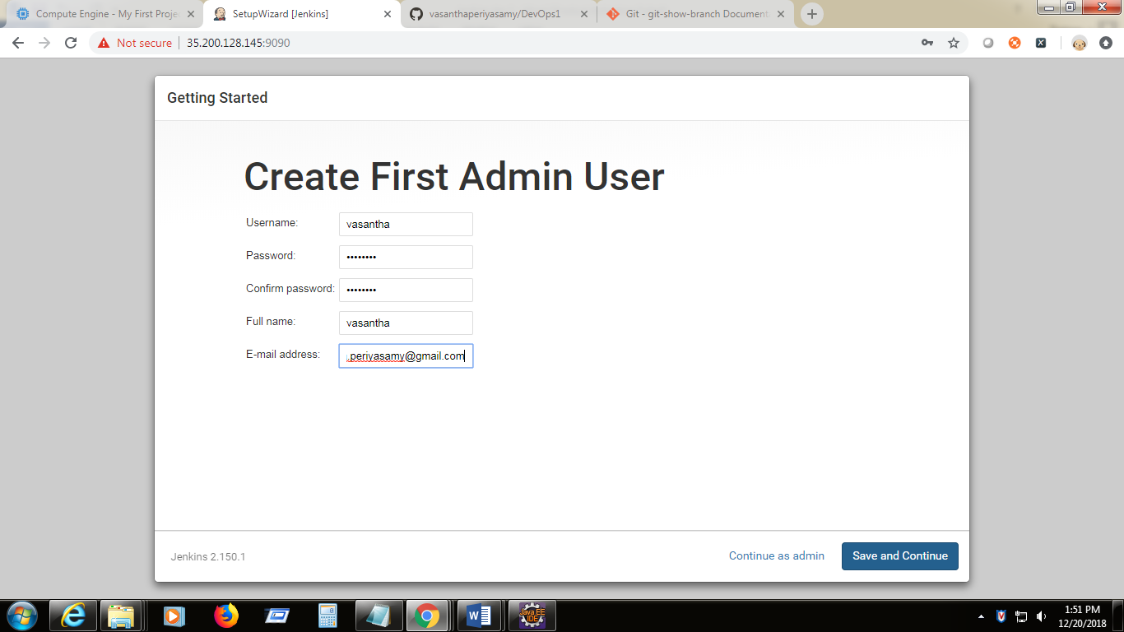

Username : vasantha

Password: vasantha

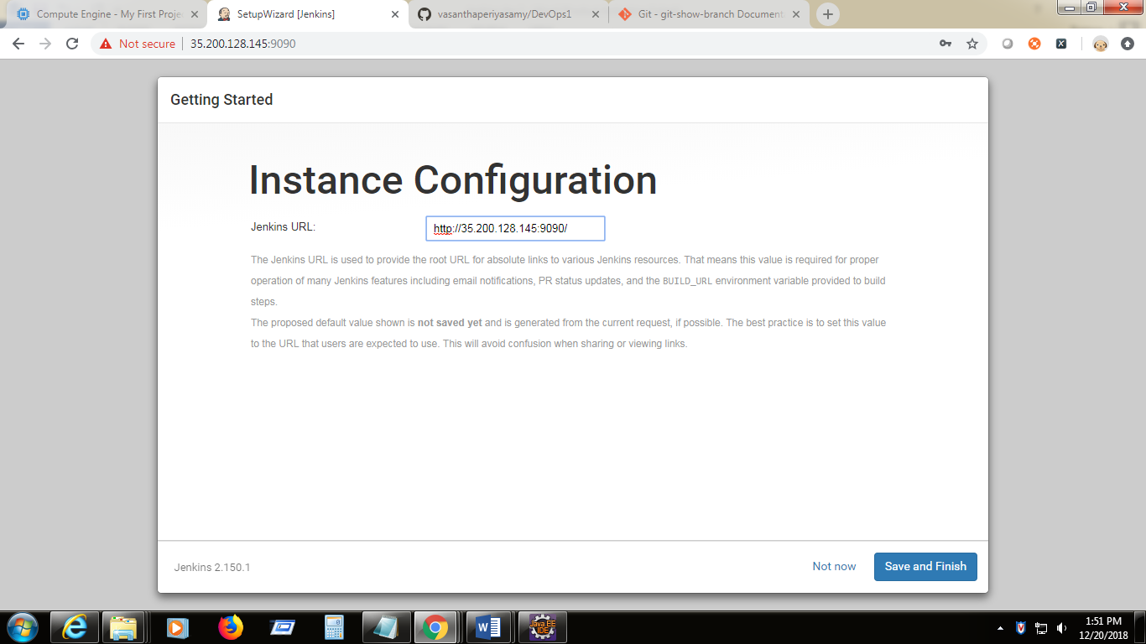

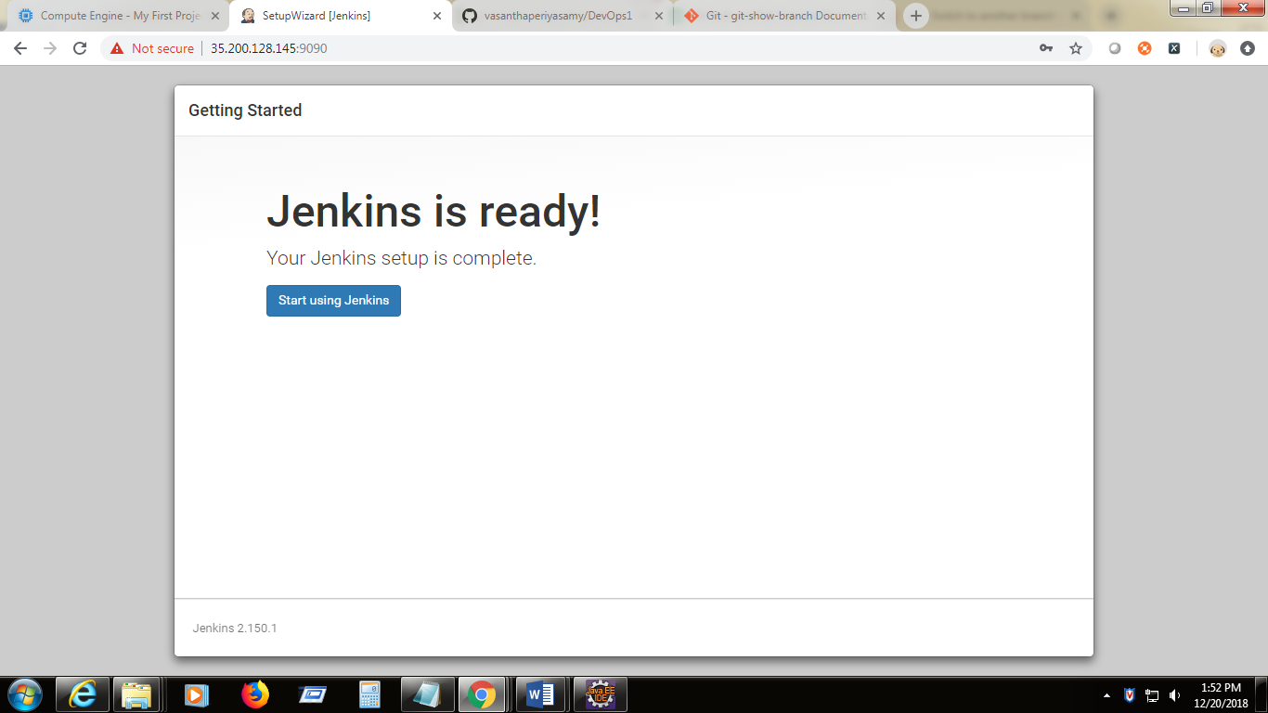

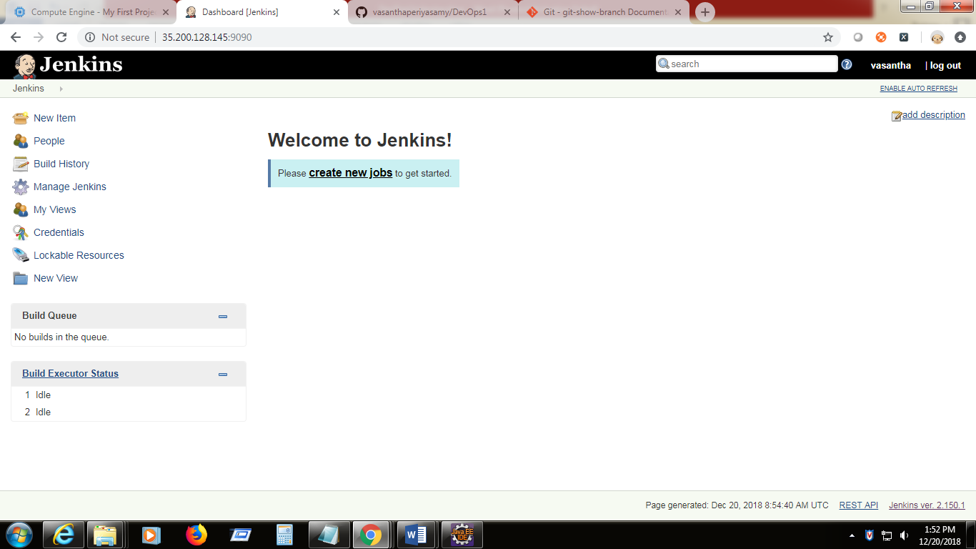

1. Now create an item

New item -> give item name - > select free style project

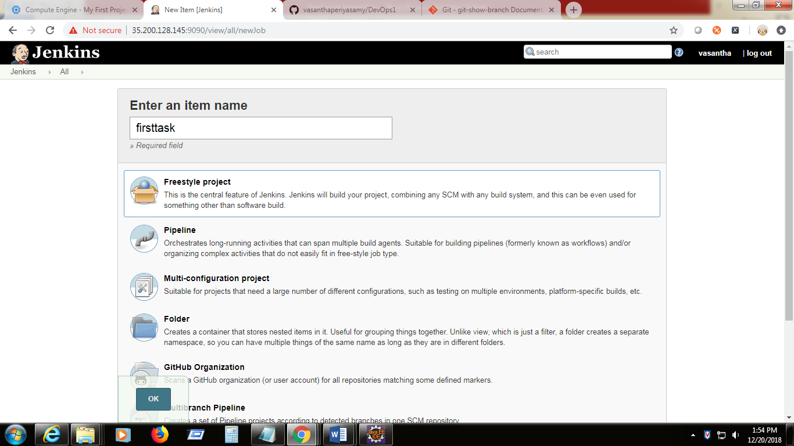

1. Click on build tab -> build -> add new build -> execute shell -> give the command

yum install net-tools –y 🡪 save

1. Got to the dashboard and run the job

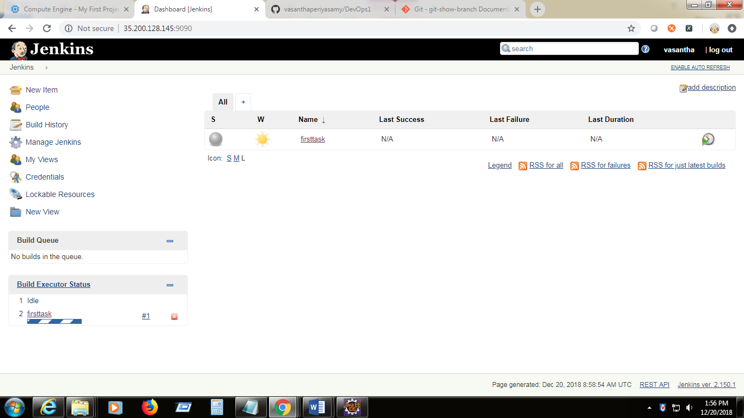

1. Check the console output as like below to see the result. This is the job created for automating the net tools installation

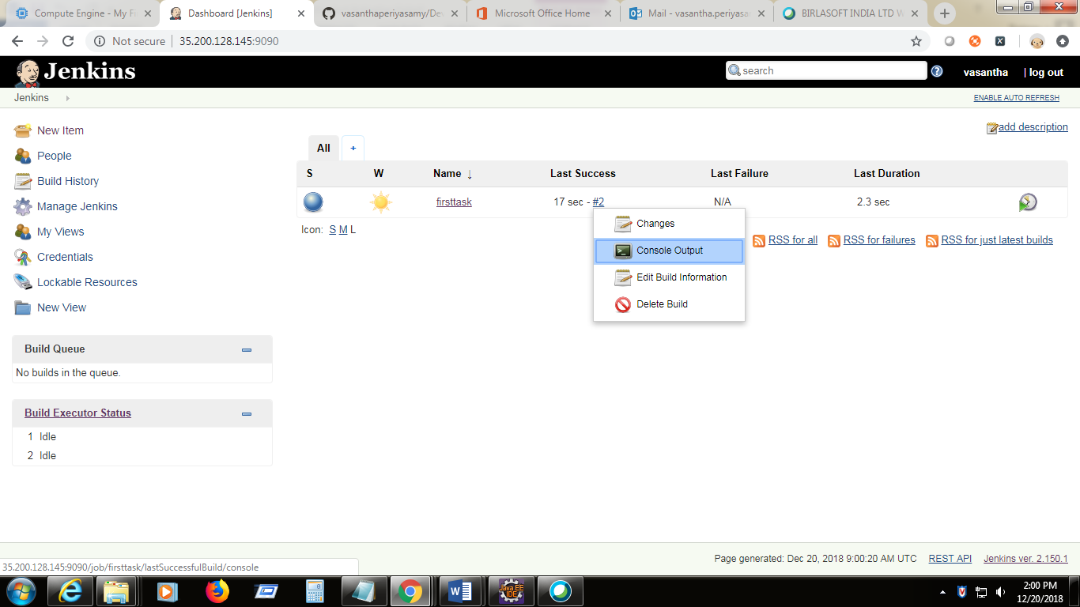

1. Create another job , and link to job 1 for automatic triggering

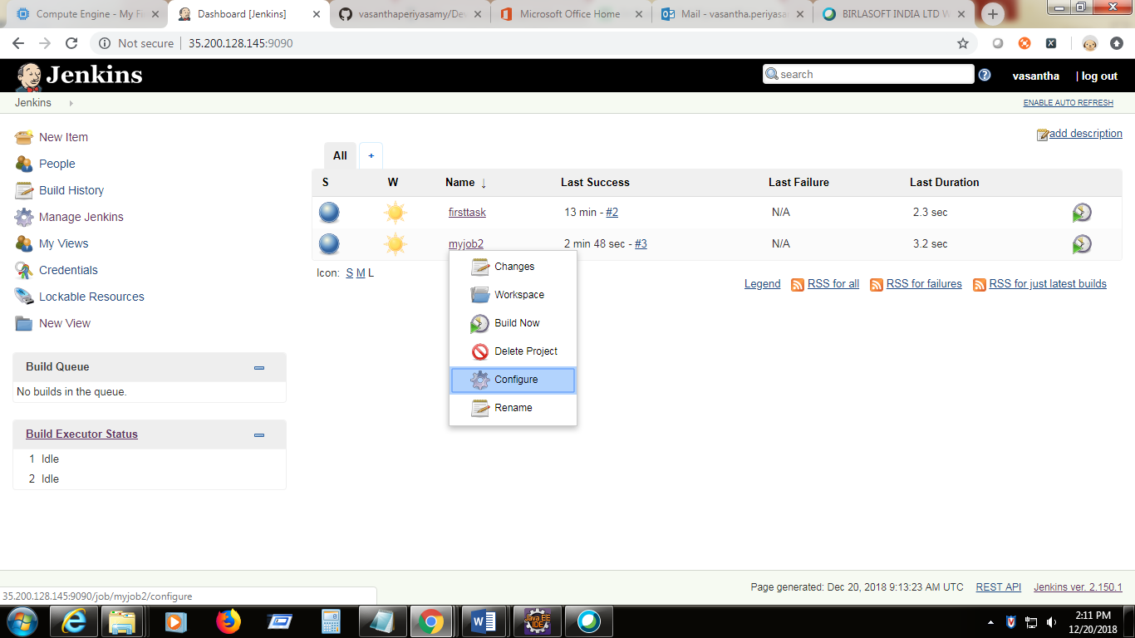

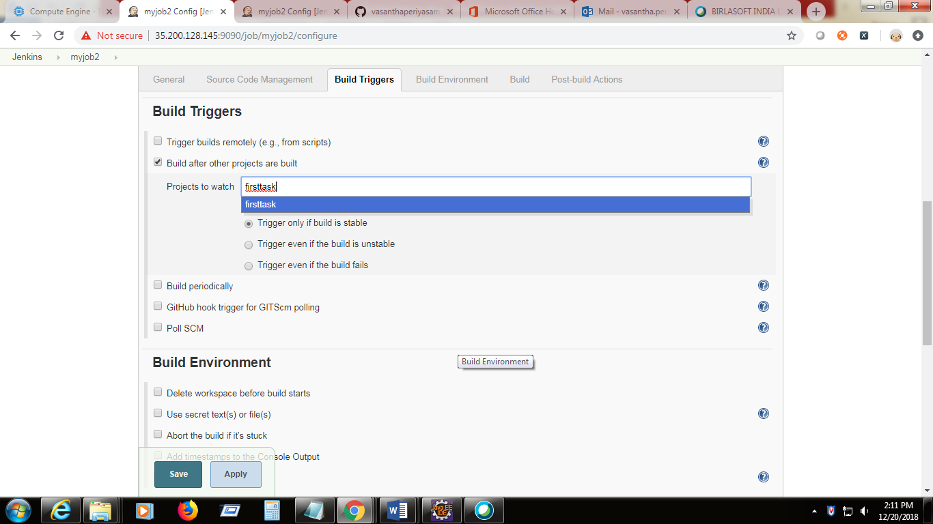

The second job will automatically trigger after the first job named firsttask

This can be verified in console output also in the dashboard Last success column value.

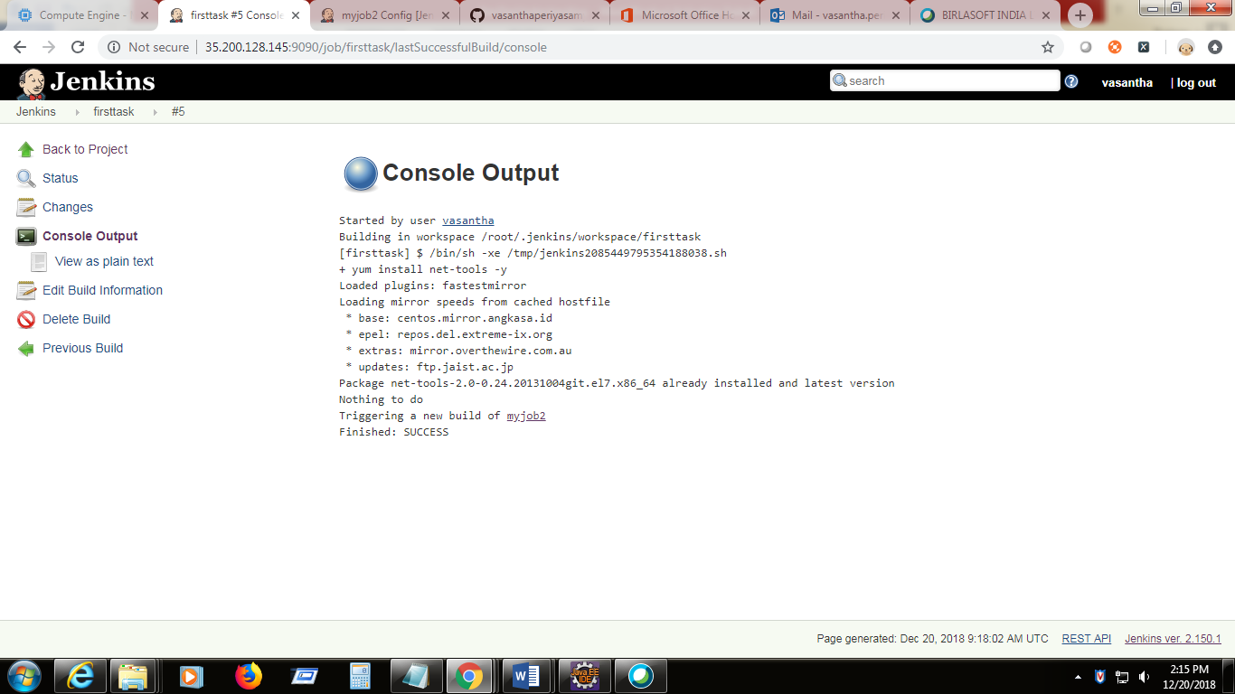

1. Install delivery pipeline plugins
2. Click on Manage Jenkins 🡪 Manage Plugins-> search for delivery pipeline under the available tab.

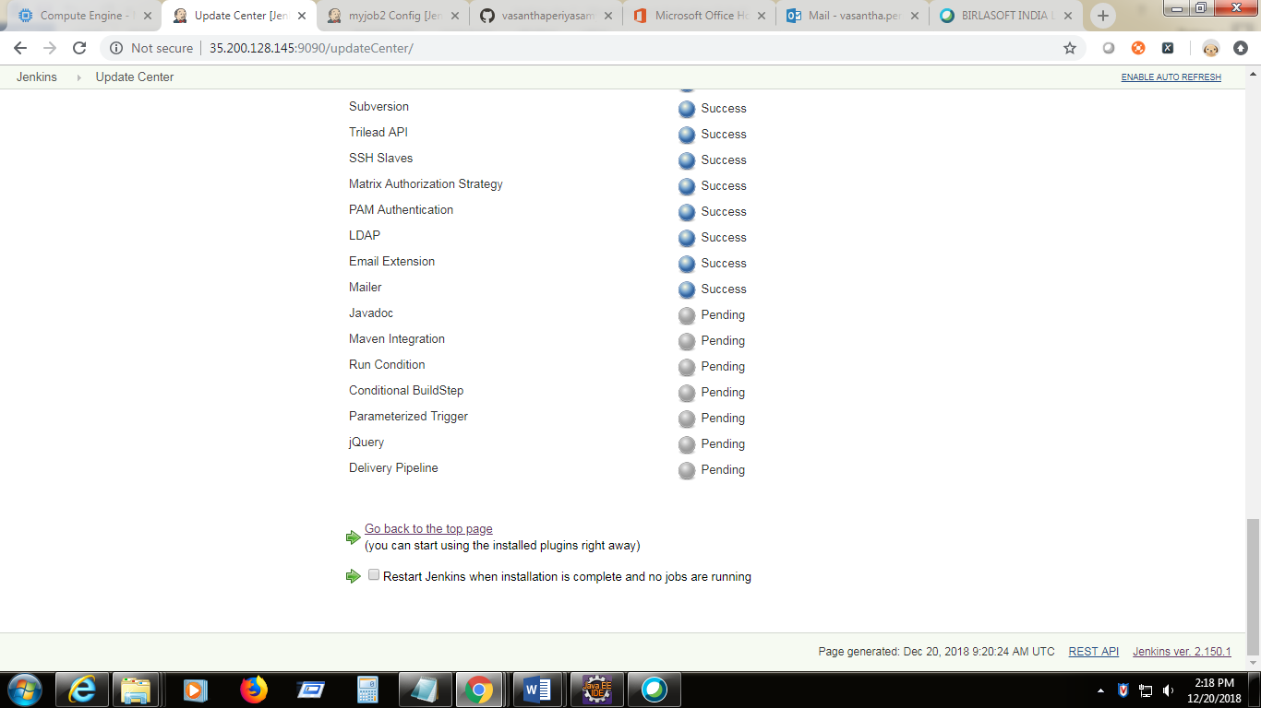

1. Click on the “+” button in dashboard and give the view name as pipeline -> select delivery pipeline
2. Click -> pipeline-> component- > add
3. Specify the job details

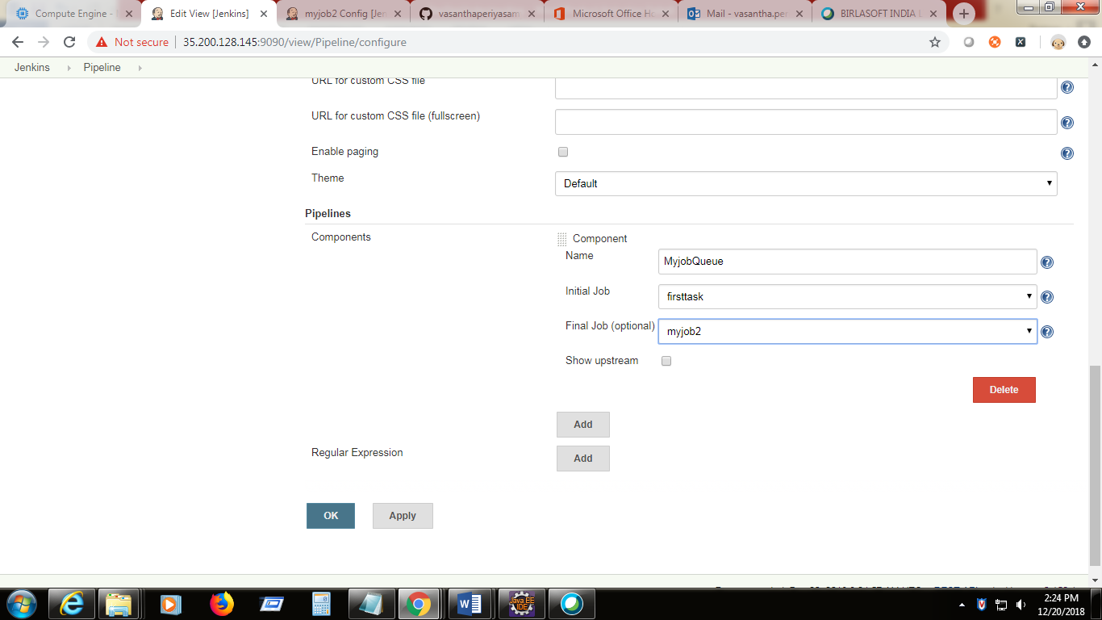

1. We can view the job queue flow in pictorial form. This way we can make use of the Jenkins for creating the chained jobs.

**Working on Maven (Integrating with Jenkins)**

1. Install the maven using **yum install maven –y**

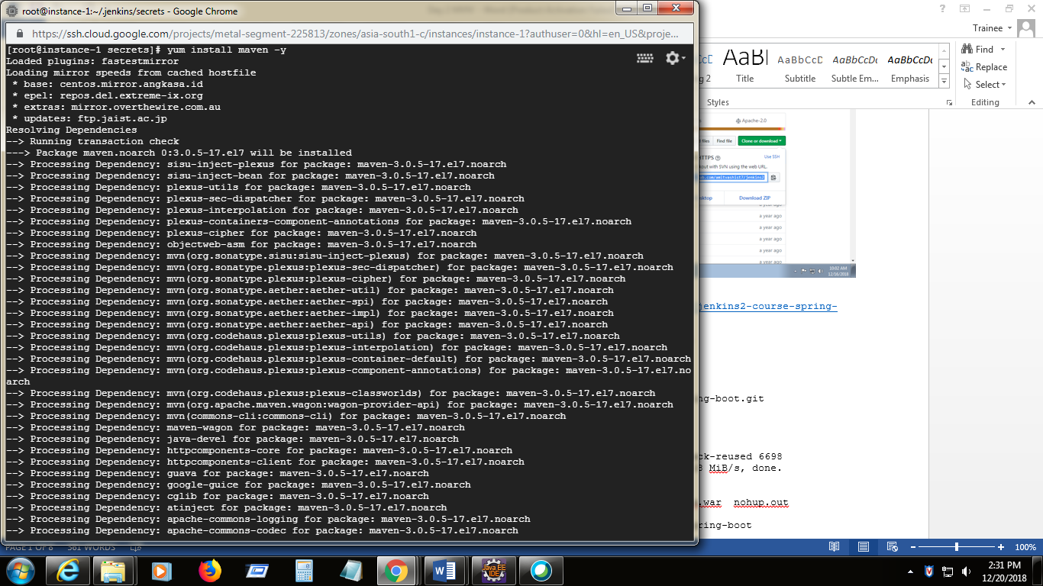

1. Now we have to clone the spring boot sample project from trainers repo

**git clone https://github.com/amitvashist7/jenkins2-course-spring-boot.git**

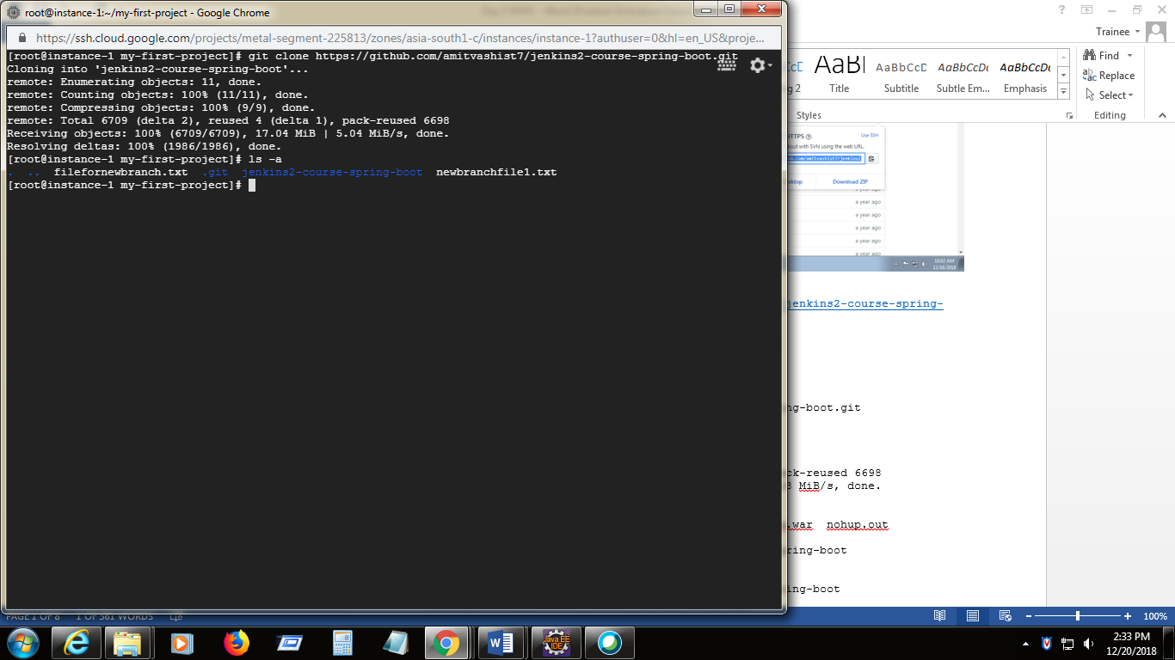

1. Now the project is cloned from remote repo to local.
2. Now we have to build the project using the maven commands

The project we need to build is jenkins2-course-spring-boot->spring-boot-samples->spring-boot-samples-atmosphere

1. Navigate the shell to this project and list out the files
2. Target will not be there where our jar file will be created.
3. **mvn clean**
4. **mvn package ->** it will create the jar file in the target folder ( verify with ls –a command)

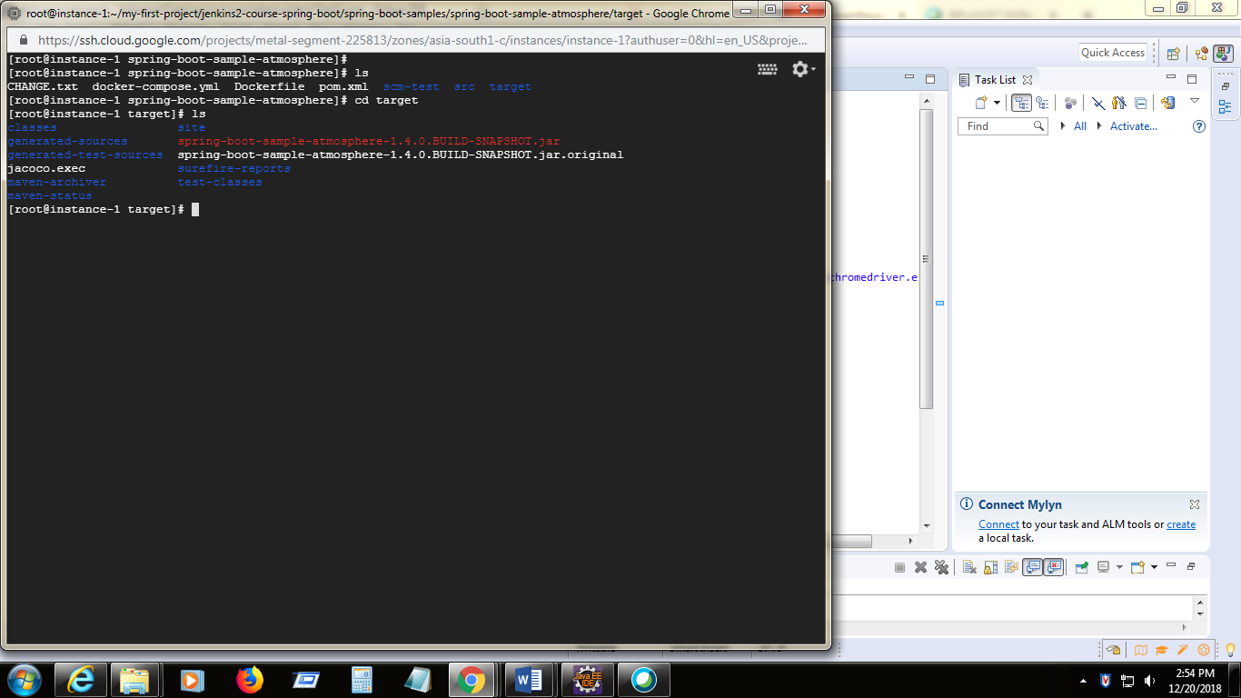

1. Now intall this jar into jenkins to launch the application.

**Java –jar spring-boot-sample-atmosphere-1.4.0.BUILD-SNAPSHOT.jar**

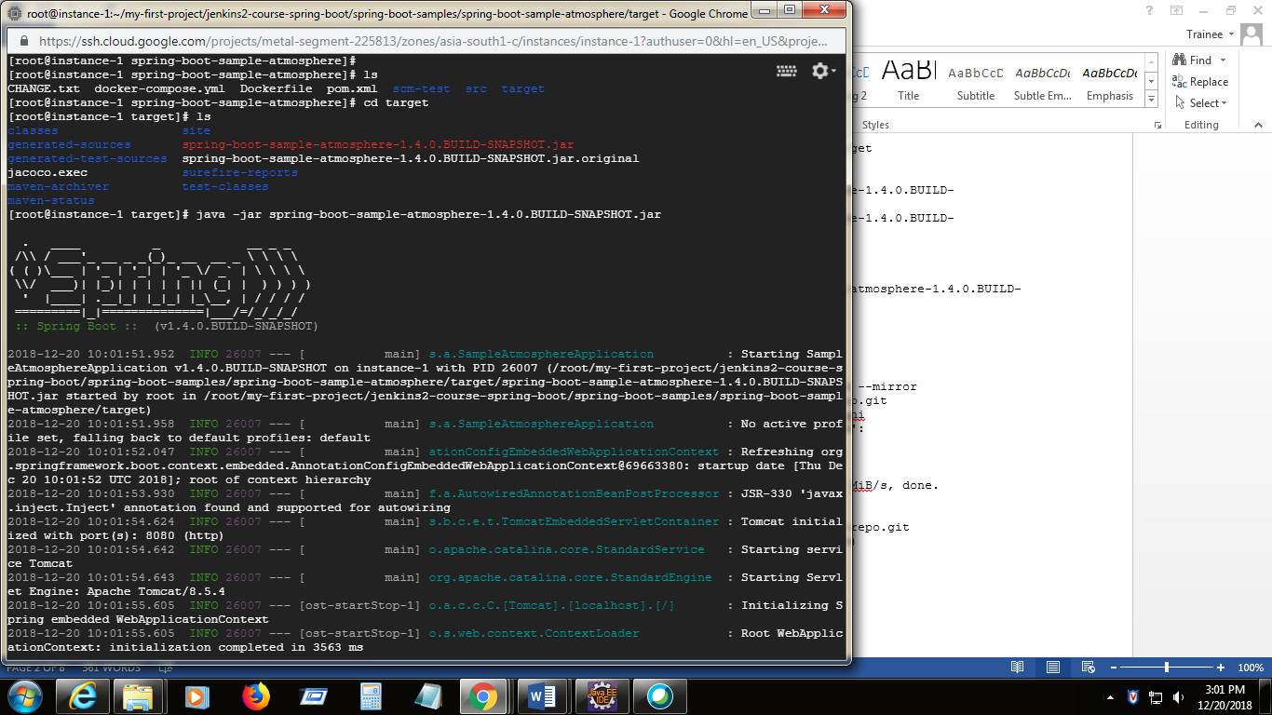

1. To launch the application try **http://35.200.128.145:8080/home/home.html**
2. Now push these projects from my local repo to my remote repository [**https://github.com/vasanthaperiyasamy/DevOps1**](https://github.com/vasanthaperiyasamy/DevOps1)
3. **git push -mirror** [**https://github.com/vasanthaperiyasamy/DevOps1**](https://github.com/vasanthaperiyasamy/DevOps1)

it will push the local git repository to the remote git repository in github.com

1. All projects are pushed to remote repo in github.com

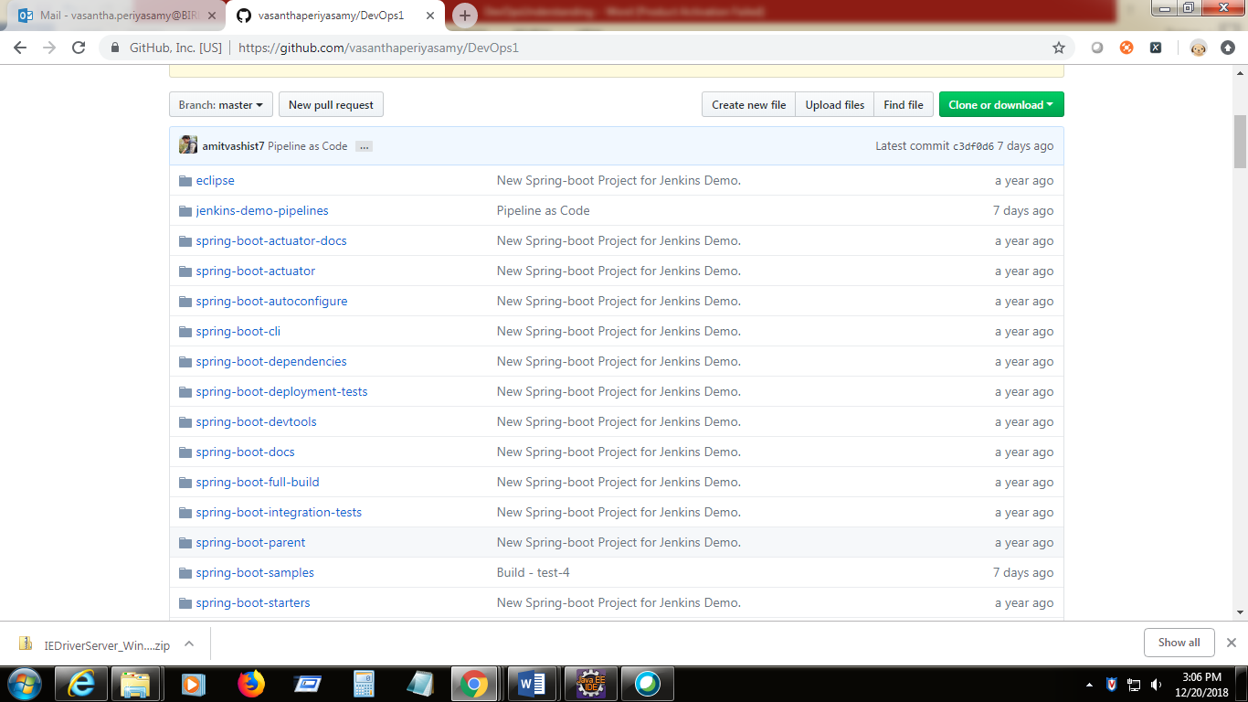

1. Maven intergration with Jenkins

Jenkins Dashboard -> new item -> give itme name -> select Maven Project

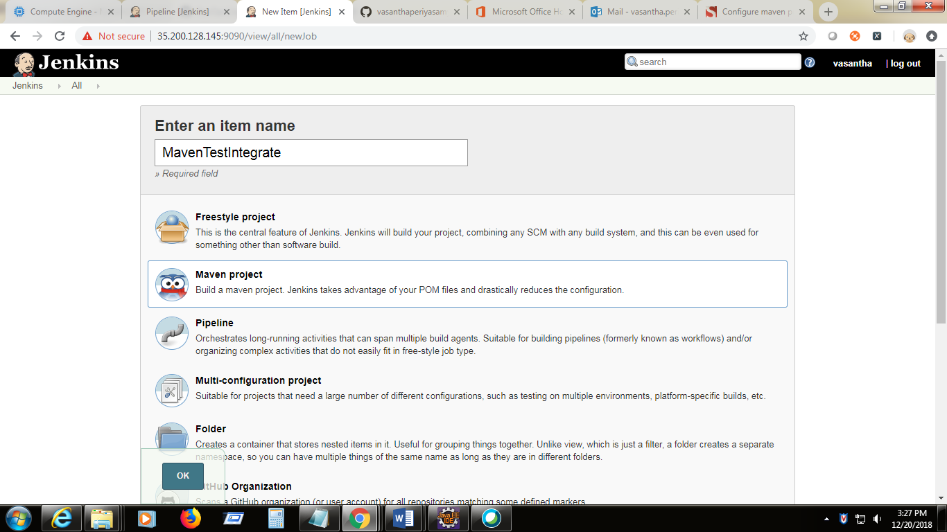

1. Specify the git url in the source code management section

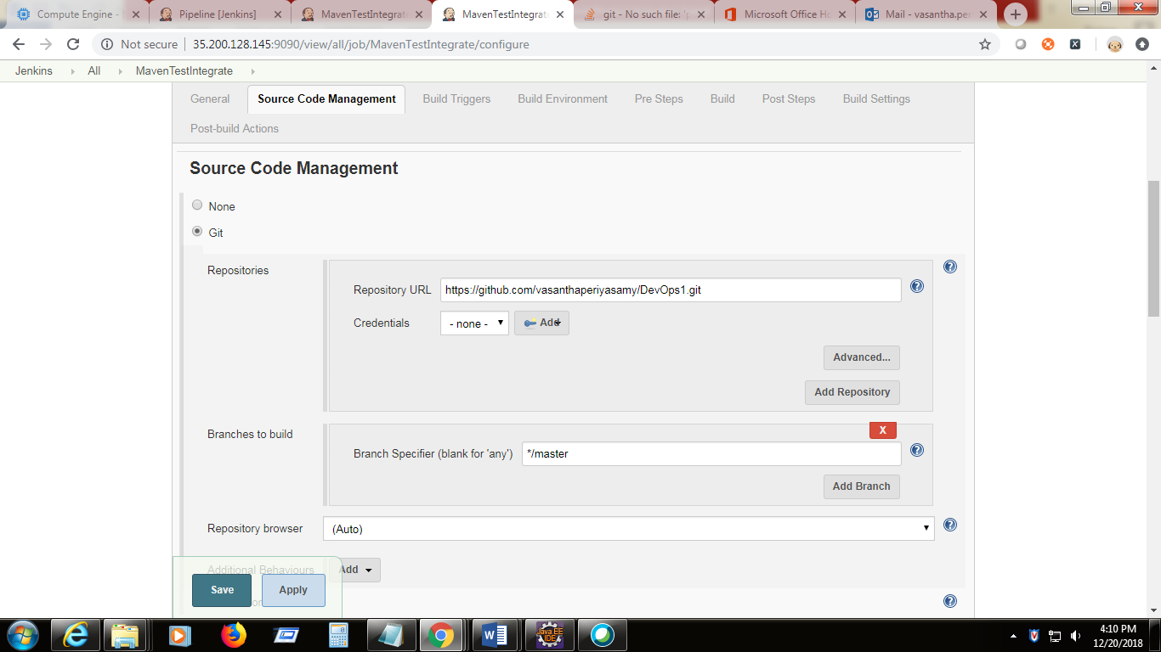

1. Give pom.xml location in the build section

**spring-boot-samples/spring-boot-sample-atmosphere/pom.xml**

(if we get Jenkins not able to fine the maven installation error then got to tool configuration -> under maven section- > add maven

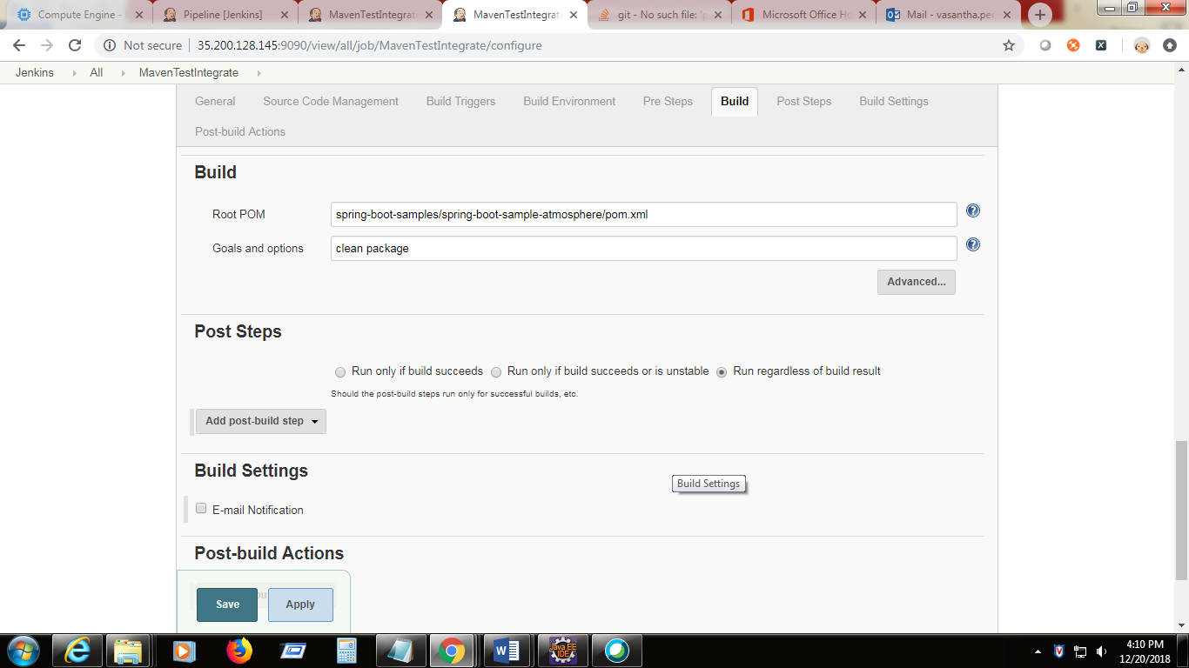

17 ) Do the build and see the console

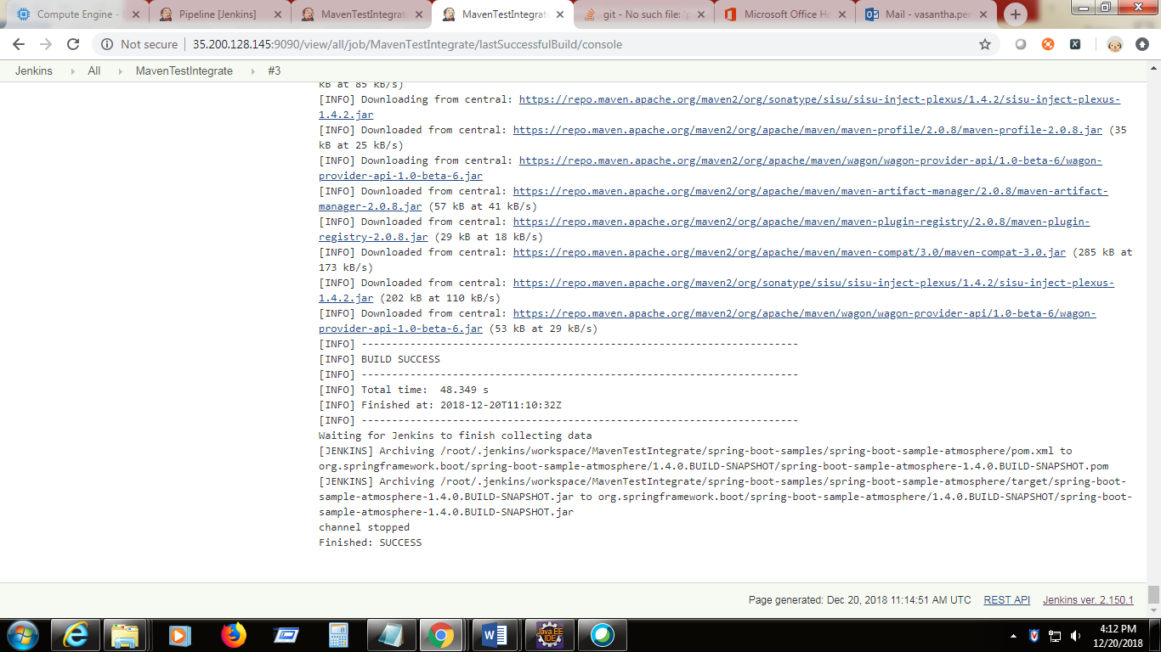

1. It will package the project folders into the workspace folder of Jenkins installation dir.

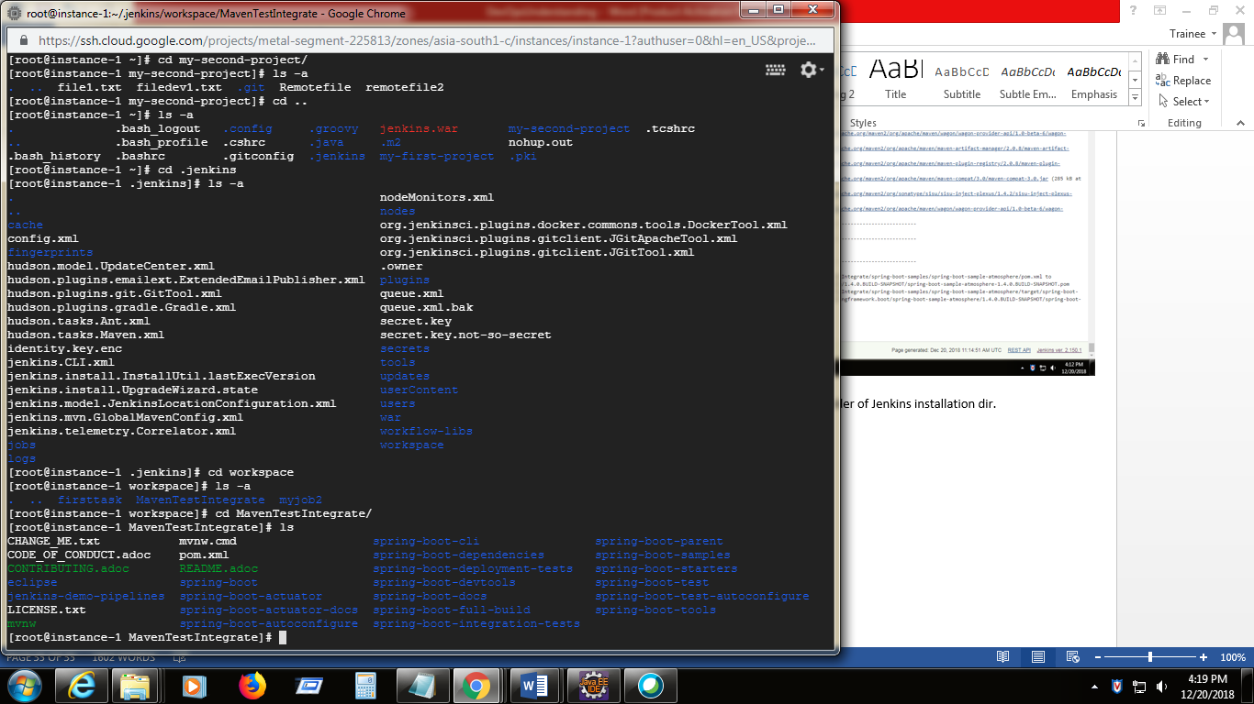

**Dockers:**

Dockers are the replacement for Virtual Machine.

**Virtual Machine :**

* is an computer file , an image acts like an actual computer system. (creating the computer within the computer)
* It shares the hardware’s of the host system.
* There can be multiple VM’s can run simultaneously on single host.
* The VMs can call as guest and the actual system is known as host
* VMWare and Microsoft are main vendors to support VM.
* Each VM can run in Different OS(heterogeneous OS) . One in Linux and one in windows.
* It allows to run an operating system in an app window like an other applications.
* It is an process running on the current operationg system
* Virtual machine monitor(VMM) or hypervisor is an software which supports VM’s.
* It determines how virtual resources are mapped to physical resources.

**VM Architecture:**

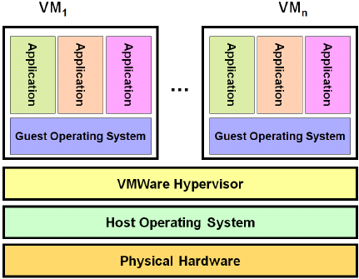

**Dockers :**

* Docker is a container management service
* Docker is a platform for developers and sysadmins to develop , deploy and run the application with containers
* Containers are lightweight ,scalable ,flexible, portable, stackable and interchangeable
* A container is launched by running an image.
* An image is an package that includes everything needed to run an application such as code, libraries, environment variables and configuration files.
* A container is an runtime instance of an image
* A container natively runs in Linux that shares the kernel of the host system to other containers. It runs a discreate process ,taking no more memory like other executable making it lightweight.
* It allows developers to easily develop the applications ship them into containers and deploy anywhere.
* The keywords of dockers are develop , ship and run.

**Features:**

* Dockers has the ability to reduce the size of development by giving the smaller footprint of the operating system via Conteiner.
* Docker container can be deployed anywhere on any physical machine or any virtual machines or any cloud machines.
* Docker containers are light weight and easily scalable.

**Advantage:**

* Easy to deploy
* Easy to ship
* Minimize the hardware usage

**Components:**

* Docker for Mac : it allows one to run the docker container on any mac system
* Docker for Windows : it allows one to run the docker container on any windows system
* Docker for Linux : it allows one to run the docker container on any Linux system
* Docker Engine: it is used to buid the docker images and creating the docker containers
* Docker Hub: it is the registry which is used to host the docker images
* Docker Compose : it is used to define applications using multiple containers.

**Architecture :**

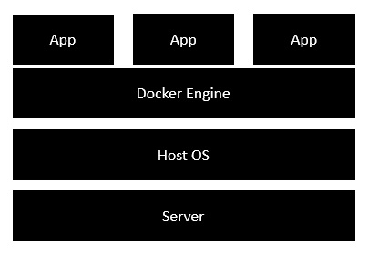

**Docker installation :**

Refer this link : <https://docs.docker.com/install/linux/docker-ce/centos/#os-requirements>

Uninstall the dockers if any older version

sudo yum remove docker \

docker-client \

docker-client-latest \

docker-common \

docker-latest \

docker-latest-logrotate \

docker-logrotate \

docker-selinux \

docker-engine-selinux \

docker-engine

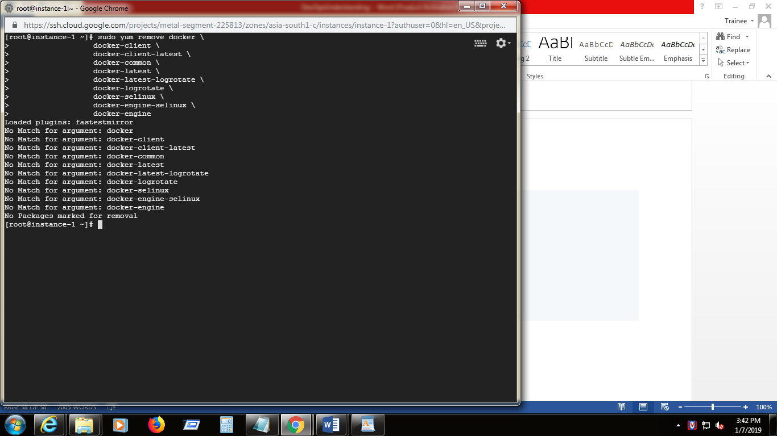

**Install:**

1. Go to the respective directory structure
2. Install required packages

**sudo yum install -y yum-utils \**

**device-mapper-persistent-data \**

**lvm2**

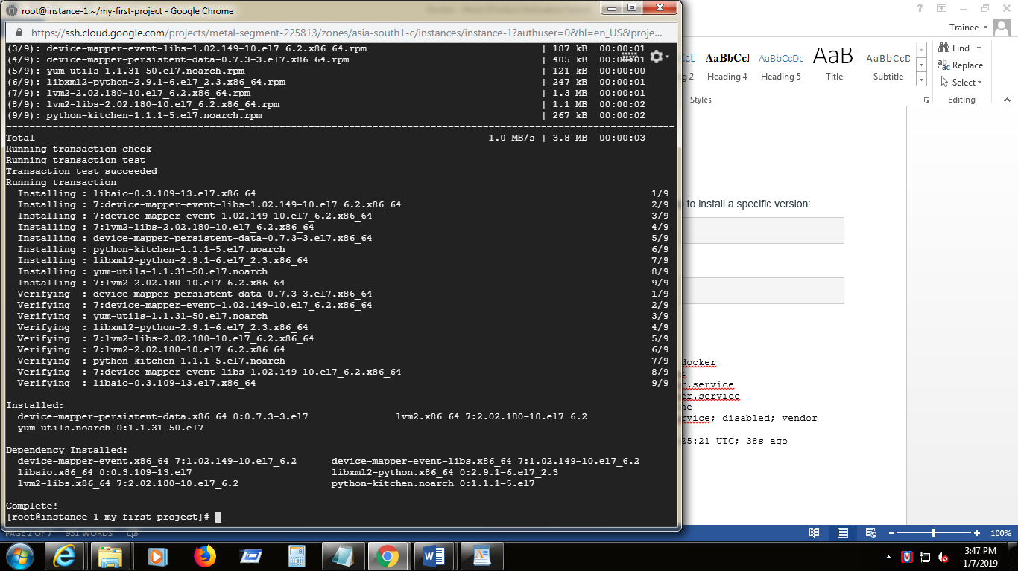

1. Setup stable repository

**sudo yum-config-manager \**

**--add-repo \**

**https://download.docker.com/linux/centos/docker-ce.repo**

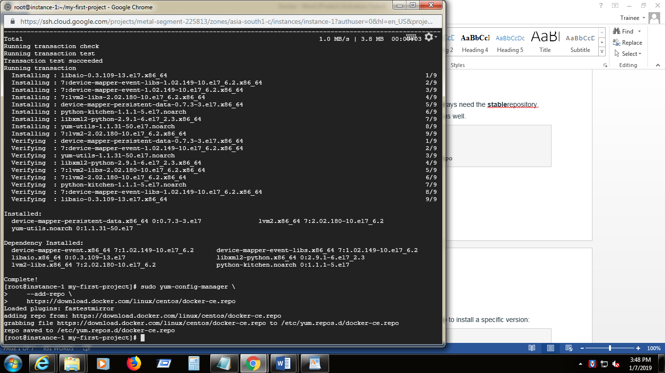

1. Install latest version of docker ce

**sudo yum install docker-ce**

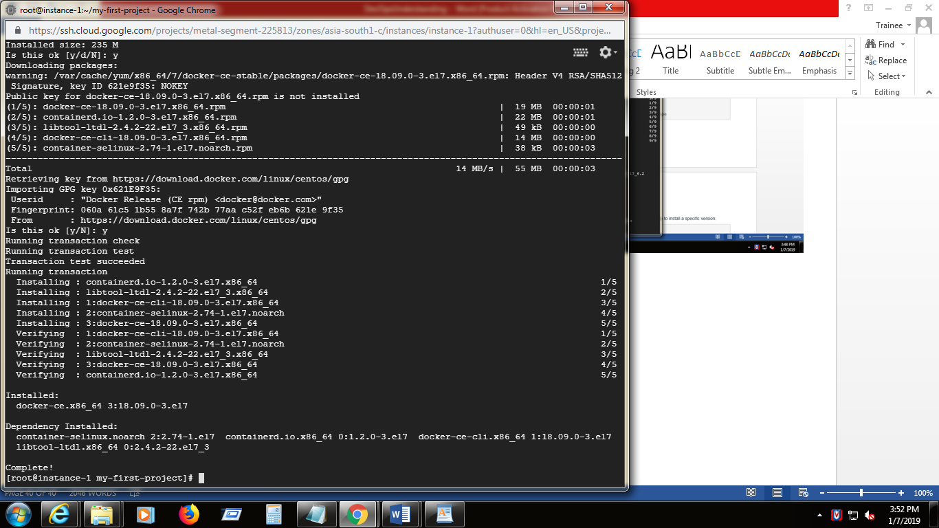

1. Start the docker

**sudo systemctl start docker**

1. Verify the docker installation by running the hello-world image

**sudo docker run hello-world**

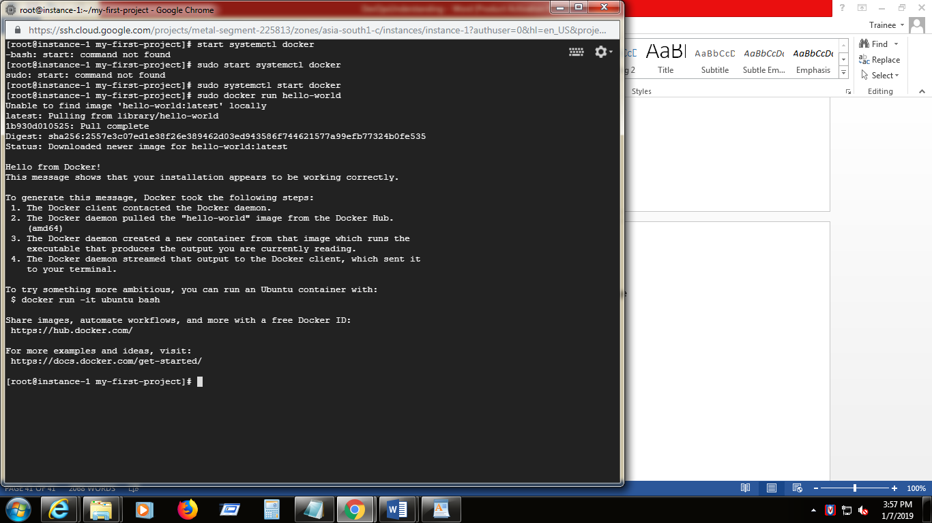

1. Start the docker service and verify the status(start the docker engine)

**systemctl start docker.service**

**systemctl status docker.service**

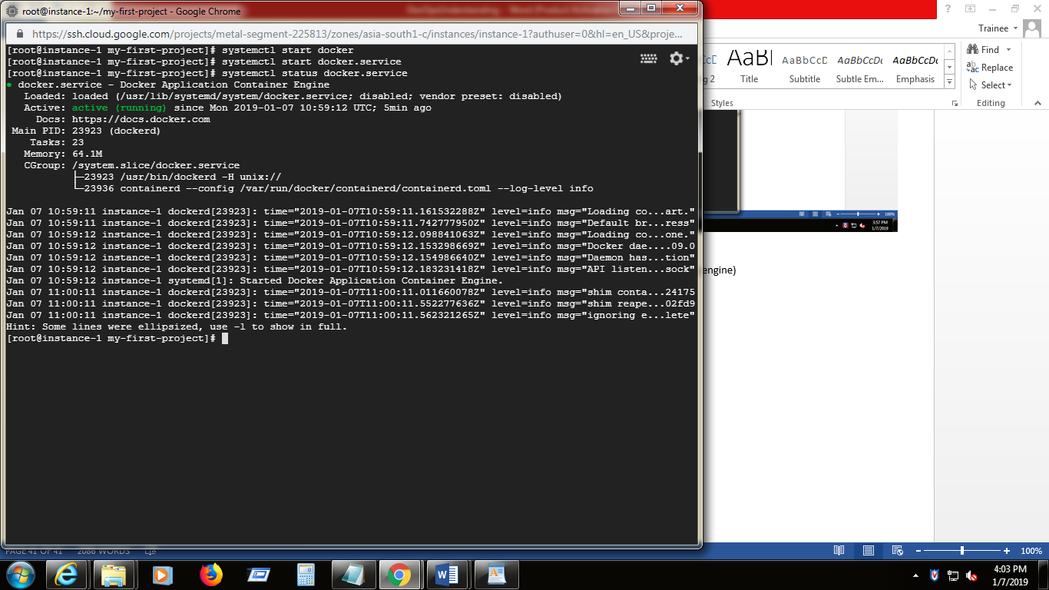

1. Enable the docker service

**systemctl enable docker**

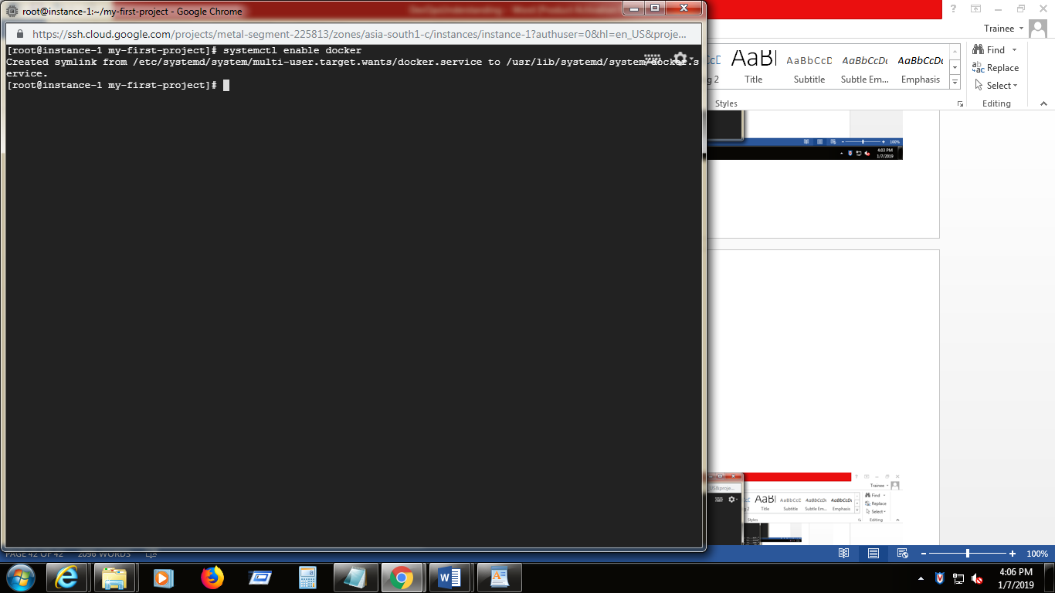

1. Check the docker version

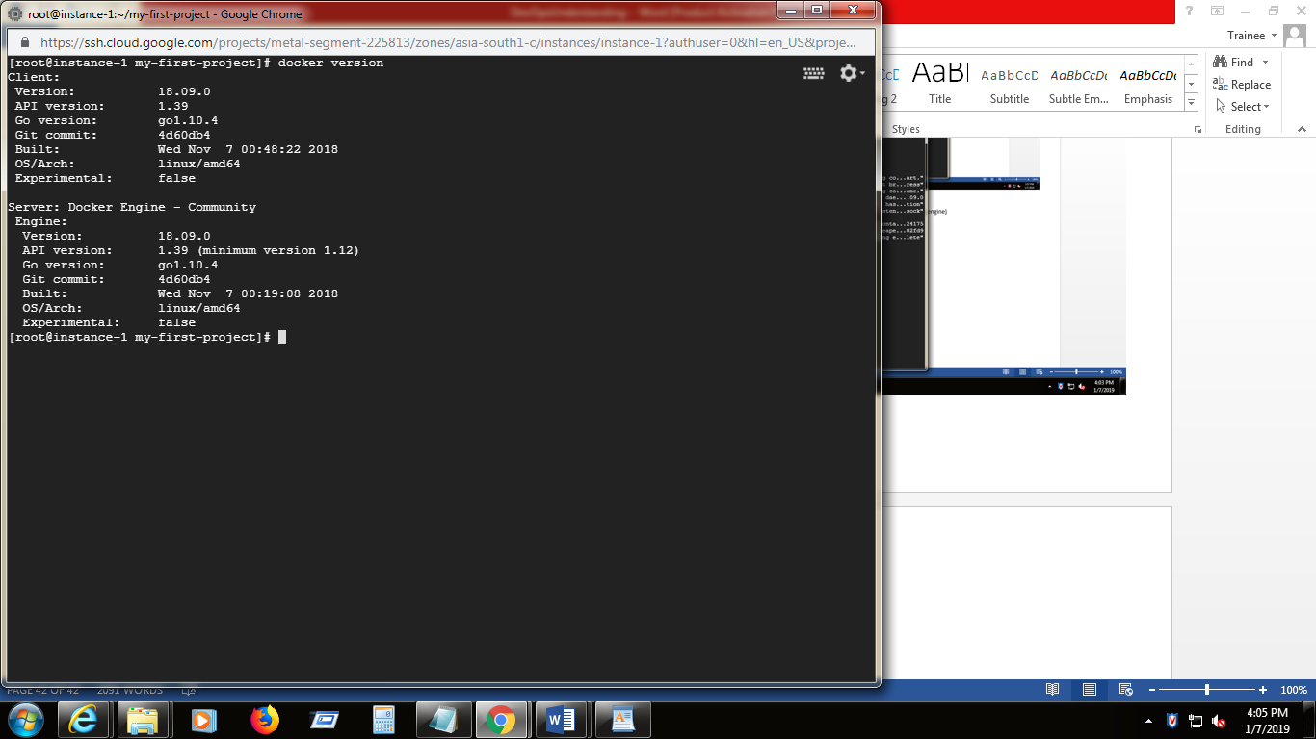

1. List out the containers running

**docker ps –a**

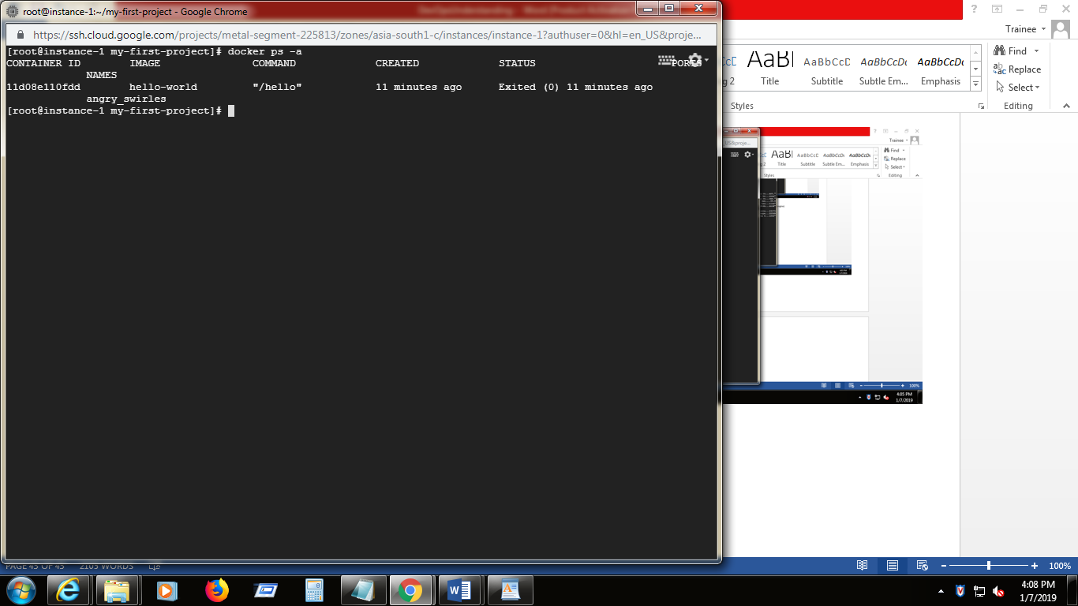

1. List out the images

**docker images**

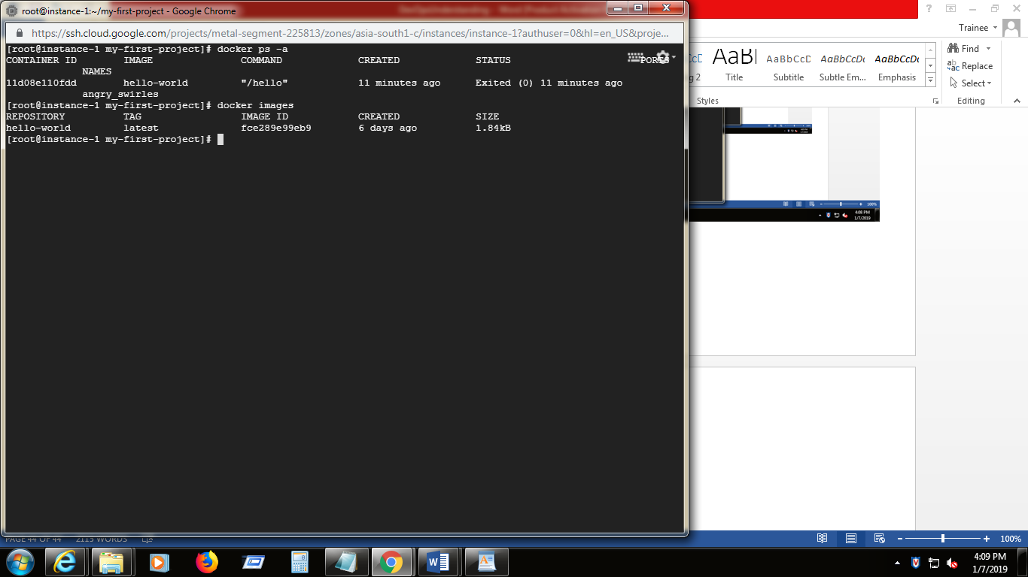

1. Install Ubuntu

**docker run ubuntu echo “Welcome to Ubuntu”**

docker run command first creates the writable container layer over the specified image and doest not start the container .

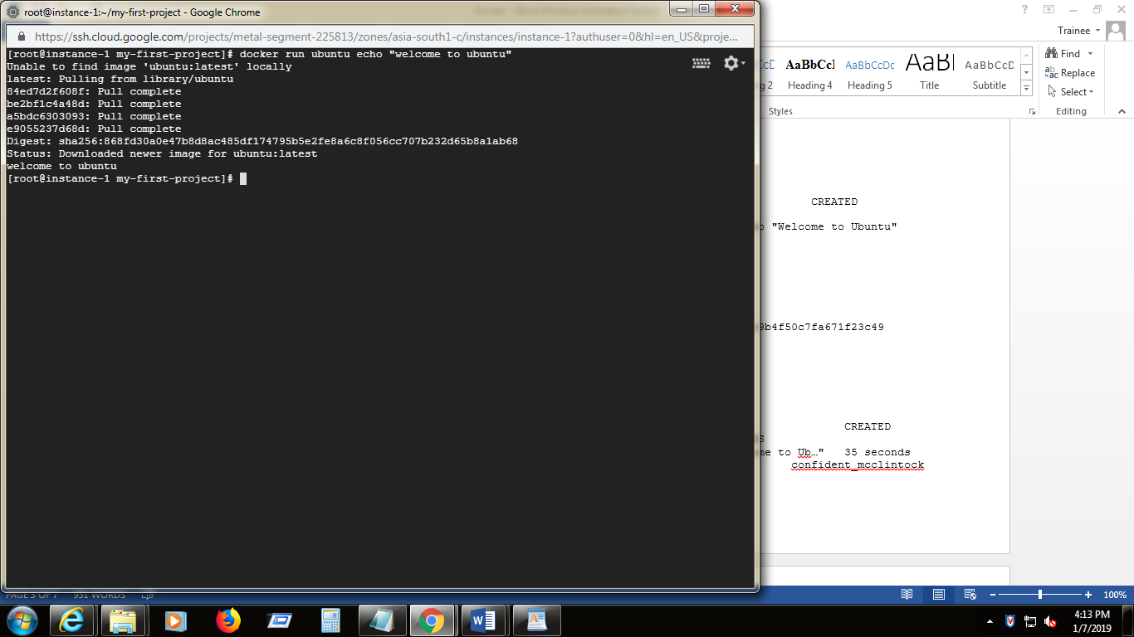

1. Check the Ubuntu installation

docker ps –**a**

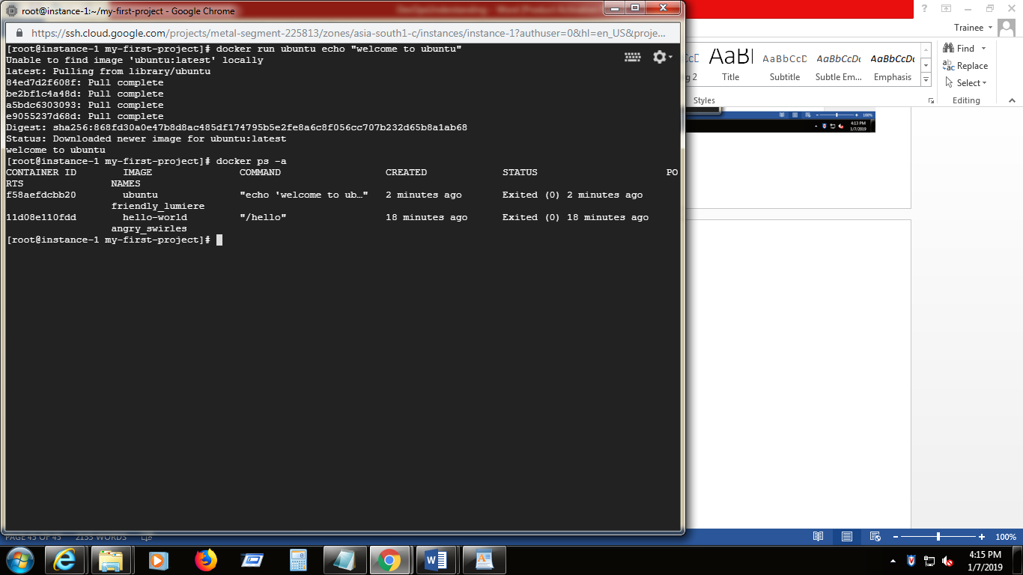

1. **cat /etc/\*-release**

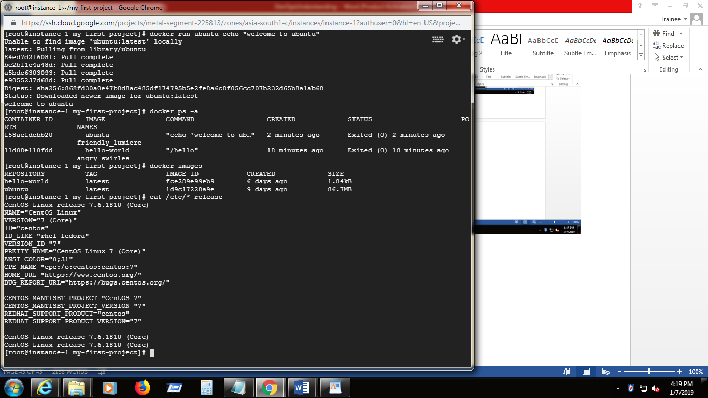

1. To remove (Delete) the container

**docker rm containerid**

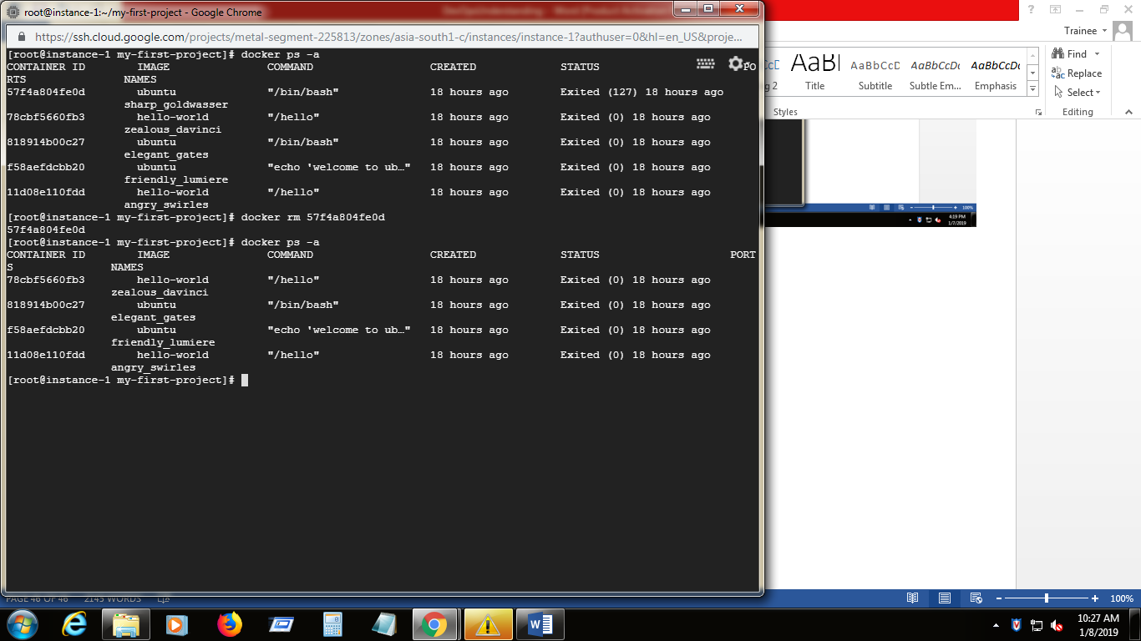

1. To delete all stopped containers

**docker container prune**

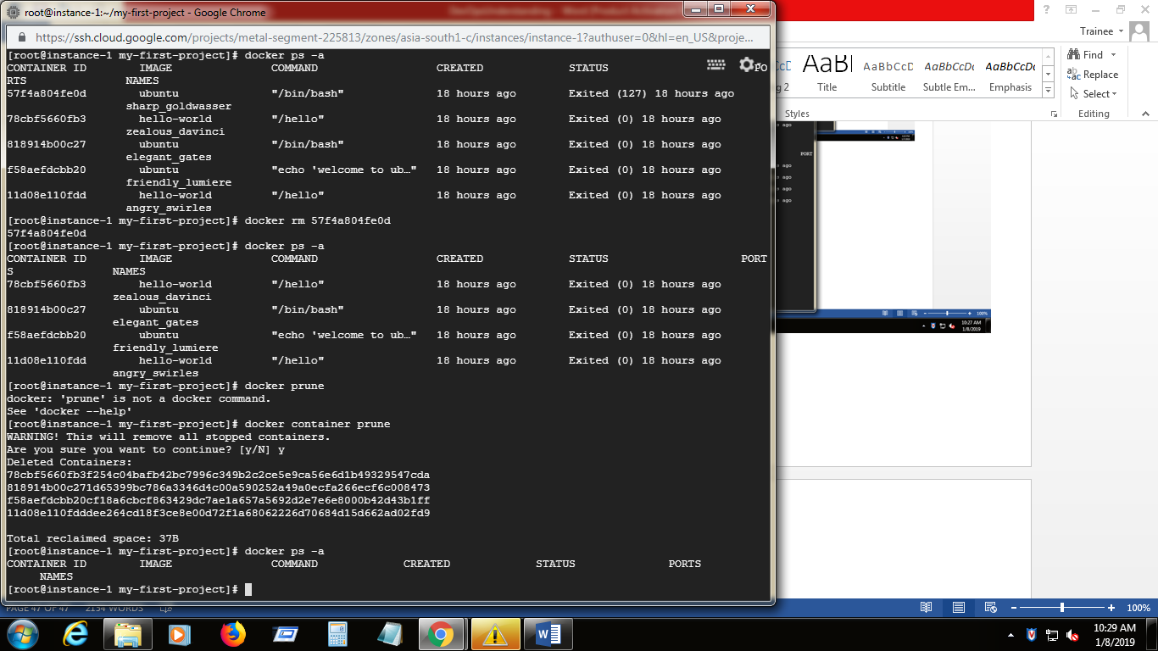

1. To delete the docker image

**docker image rm image- id**

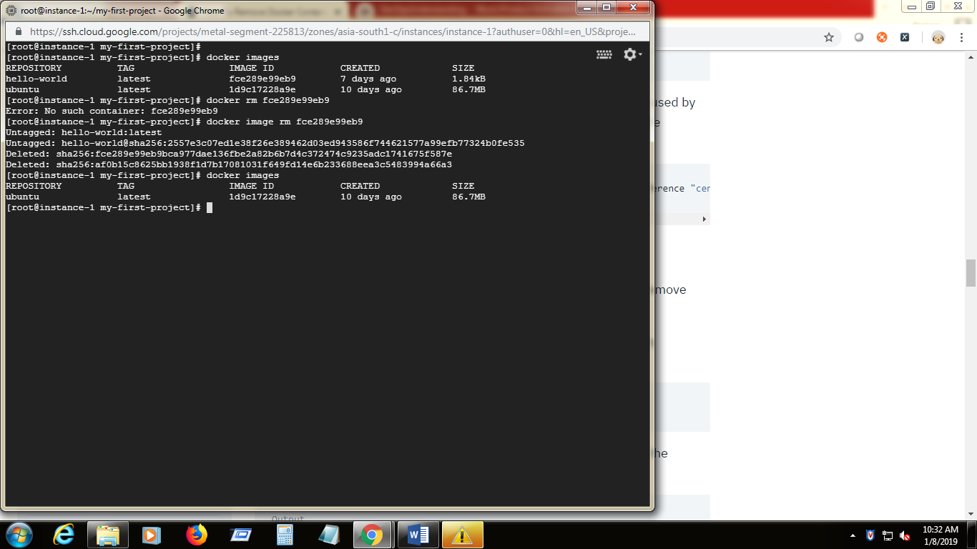

1. To remove all unused images

docker image prune 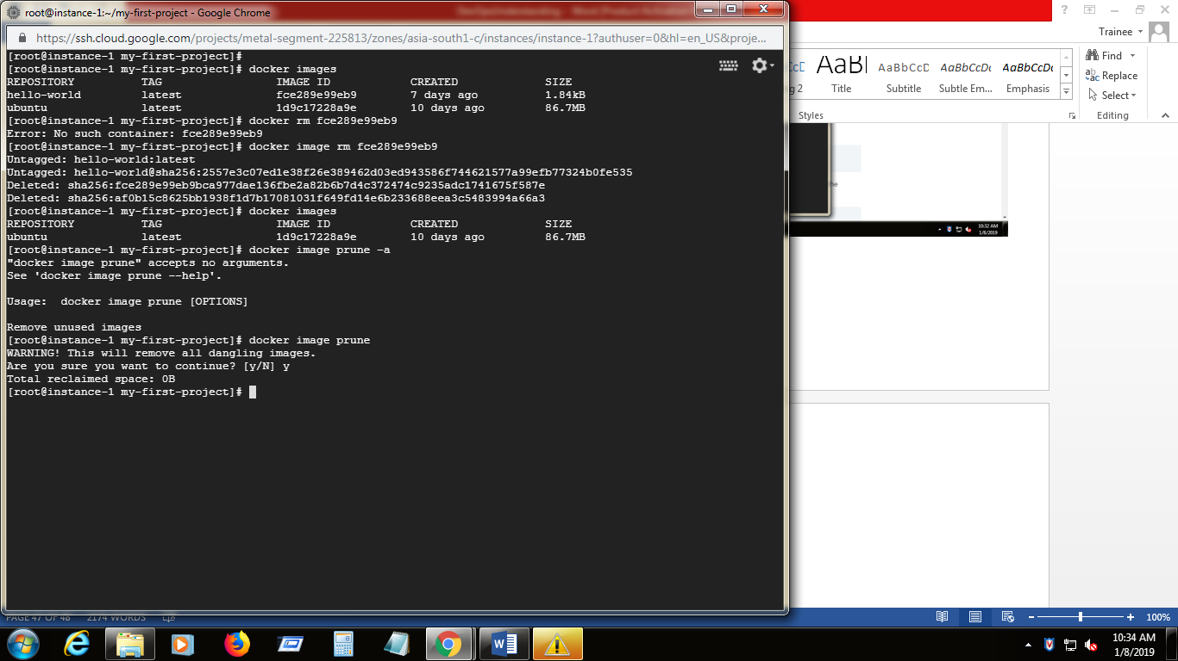

1. Created two containers over two images as below using docker run command

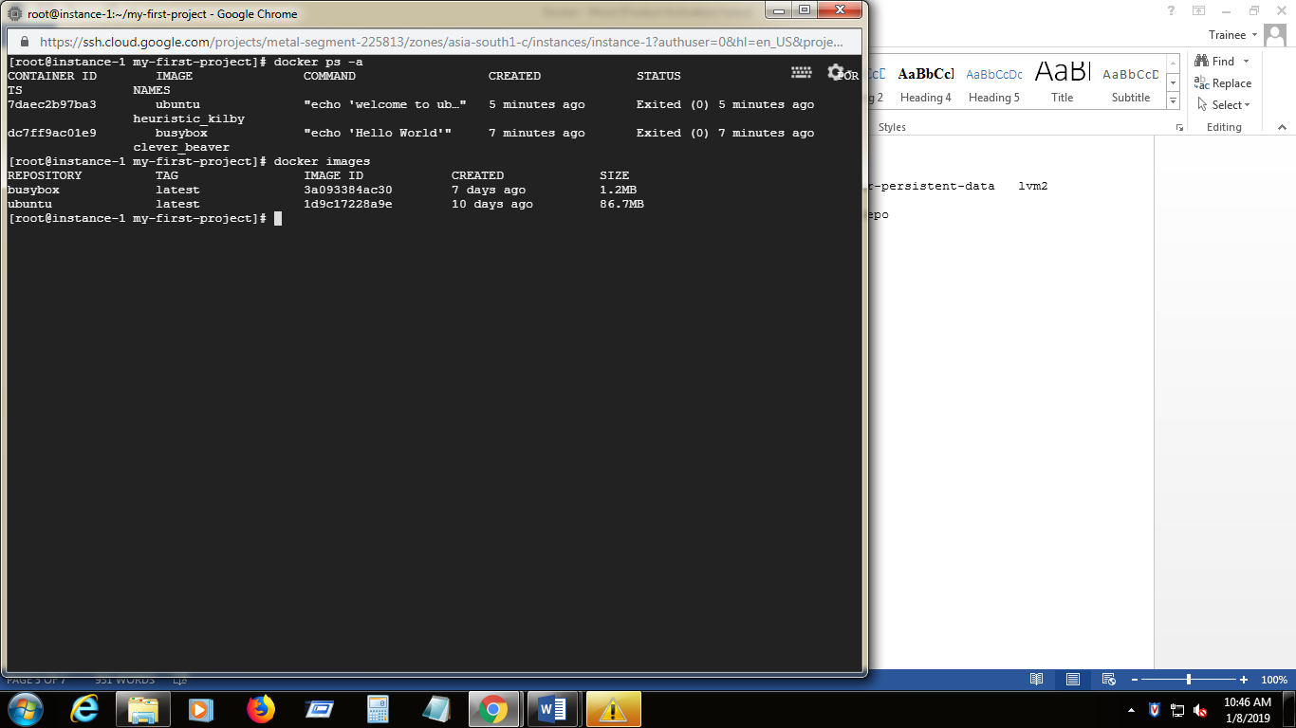

1. **uname –a -** which gives system information

**uname –**p – which gives processor type

**uname –**m – which gives machine type

**cat /etc/\*release** – which gives OS version details of the shell prompt

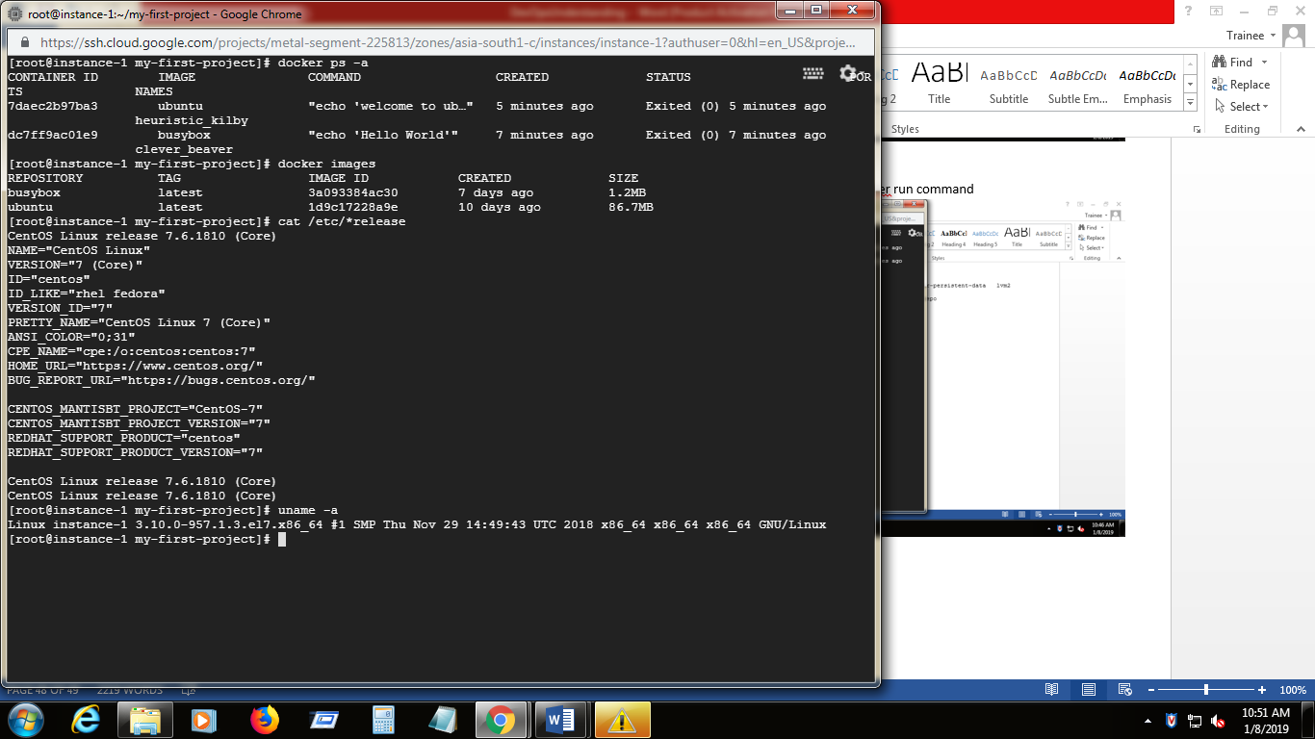

1. We can search repository in  **[https://hub.docker.com/explore/](https://hub.docker.com/explore/" \t "_blank) .** which has official and non official images.
2. We can also search image from out terminal

Sudo docker search “ am image want to get” (ex: centos”) | more

**sudo docker search centos | more**

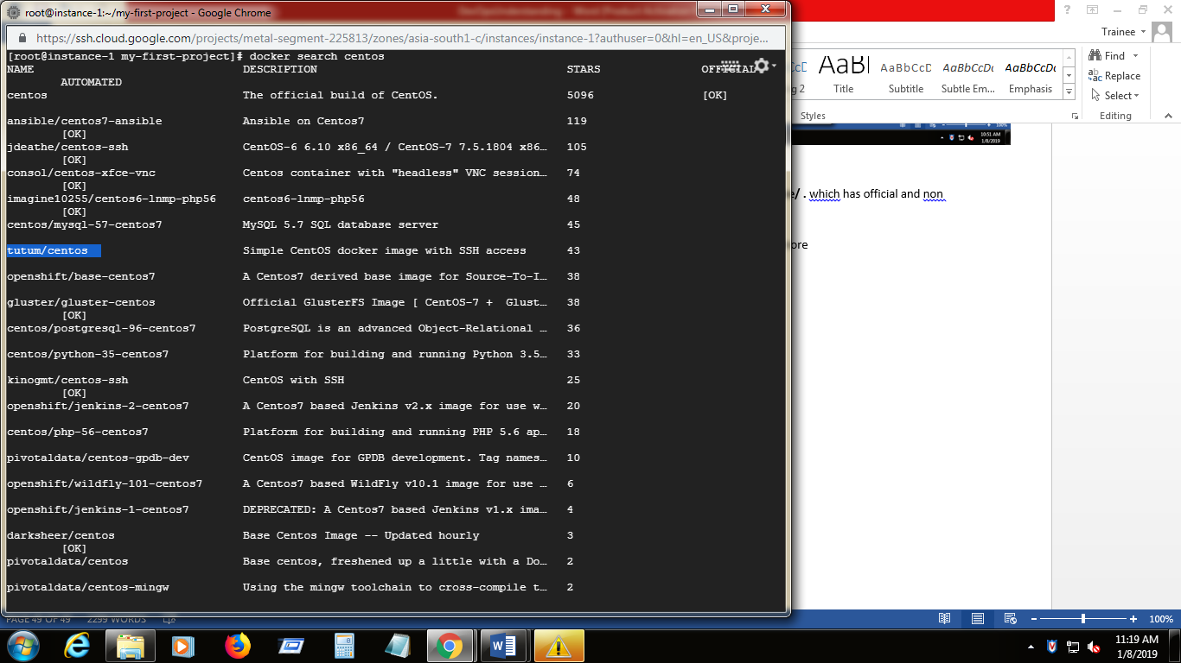

1. To pull an image into local repo and check the images information

docker pull “image id”

**docker pull tutum/centos**

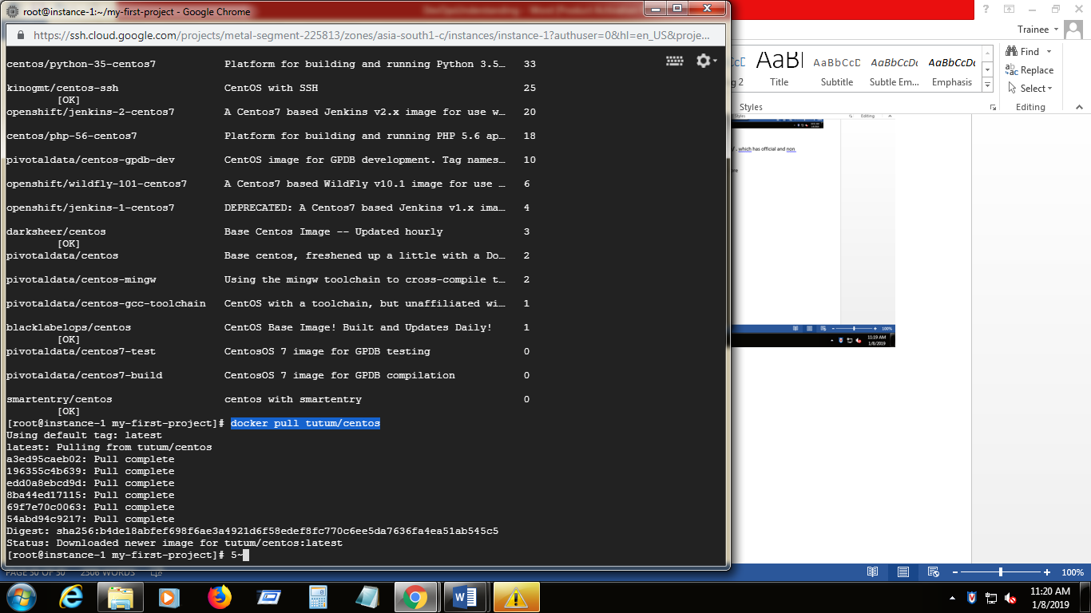

1. Now we can list out the images

**docker images**

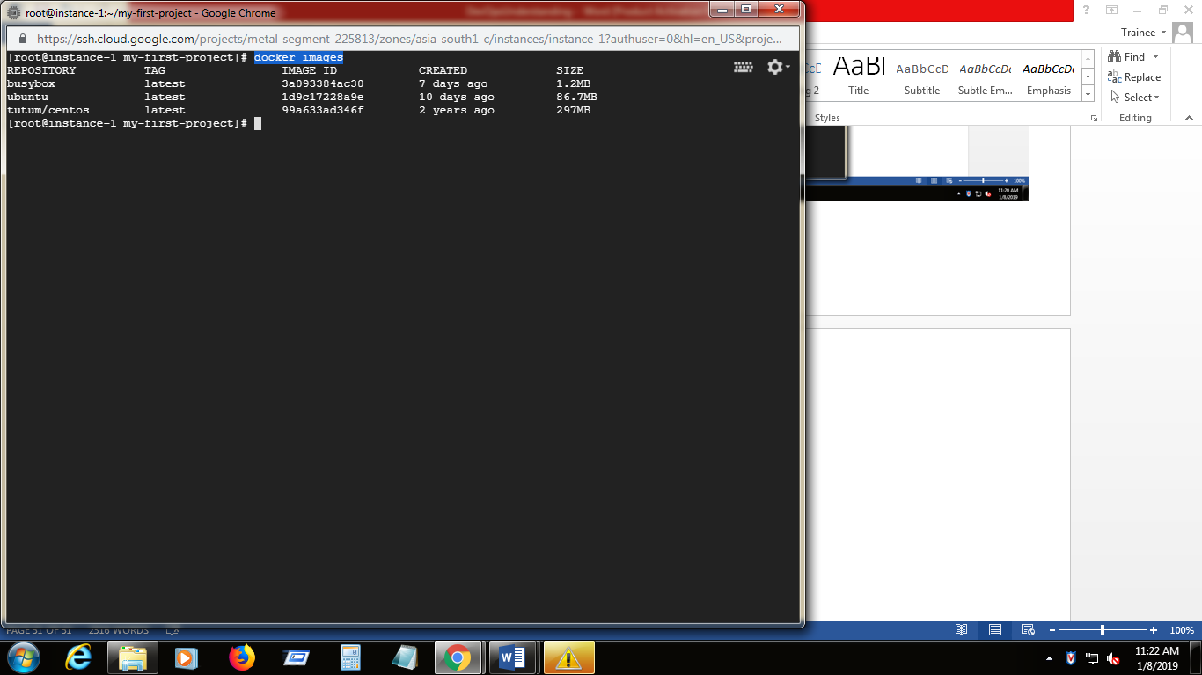

1. To open the image and see the image details

docker inspect “image-id”

**docker inspect 3a093384ac30**

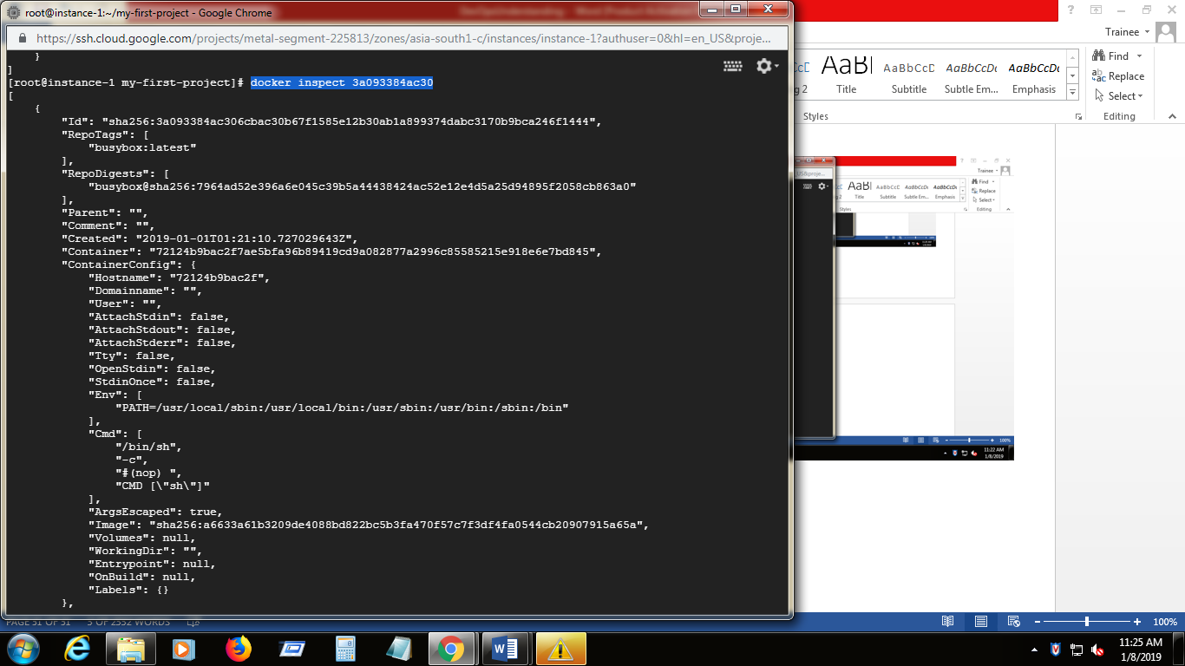

1. To delete image from local repo

Docker rmi image id

**Docker rmi 99a633ad346f**

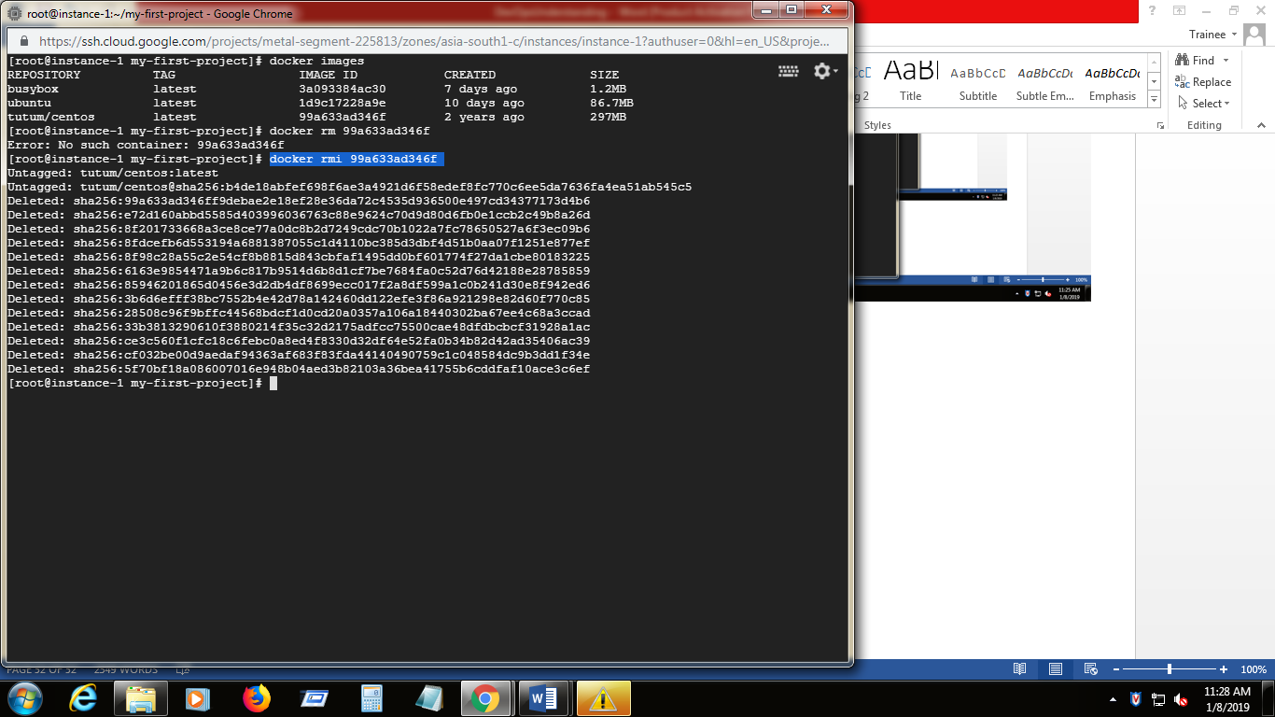

1. By default all the created containers are in stopped state
2. We have to start the container

docker start –ai container-id

**docker start –ai 502356430b2c**

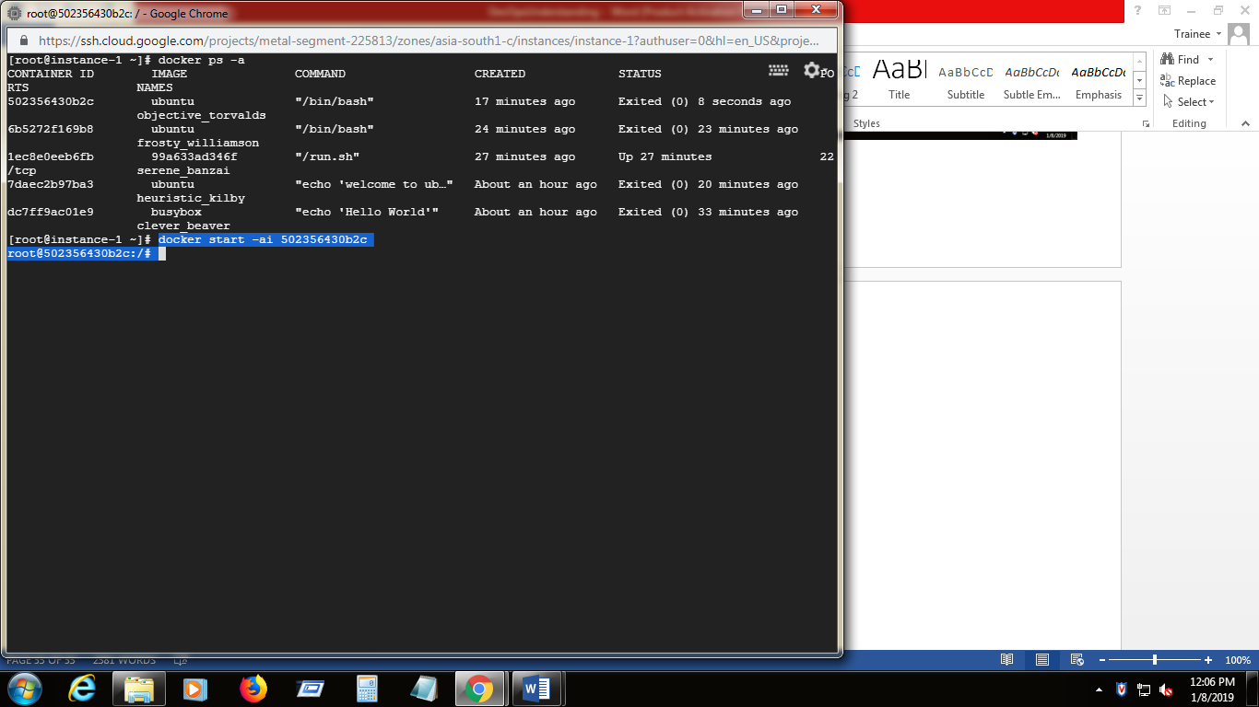

**docker run –it “imagename “ –** creates the writable container layer over the image and start the container

1. Create the new file in the above started container

**touch helloworld.txt**

To list out the files & contents in the container

**ls**

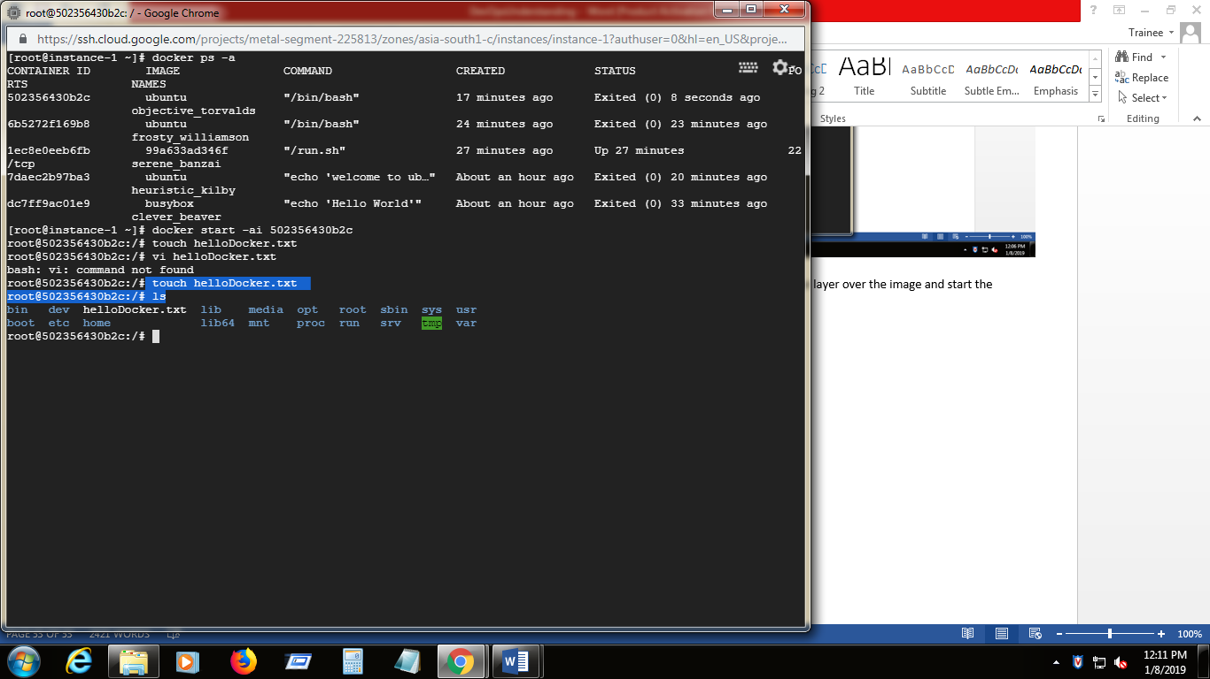

1. To create the new image ,come out of the container using exit and commit

docker commit container-id repositoryname

**docker commit 502356430b2c localrepo**

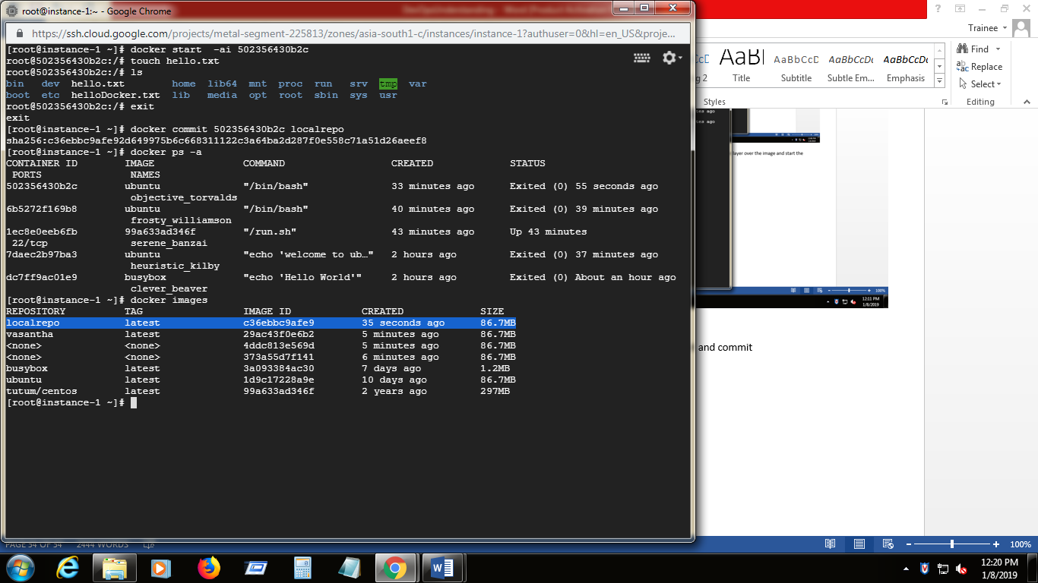

1. Lets create another container using the newly created image

docker run –it newly created image name

**docker run –it localrepo**

The txt create in the above step will get listed out in this container

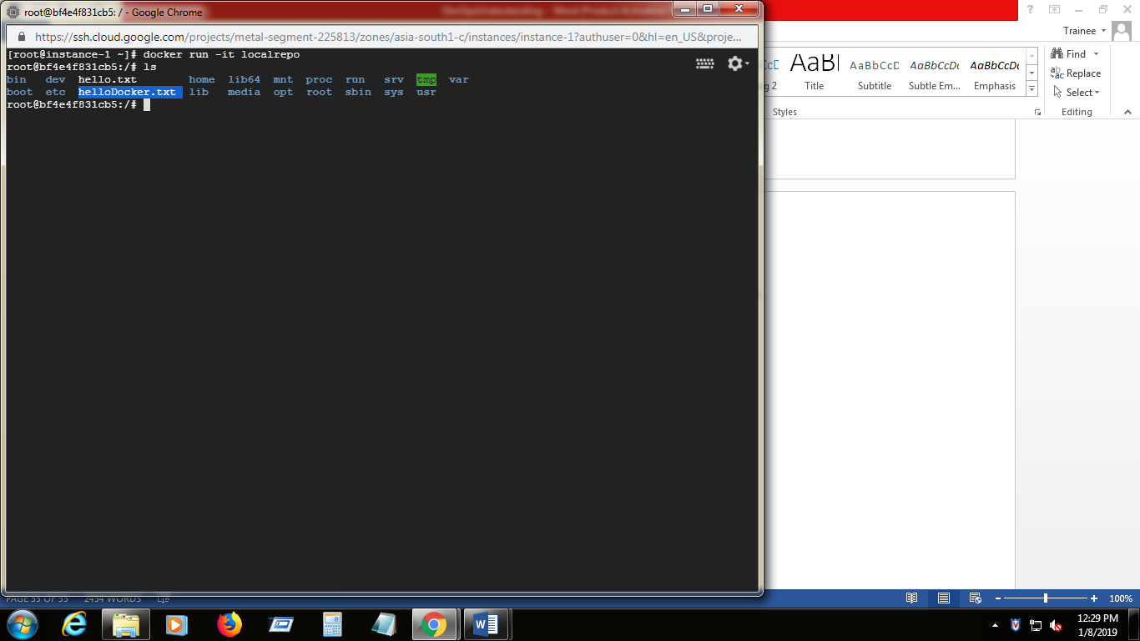

**Build an application using dockers:**

1. With dockers we can grab the python (for ex) runtime as an image (installation is not necessary) then our can include base python image along with application code, ensures dependencies , runtime , app code all travel together.
2. Docker file is a file which defines the portable images.
3. Docker files defines what goes in an our environment inside the container . Access to the resources like network interfaces , disk drives are virtulized here . The container needs to exposed to outside world using the port is defined here.
4. Create the Dockerfile and other necessary files in the current directory as mentioned in the following link

[**https://docs.docker.com/get-started/part2/#define-a-container-with-dockerfile**](https://docs.docker.com/get-started/part2/#define-a-container-with-dockerfile)

1. now list out the files in current directory

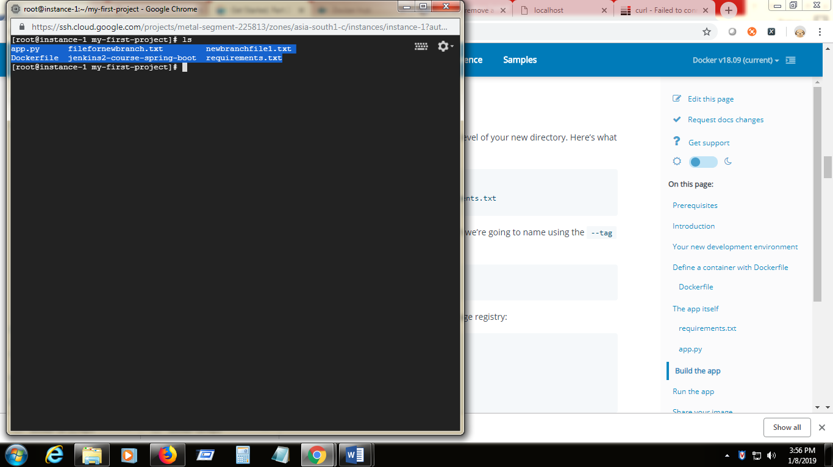

1. build the application using the

**docker build --tag=containercreation:v0.0.1 . [containercreation is the repository name v.0.0.1 is the tagname which is refered later]**

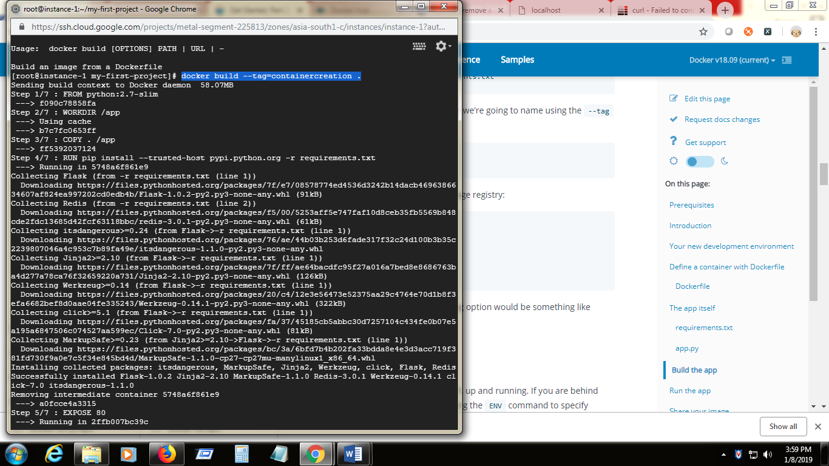

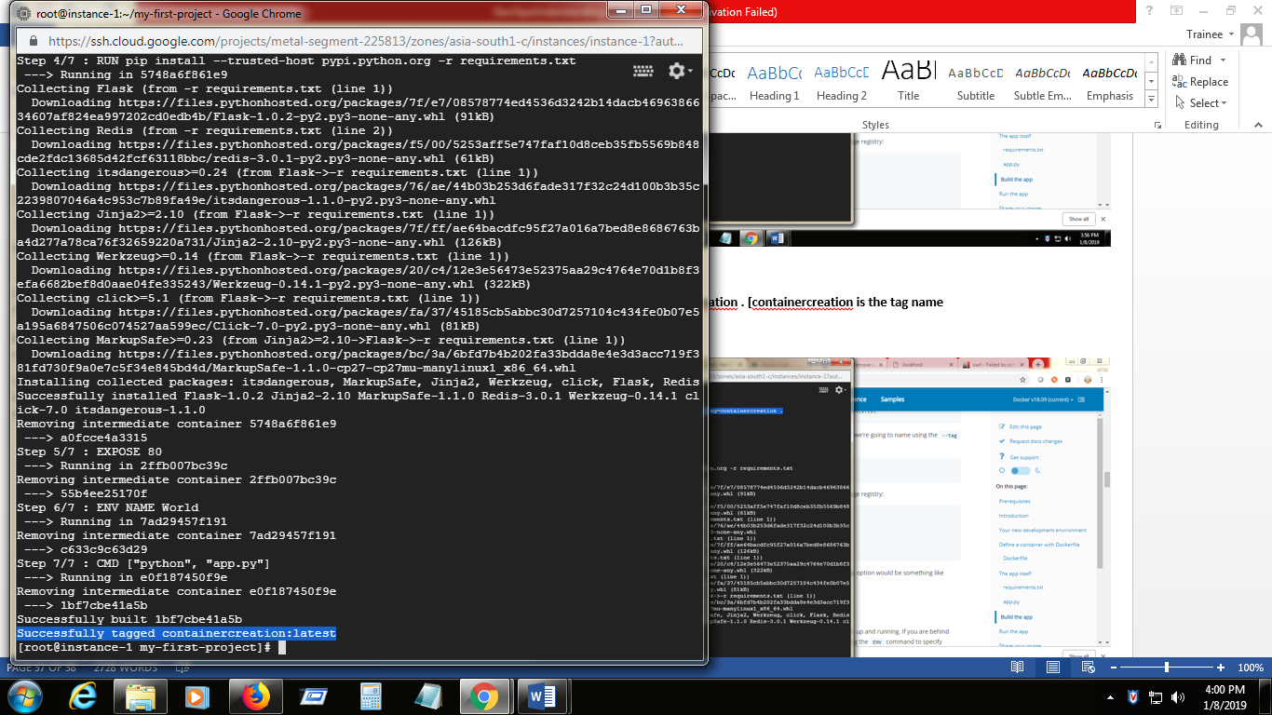

1. Now the image is created in our local registry.

**docker image ls**

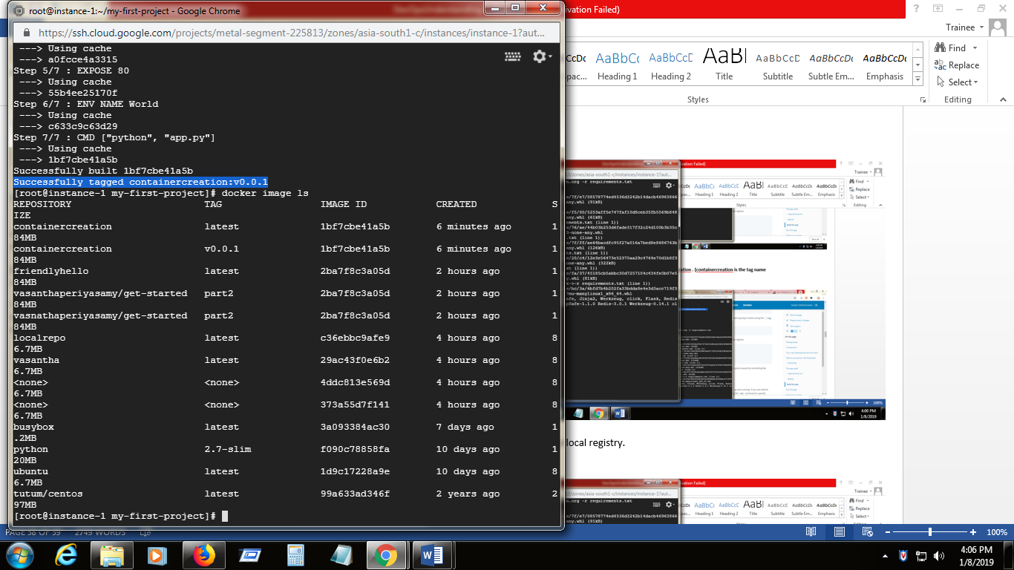

1. Now run the application from this image. Ie. Create and Launch the container

**docker run -p 5000:80 containercreation**

while running the application using the docker run we are mapping the allication port to dockermachine port

80 is mentioned in the app.py file

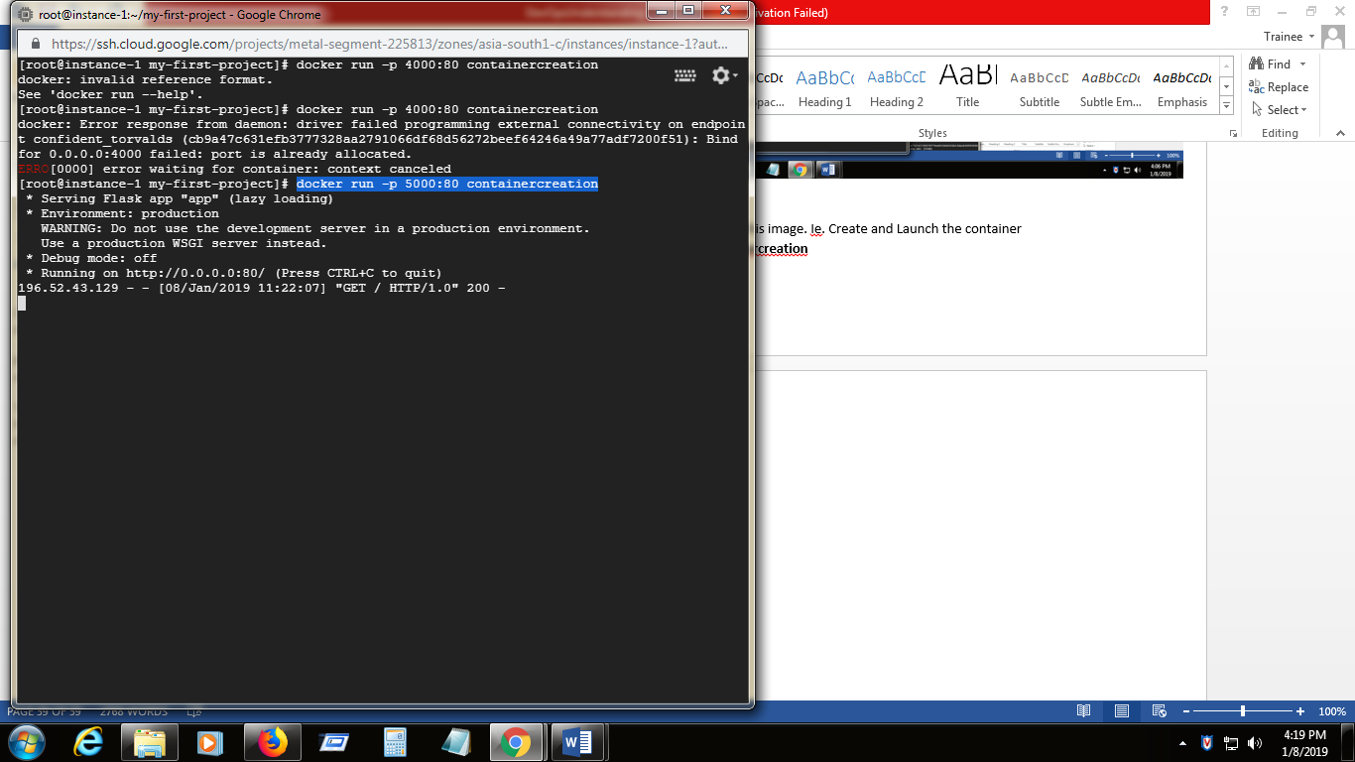

1. Now the application is accessed by <http://35.200.128.145:5000/> (http://localhost:50000

Since using the GCP cloud for development 35.200.128.145 is the VM instance ip

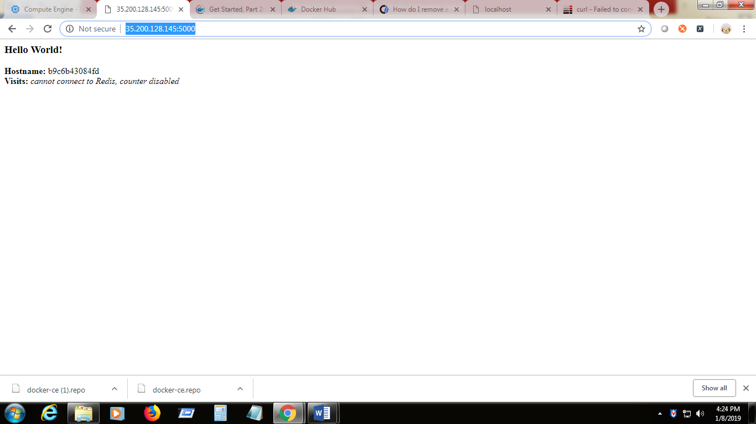

1. Now the newly created container is listed out in containers list

**docker ps –a**

1. To start the container in detached mode . so that the container is running in the background

**docker run –d –p 5000:80 containercreation**

1. We have to publish the image into registry , so that it can be accessed anywhere

Login to the docker public registry .

Dockerhub is the public dcoker registry. Create the acoount on **https://cloud.docker.com**

**DockerHup credentials:**

Vasanthaperiyasamy

January@2019

1. Login to docker public registry using credentials

**docker login**

1. Tag the image into public registry

docker tag imagename username/repository:tag

**docker tag containercreation vasanthaperiyasamy/firstimage:v0.1.1**

Now it will be available in the local registry

1. Push this to public registry

docker push username repository:tag

**docker push vasanthaperiyasamy/firstimage:v0.1.1**

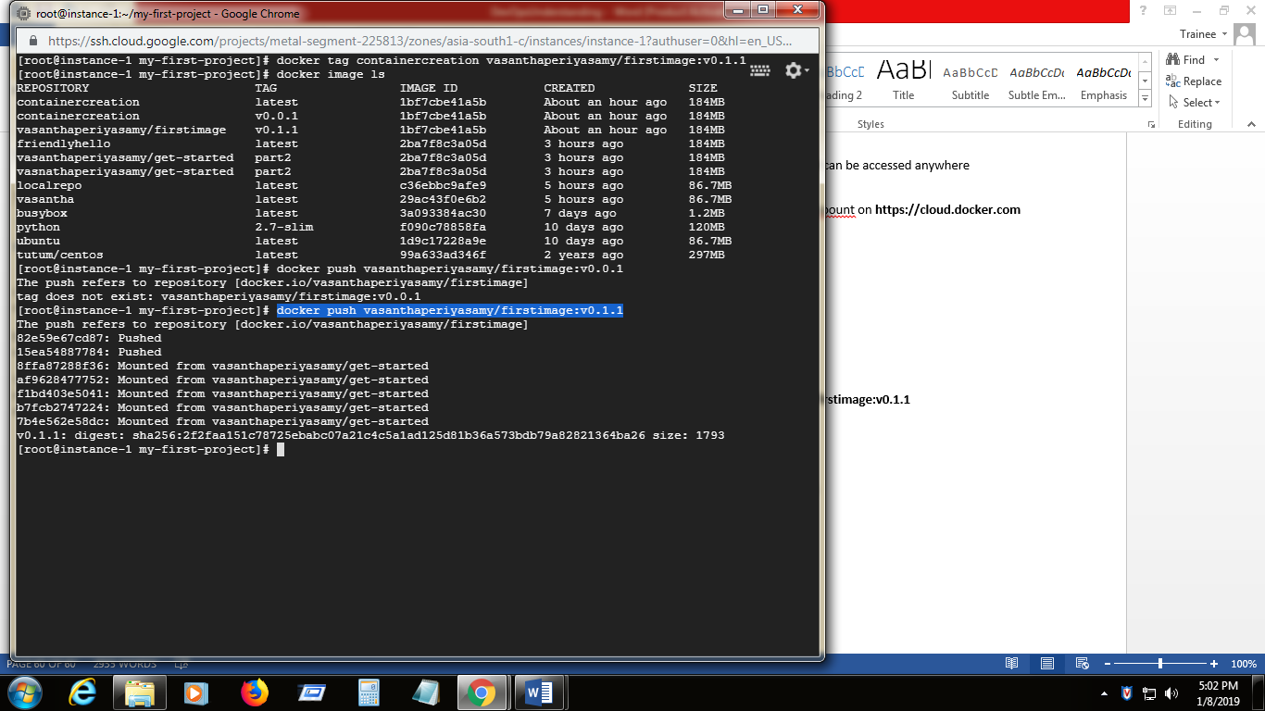

1. This image is now available in [**https://cloud.docker.com/u/vasanthaperiyasamy/repository/list**](https://cloud.docker.com/u/vasanthaperiyasamy/repository/list)

**Running the image as Service: [launch the container as service)**

In an distributed application , different pieces of application are called as service. Services are containers. Services run only one image and specify the replicas of the images inform of containers.

Docker-compose.yml is an YAML file containes the details of the service like service name , which image needs to be acts as service , how many replicas.

Refer the site **https://docs.docker.com/get-started/part3/#docker-composeyml**

1. Create the docker-compose.yml file

**vi docker-compose.yml**

copy the contents from the above site and change the username/repository:tag details

and change the replica number also.

Save the file.

1. Since we are imitating as cluster environment the current machine should be swarm manager

**docker swarm init**

1. Now run the service from dokcer-compose.yml file

Docker statck deploy –c docker-compose.yml nameof the service

**docker stack deploy -c docker-compose.yml firstservice**

Now the service is created in the name firstservice\_web (login defined in docker compose file)

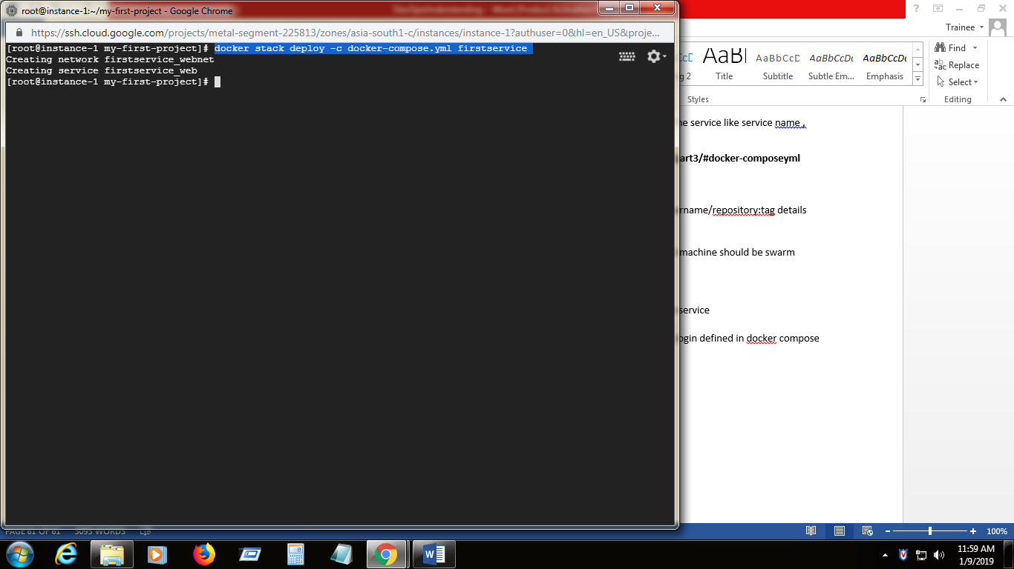

1. Check the created service and replicated

**docker service ls**

Now the image is launched as service and replicated as many containers mentioned in the docker-compose file.

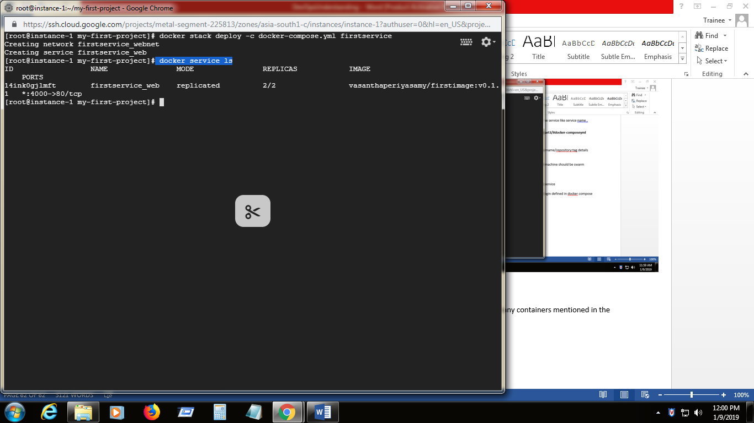

1. Check the container list for the newly create ones.

**docker container ls**

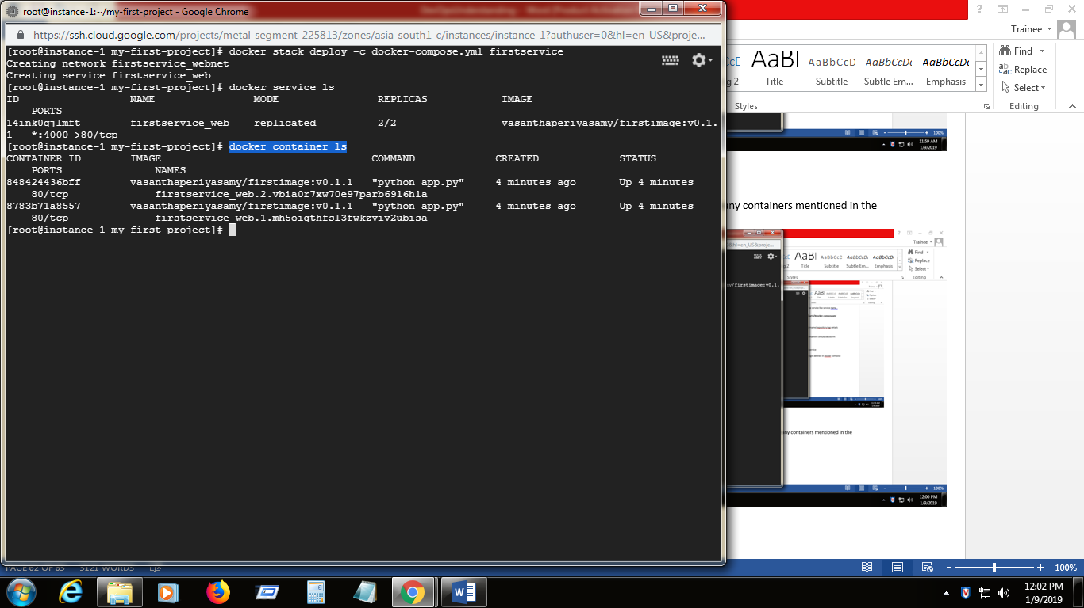

1. List out the service replicated

**docker service ps firstservice\_web**

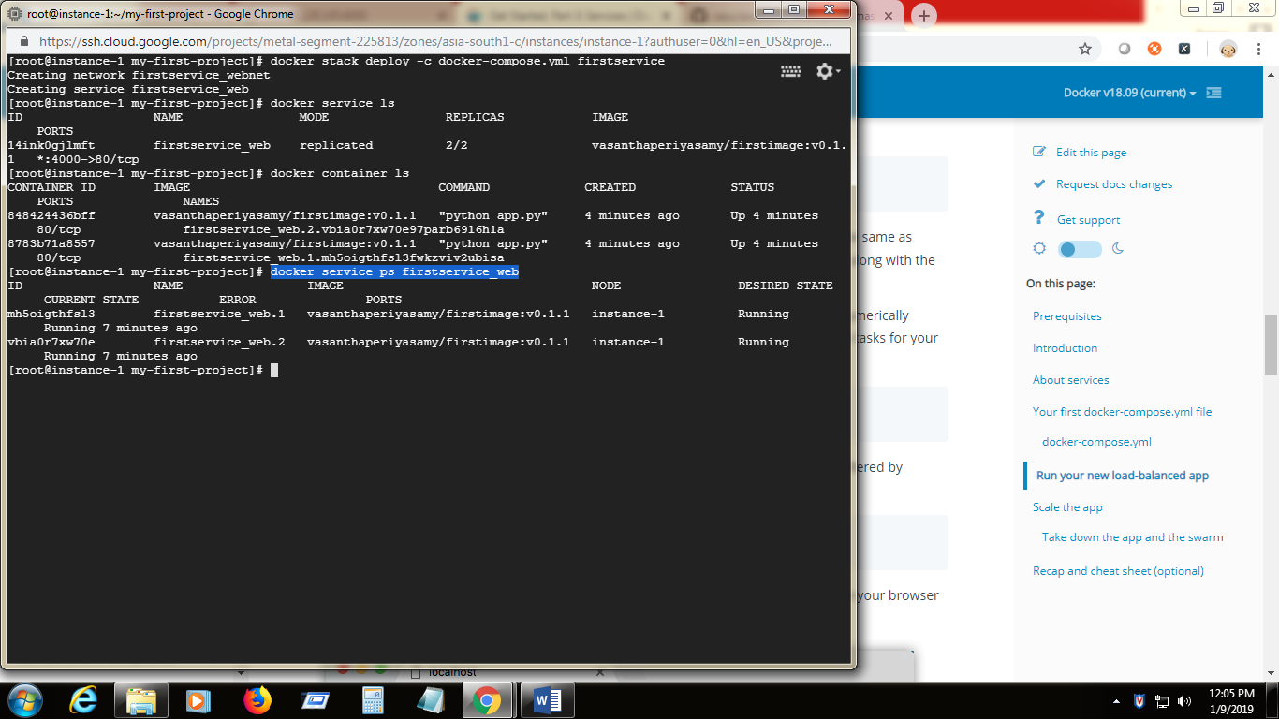

1. Now hit the <http://host:4000/> (<http://35.200.128.145:4000/>)

The host name changes for every hit (host name is same as container id)

The subsequent request to the application is balanced with two services which is mentioned in docker compose file.

We can also scale the app by changing the replicas value in dokcer compose file.

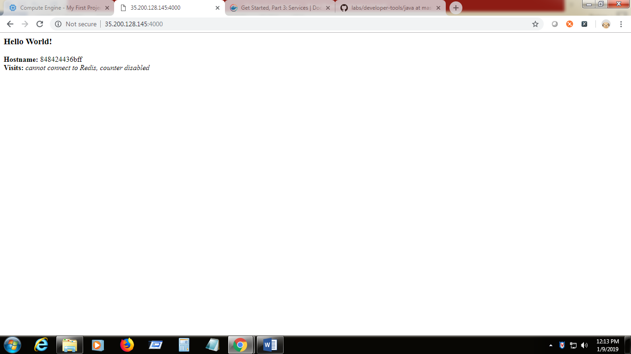

1. Remove the service from stack

**docker stack rm firstservice**

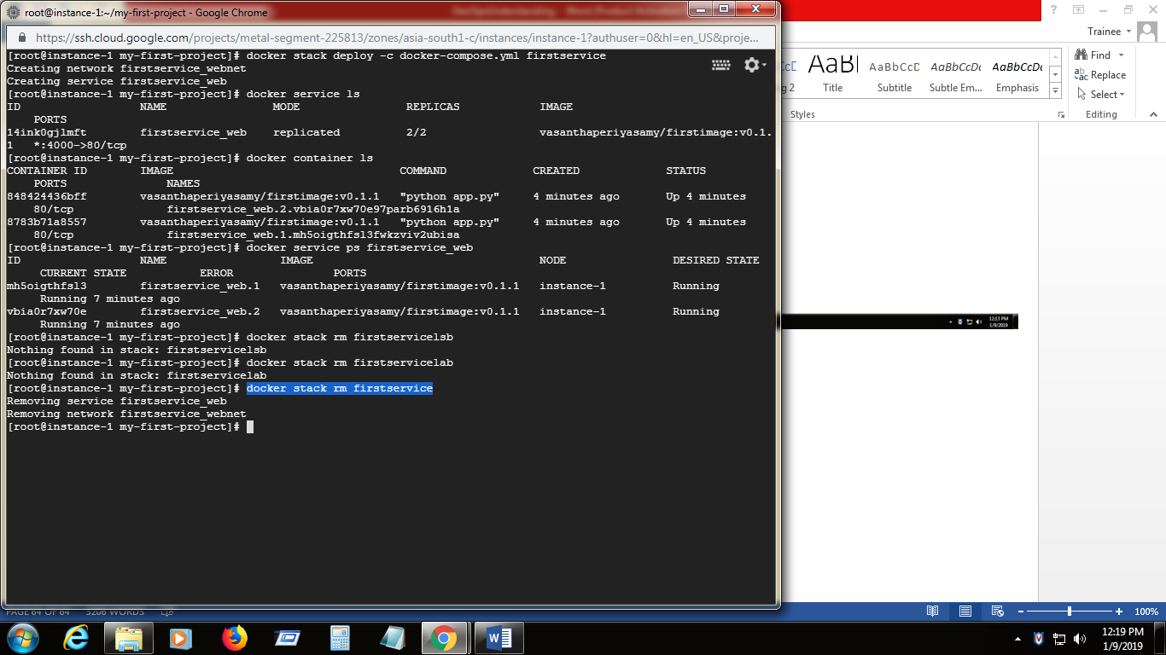

1. Remove the Swarm

**docker swarm leave –force**

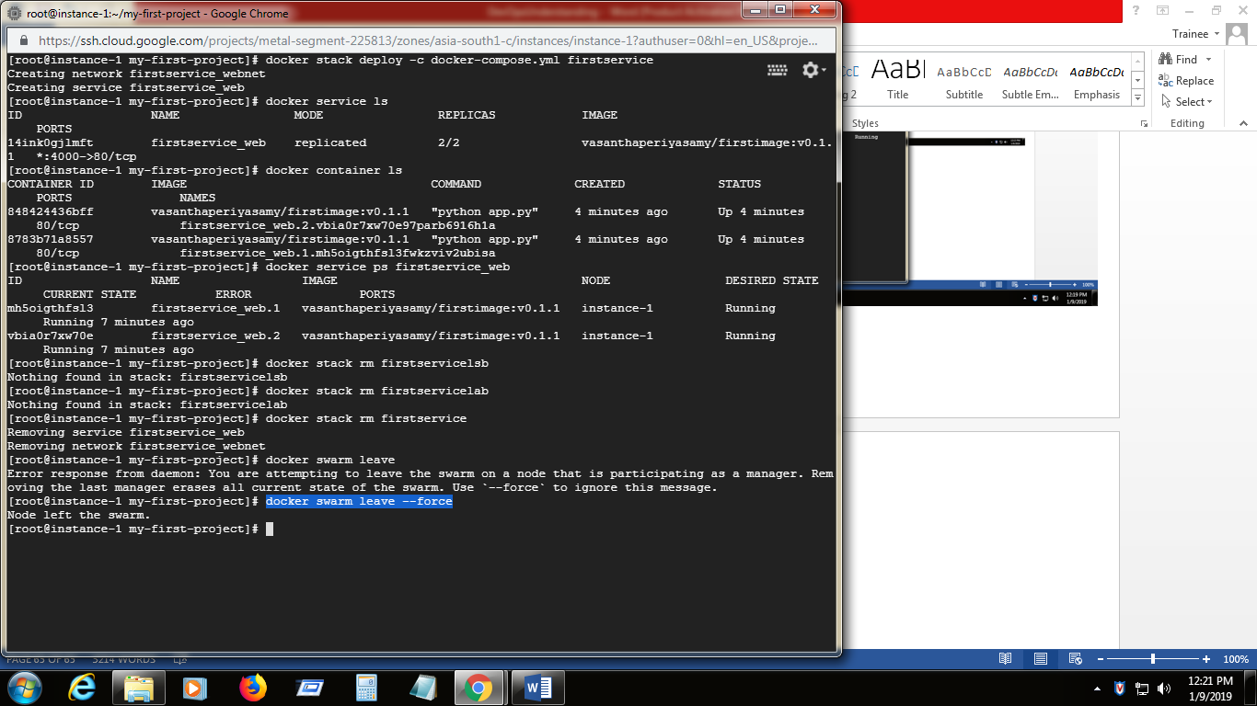

**Understanding swarm clusters with Docker:**

1. Swarm is a group of machines that are running dockers joined into a cluster.
2. Swarm is made up of multiple nodes which can be either physical of virtual machines.
3. There will be only on machine should acts as swar managers and others are workers joined with swarm
4. Swarm manager only has the rights to execute commands what other can do . but not by the worker

**Set up the Swarm:**

1. Create the one more virtual machines(GCP) as described earlier in this document(instance-2)
2. Install the dockers in instance 2
3. Switch to instance 1 kernel and make this as swarm manager

**docker swarm init**

it will print the manager token and the commands to join another machine as worker to this swarm

**Swarm initialized: current node (zgsxur6drwi8db5ivqgsjbcry) is now a manager.**

**To add a worker to this swarm, run the following command:**

**docker swarm join --token SWMTKN-1-2k5wh70g76z2vnejeg4bnlfrtmtcsbe0nhtb3pf8fwwictr66y-2ulis3dvjuc6vrb5374ou2jik 10.160.0.2:2377**

**To add a manager to this swarm, run 'docker swarm join-token manager' and follow the instructions.**

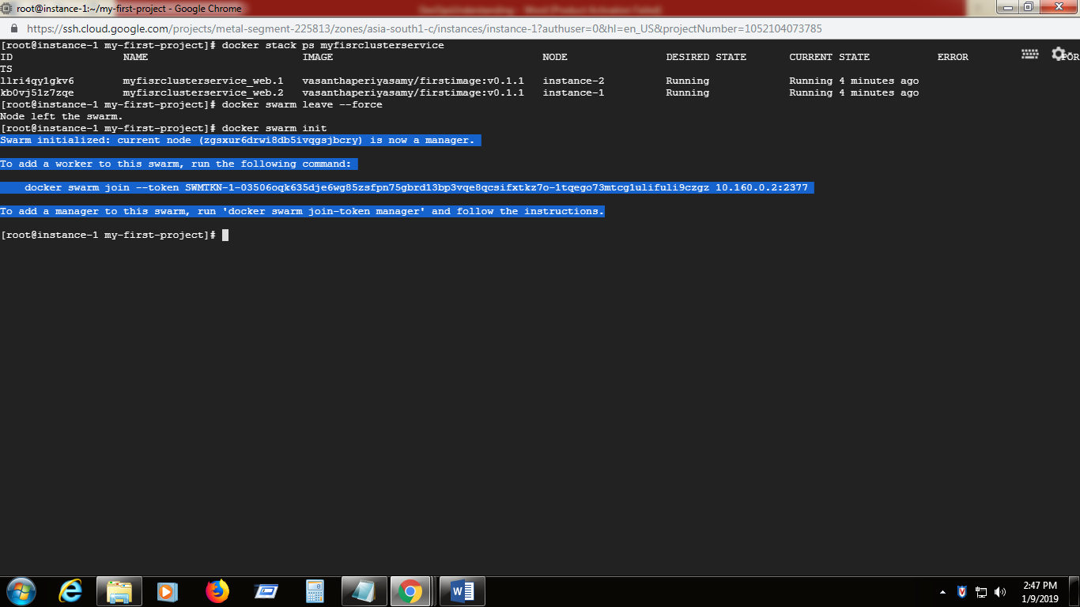

1. Switch to instance-2 kernel and execute the swarm join command which is mentioned in previous step.
2. Now deploy the app as service in the swam enabled docker.

**docker stack deploy -c docker-compose.yml firstswarmnode(**name of the service)

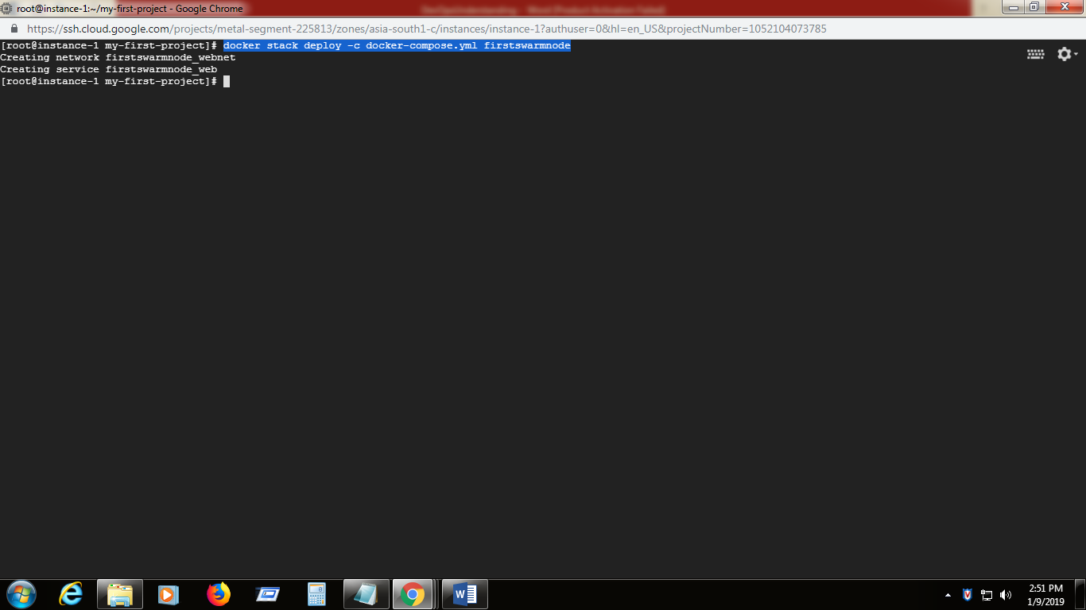

1. Service is getting created

**docker service ls**

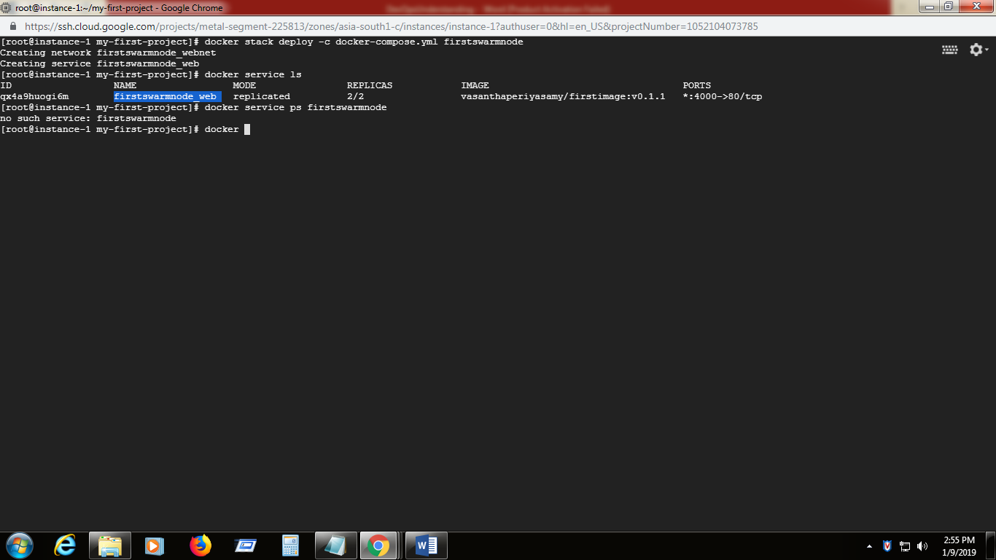

1. The replicated instances are listed in stack (mentioned in docker-compose.yml )

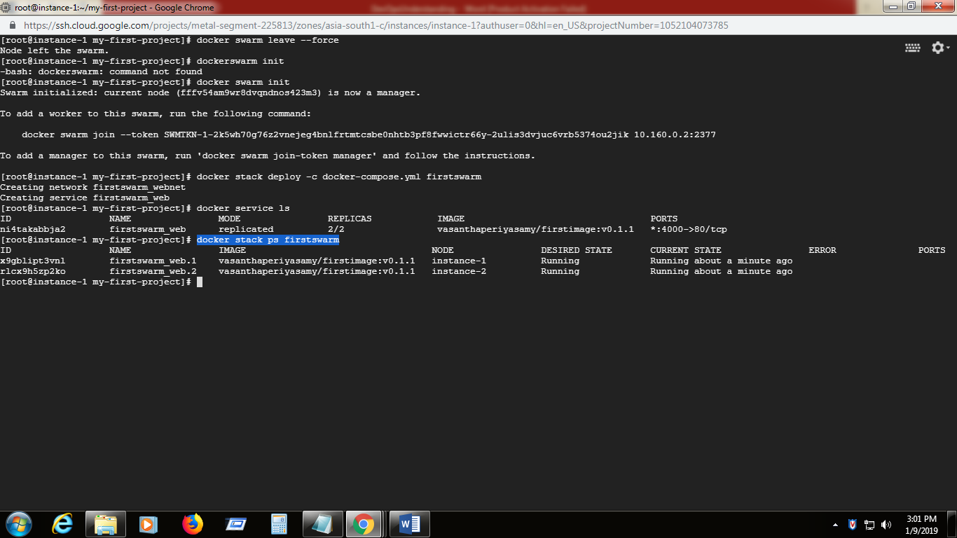

Now the the application instances are distributed into nodes in swarm.(shown in Node column)

So the subsequent request to the application are balanced to different instances in swarm which is taken care by load balancer

Refer : [**https://docs.docker.com/get-started/part4/#iterating-and-scaling-your-app**](https://docs.docker.com/get-started/part4/#iterating-and-scaling-your-app)

1. Now clear the stack

**docker stack rm firstswarm(service name)**

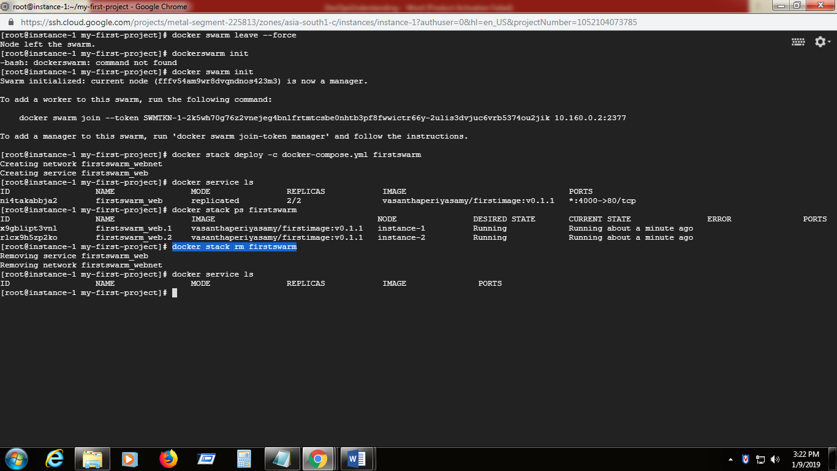

**Running Multiple services on Stack :**

1. Copy the contents from link into docker-compose.yml file .There are three services defined here.

[**https://docs.docker.com/get-started/part5/#persist-the-data**](https://docs.docker.com/get-started/part5/#persist-the-data)

1. Execute the docker deploy file

**docker stack deploy –c docker-compose.yml firststack**

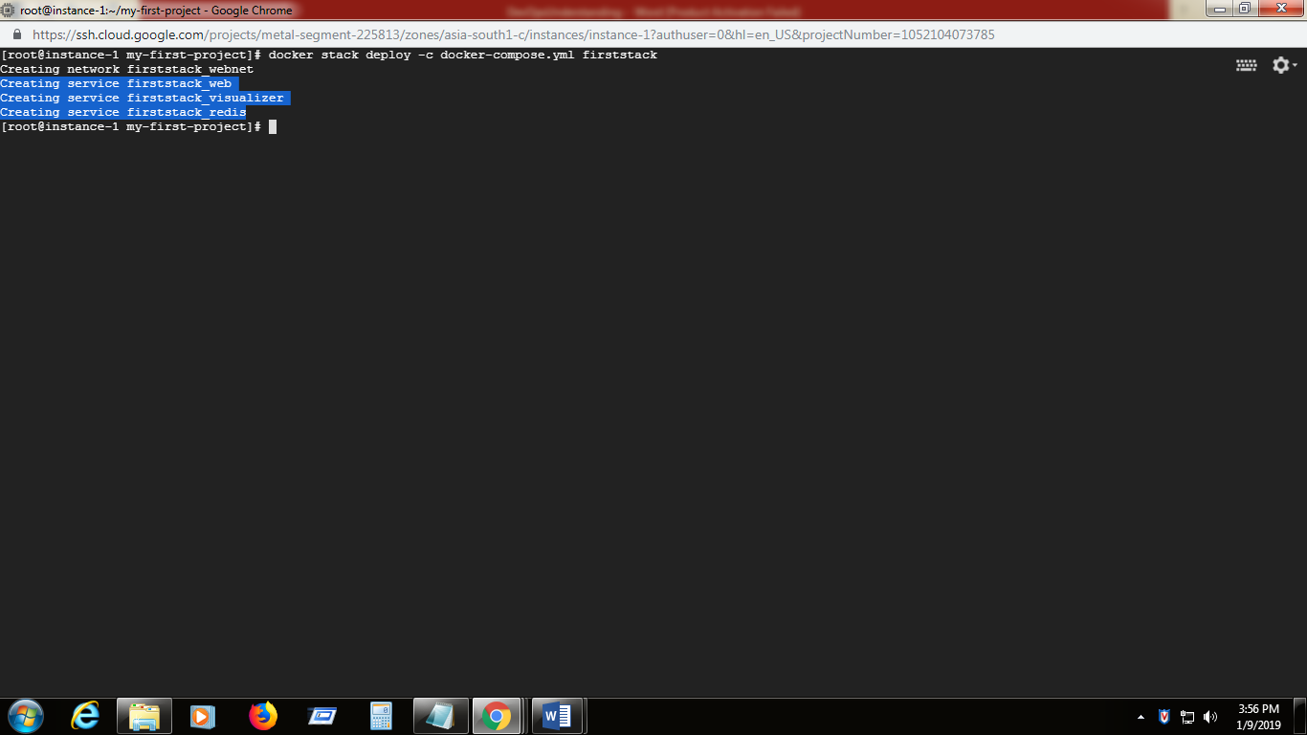

Now three services are running in the stack

1. To view the services

**docker service ls**

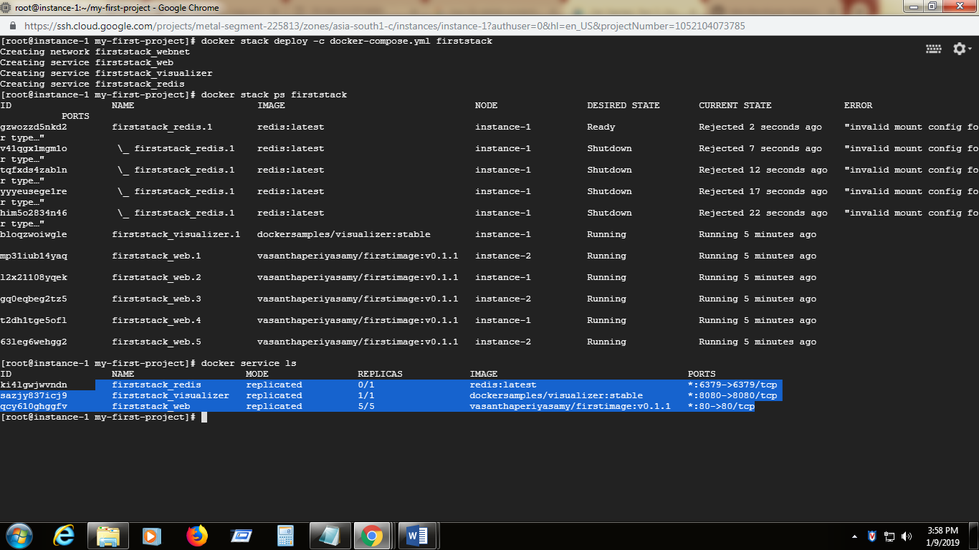

1. To view the contents of the stack (which is distributed across instances in swarm )

docker stack ps firststack

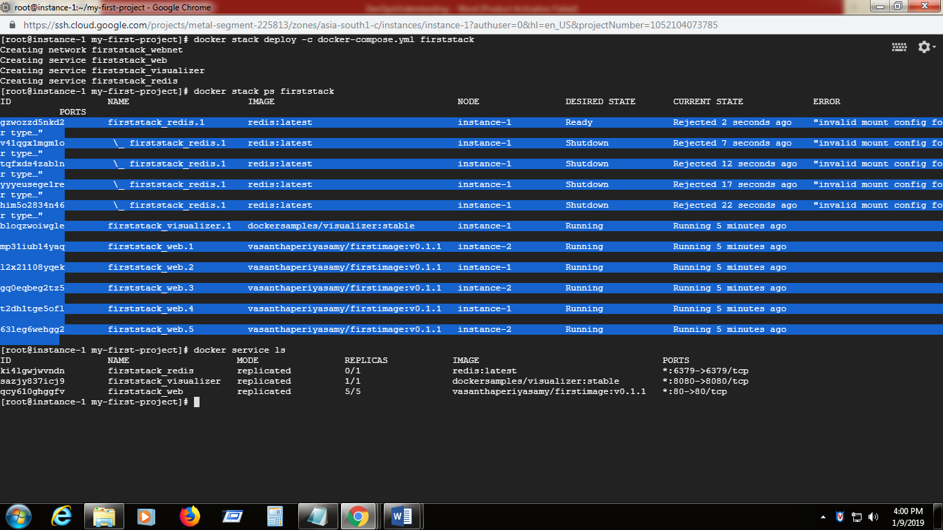

**PIP** – is an package management system for installing and managing the software packages written in python

**docker-compose –** is a tool used todefine and run multicontainer docker applications.

There are three steps involved in the docker-compose

1. Define the applications environment with **Dockerfile**
2. Define the services that makes the application with **docker-compose.yml**
3. Use **docker-compose up** command to start the entire application .